BACMan User Manual

BACMan v 2.1



This Manual Prepared by James C. Estill
jestill@uga.edu

Manual Version
October 11, 2004

Table of Contents

1. Introduction 9
2. Getting Started 12
2.1. Full BACMan Suite Installation 12
2.1.1. BACMan Installation 12
2.1.2. BACGrid Installation 13
2.1.3. BACEater Installation 13
2.2. Starting BACMan 13
2.3. BACMan Menus 14
3. Setting BACMan Properties 15
3.1. Project Properties 15
3.2. Library List 16
3.3. Library Numbers 16
3.4. Library Data 17
3.5. People 18
3.6. Defining Gridding Formats 18
3.7. Defining Multiplex Experiment Designs 20
4. Gridding Libraries 22
4.1. General Grid Job Information 22
4.2. Individual Filter Information 23
4.2.1. Filters 23
4.2.2. Gridding Problems 24
4.2.3. Contamination 24
4.2.4. Overgrowth 25
4.2.5. Plates 25
5. Probe Synthesis 27
5.1. Locus Information 27
5.2. Genomic Clone Isolation 27
5.3. Overgo Probe Design 27
6. Hybridization Experiments 29
6.1. Multiplex Experimental Design 30
6.1.1. Grid Multiplex Format 31
6.1.2. Triangle Multiplex Format 34
6.2. Experiment Builder 35
6.3. Printing Labels 38
7. Scoring Films 40
7.1. Printing Scoring Templates 40
8. Film Data Entry 42
8.1. Manual Data Entry 42
8.2. BACGrid Data Entry 43
8.2.1. BACGrid Menu and Toolbar 43
8.2.2. Setting BACGrid Options 44
8.2.3. Scanning and Naming Grid Images 45
8.2.4. Importing and Aligning Grid Image 46
8.2.5. Score Grid 48
8.3. ABBYY FineReader Data Entry 49
8.3.1. Initializing a FineReader Batch 49
8.3.2. Scanning Scoring Templates 53
8.3.3. Formatting Scanned Templates 54
8.3.4. Training a User Pattern 57
8.3.5. Reading a Template 59
8.3.6. Check Spelling 60
8.3.7. Data Conversion Using BACEater 61
8.3.8. Uploading Data to BACMan 63
9. Experiment Deconvolution 65
9.1. Single Library Deconvolution 65
9.2. Deconvolution Results 66
9.3. Batch Deconvolution 67
10. Error Checking 68
10.1. Flagging Films that Need to Be Error Checked 68
10.2. Printing Error Checking Templates 70
10.3. Film Data Editing 71
11. Database Queries 74
11.1. Scored Films Query 74
11.2. Database Overview Query 75
11.3. Completed Probes 75
11.4. Filter Hits Plot 76
12. Web Publication of Database 77
12.1. Web Query Interface 77
12.2. Uploading Data to MySQL Database Server 80
12.2.1. Creating Text Files From Within BACMan 80
12.2.2. Uploading Data to MySQL Database 80
12.3. Uploading PHP Pages to the Web Server 82
13. FPC Interoperability 83
14. Advanced Topics 84
14.1. Using External RDBMS for Data Tables 84
14.2. Updating Your Version of BACMan 84
14.1. Gridding and Scoring High-Density Grids 85
14.2. BACMan Database Schema 86
14.3. Data Entry Barcode Program 87
14.4. Data Editing Barcode Program 88
14.5. Data Flow Diagrams 89
14.6. BACMan Forms 95
14.7. BACMan Tables 127
14.8. Materials and Software 147
Index 148

Table of Figures

Figure 1-1. Overview of Using BACMan in a Physical Mapping Project 11
Figure 2-1. BACMan Startup Form 14
Figure 2-2. Example of a Typical BACMan Pull Down Menu 14
Figure 3-1. Properties Selection in the Tools Menu 15
Figure 3-2. Project Properties Tab in the BACMan Properties Dialog 15
Figure 3-3. Library List Tab in the BACMan Properties Dialog 16
Figure 3-4. Library Numbers Tab in the BACMan Properties Dialog 17
Figure 3-5. Library Data Tab in the BACMan Properties Dialog 17
Figure 3-6. People Tab in the BACMan Data Properties Dialog 18
Figure 3-7. Select Gridding Formats from the BACMan Tools Menu 18
Figure 3-8. Gridding Formats Form 19
Figure 3-9. Selecting Experimental Design From the BACMan Tools Menu 20
Figure 3-10. Multiplex Experimental Design Form 20
Figure 4-1. Library Gridding Form 22
Figure 4-2. Filter Tab in Library Gridding Form 23
Figure 4-3. Gridding Problems Tab in Library Gridding Form 24
Figure 4-4. Contamination Tab in The Library Gridding Form 25
Figure 4-5. Overgrowth Tab in the Library Gridding Form 25
Figure 4-6. Library Gridding Tab in the Library Gridding Tab 26
Figure 5-1. Form Displaying the Properties of Overgo Probes 28
Figure 6-1. Experiments Form 29
Figure 6-2. Pooled Probes in Grid Multiplex Format (96 Grid 8x12) 31
Figure 6-3. Grid Multiplex Format with Redundancy (Grid 96 8x12x12) 32
Figure 6-4. Pooled Probes in 24 by 24 Grid Multiplex Format (576 Grid 24x24) 33
Figure 6-5. 576 Pooled Probes in 24 by 24 by 24 Grid Multiplex Format 33
Figure 6-6. Triangle Multiplex Format (36 Triangle 9x9) 34
Figure 6-7. List of Probes Added to Each Set in a Triangle Multiplex Design 35
Figure 6-8. Selection of Experiment Builder from the Tools Menu 36
Figure 6-9. Experiment Builder Dialog Step 1 36
Figure 6-10. Experiment Builder Dialog Step 2 37
Figure 6-11. Experiment Builder Dialog Step 3 37
Figure 6-12. Experiment Builder Dialog Step 4 38
Figure 6-13. Barcode Identification Format 38
Figure 6-14. Example of a Label Generation by BACMan 39
Figure 7-1. Selection of Print Scoring Template From the Tools Dropdown Menu 40
Figure 7-2. Print Scoring Template Dialog 40
Figure 7-3. Example of the Top Portion of a Scoring Template 41
Figure 7-4. Scoring Template Layouts Available From the BACMan 41
Figure 8-1. Film Data Entry Form 42
Figure 8-2. BACGrid Pull Down Menu 44
Figure 8-3. BACGrid Toolbar 44
Figure 8-4. Selection of Options from the BACGrid Menu 44
Figure 8-5. BACGrid Options Dialog 45
Figure 8-6. Selection of Import Grid From The BACGrid Pull Down Menu 46
Figure 8-7. Initial View of Red Scoring Grid in the BACGrid Program 46
Figure 8-8. Imported Image Behind BACGrid Scoring Grid 47
Figure 8-9. Top Left Corner Alignment in BACGrid 47
Figure 8-10. Finished Alignment in BACGrid 48
Figure 8-11. Scored BACGrid Image 48
Figure 8-12. Selection of Score Grid From the BACGrid Pull Down Menu 48
Figure 8-13. Open Batch in the FineReader Menu 49
Figure 8-14. Open Batch Dialog in FineReader 50
Figure 8-15. Selecting New Batch From the FineReader Menu Bar 50
Figure 8-16. Create New Batch Dialog in FineReader 50
Figure 8-17. Selecting Options Under the Tools Menu 51
Figure 8-18. Recognition Settings in FineReader 51
Figure 8-19. FineReader Language Editor Dialog 52
Figure 8-20. FineReader New Language or Group Dialog 52
Figure 8-21. FineReader Simple Language Properties Dialog 52
Figure 8-22. Language Editor with The New User Defined Language 53
Figure 8-23. Select ‘Scan Multiple Images’ From the FineReader File Menu 53
Figure 8-24. Twain Driver Dialog in Fine Reader for Setting the Image Scan Settings 54
Figure 8-25. Reading Templates in FineReader 55
Figure 8-26. Selecting Load Blocks from the Image Menu Bar 55
Figure 8-27. Editing the Position of the Label Box 55
Figure 8-28. Selecting Analyze Table Structure for the Selected Table 56
Figure 8-29. Table Editing Tools in Fine Reader 56
Figure 8-30. Adding and Removing Table Separators in FineReader 57
Figure 8-31. Selecting Options Under the Tools Menu Bar 57
Figure 8-32. Fine Reader Options Dialog 58
Figure 8-33. Pattern Editor Dialog in FineReader 58
Figure 8-34. Read Button on the FineReader Toolbar 58
Figure 8-35. Skip Numbers Where the Pattern is Unclear. 59
Figure 8-36. Train Those Numbers That are Clearly Identifiable 59
Figure 8-37. Read Button on the FineReader Toolbar 60
Figure 8-38. Check Spelling Button in the FineReader Toolbar 60
Figure 8-39. Check Spelling Dialog in FineReader 60
Figure 8-40. Save Text As Dialog in ABBYY FineReader 61
Figure 8-41. Process Folder Dialog 62
Figure 8-42. BACEater Set Grid Dialog 62
Figure 8-43. BACEater Status Dialog 62
Figure 8-44. BACEater Finished Processing Files Message Box 63
Figure 8-45. Errors Detected Message Box 63
Figure 8-46. Select Upload Hit Data From the BACMan Tools Menu 63
Figure 8-47. Upload Raw Hit Data Form 64
Figure 9-1. Select Single Deconvolution from the BACMan Tools Menu 65
Figure 9-2. Dialog For Single Experiment Deconvolution 65
Figure 9-3. Deconvolution Status Dialog 65
Figure 9-4. Completed Deconvolution Dialog 66
Figure 9-5. Deconvoluted Data Form 66
Figure 9-6. Select Batch Deconvolution From the BACMan Tools Menu 67
Figure 9-7. Batch Deconvolution Dialog 67
Figure 10-1. Experiment Error Checking Form 69
Figure 10-2. Batch Print Error Checking Sheets Dialog 70
Figure 10-3. Error Checking Sheets Properties Dialog 70
Figure 10-4. Error Checking Template Used To Correct Data 72
Figure 10-5. Film Data Editing Form 72
Figure 11-1. Results of Scored Films Query 74
Figure 11-2. Results of Database Overview Query 75
Figure 11-3. The probes that have been assayed 75
Figure 11-4. Hits Trend in Filter Use Form 76
Figure 12-1. Online Database Query Start Page 77
Figure 12-2. Physical Map Query PHP Page 78
Figure 12-3. Online Database Query Results 78
Figure 12-4. List of Probes Sharing BAC Addresses. 79
Figure 12-5. Select Export Tables as Text 80
Figure 12-6. Export BACMan Text Files Dialog 80
Figure 12-6. Example Session Uploading BACMan to MySQL Table 81
Figure 12-8. Display Tables in the BACMan MySQL Database 82
Figure 13-1. Export FPC Dialog 83
Figure 13-2. FPC Export Preview Form 83
Figure 13-3. Export FPC File Name Dialog 83

Introduction

The purpose of the BACMan software package is to provide a single application that will allow for (1) the management of hybridization data related to high throughput hybridization screening of large insert genomic DNA libraries, (2) design and deconvoluted of pooled probe multiplex hybridization experiments (3) automation of data input from dot-blot autoradiographs, (4) quality control of hybridization data, and (5) interoperability with existing physical mapping software. BACMan has been designed to facilitate the physical mapping work that is taking place at the University of Georgia Plant Genome Mapping Lab (PGML). For more information on BACMan and other bioinformatics software developed by PGML, visit our website at http://www.plantgenome.uga.edu/projects.htm#Bioinformatics.

BACMan was developed in the Microsoft Access 2000 format on the Windows operating system. Since the Access 2000 format is used, the database structure is compatible with Access 2000, 2002/XP and Access 2003. The current version of BACMan requires the user have installed MS Access version 2000 or later. A runtime version of Access is available for users that do not wish to purchase the full version of MS Access. The file BACMan.mdb contains all the tables, queries, forms and visual basic code required to run BACMan.

It is suggested that individual physical mapping projects be contained in separate BACMan databases. For example at PGML our data related to Sorghum and associated grasses are stored in BACMan_Sorghum.mdb while our cotton physical mapping data are stored in BACMan_Cotton.mdb. Changing the name of the BACMan database itself will not affect the functioning of BACMan. These databases may reside on a single computer for use at that machine, or stored on a file server to allow for simultaneous access by multiple users.

The limitations of the BACMan database are the same as any MS Access database. For example, BACMan does allow for simultaneous database access by multiple users, but it is recommended that no more than five users access the database at any one time. The total size of the BACMan database is limited to 1 GB. This size may be distributed in any way among the tables in BACMan. Therefore, the tables are not limited by the number of records in the database as much as the fact that no more than 1GB of data may be stored in one table. Therefore if your database grows larger than 1GB total, you may save the tables in separate linked tables to get around this size constraint. The size constraints on individual fields are indicated in the Appendix of the manual.

Because Access databases save deleted data to an MSysToombstone system table, the database size will increase over time when records are deleted from the database. This can be especially problematic with functions such as multiplex deconvolution that generate temporary tables. It is therefore necessary to periodically reduce the size of the database using the Database Utilities: Compact and Repair Database option under the tools menu.

Most of the screenshots used in the manual are derived from the version of BACMan used at PGML for the physical mapping of Sorghum and associated grasses.

This manual is arranged by the order that tasks will undertaken in a physical mapping project. The process of using BACMan in a physical mapping project is illustrated in Figure 1-1 with references to the forms that are used and the sections of the manual that describe the use of these forms. The manual starts with installing the database, and then discusses setting general properties for using BACMan. We then move on to tracking information on the gridding of large insert libraries, designing experiments for the hybridization of grids, and the scoring of the films derived from these experiments. We next discuss deconvoluting multiplex experiments and error checking using error checking overlays that are generated in BACMan. Finally we end with a technical overview of how everything has been designed in BACMan. An index is provided at the end of the manual to help people jump quickly to the most relevant pages.

Throughout the user manual, words that refer to specific BACMan objects will be in italics. These objects include the tables, queries, forms, reports, and macros that are integral components of BACMan. These also include objects that are nested within forms such as textboxes or drop down menus. All of the objects that are referred to in the main body of the user manual are listed in the index.

I hope that this is a helpful manual to people getting started with BACMan. Improvements and additions to the manual will be periodically posted on the PGML bacman web site: http://www.plantgenome.uga.edu/bacman. Suggestions for improvements or clarifications within the user manual may be sent to James Estill: jestill@uga.edu.

Locus Identification
Probe Creation
Overgo Probes
Genomic Clone
Genomic Library Creation
Library Gridding
Experiment Design
Multiplex Experiment
Library Grid
Probe
Films
Score Films
YES
Error Check
Deconvolution
Errors Detected
Deconvoluted Data
FPC Database
NO
Loci are tracked in the form frmLocus described in Section 5
BACMan does not provide an interface for tracking the creation of genomic libraries
Library gridding is monitored in the frmGridMain form described in Section 4
Data for the creation of overgo probes are tracked in the form frmProbeOvergos described in Section 5
Data for the probes derived from genomic clones are tracked in the form frmProbeGenClones described in Section 5
Multiplex hybridization experiments may be designed using Experiment Builder described in Section 6.2
The data for multiplex experiments are saved in the from frmExperiments described in Section 6
The function for scoring and film data entry films are described in
Sections 7 and 8
The functions for multiplex deconvolution are described in Section 9
The mechanisms provide for error checking are described in Section 10
The deconvoluted data is saved in the database and may be exported to FPC or published on the web
Web Database
Section 13
Section 12
Figure 1-1. Overview of Using BACMan in a Physical Mapping Project

Getting Started
Getting started using the BACMan program simply involves installing the BACMan Access Database. Associated programs such as BACEater, BACGrid and the PGML Overgo Synthesis tool may also be installed as needed. Once all of the required files have been installed, you may begin browsing the forms in BACMan using the startup form or the BACMan pull down menus described below.

Full BACMan Suite Installation
It is possible to download a self installing package that will download the full suite of modules that are used by BACMan. This suite installs all of the modules that are described below.

BACMan Installation
The BACMan installation package is available packaged with the Access runtime environment or as the *.mdb Access database file with required drivers. The runtime format allows users that do not have Microsoft Access installed on their machines to run the BACMan system without purchasing MS Access. However, the disadvantage of this system is that the Runtime version of Access is limited and does not allow the users to change the database structure, or view the database objects and code independent of the BACMan forms. If users wish to work with database tables, queries or code independent of the BACMan forms, it is recommended that they purchase Access and download the Access dependent format of the database. This format will also allow users to set database and object level security to protect sensitive data or objects.

The installation files are available from the PGML bacman website: http://www.plantbio.uga.edu/bacman. The default folder for installation of BACMan is ‘C:/Program Files/PGMLSoft’. Additional software that falls under the BACMan umbrella will be placed in this folder. This additional software includes tools such as BACGrid and BACEater which are described below.

The following files and folders are installed with BACMan:
- C:/Program Files/PGMLSoft/BACMan/
  - BACMan.mdb – The main BACMan Access database. This is the only file that will need to be replicated to create additional copies of the BACMan database.
  - BACManHelp.chm – Compiled HTML Help file for BACMan
  - BACManUserManual.pdf – The BACMan User Manual in pdf format.
  - BACManUserManual.doc – The BACMan User Manual in Microsoft Word format.
- C:/Program Files/PGMLSoft/BACMan/Web
  - MyBACMan.pl – Perl script that may be used to update data in an external MySQL version of the BACMan tables for web publication.
  - *.PHP – PHP scripts that allow for web access to the BACMan database.
- C:/Windows/Fonts/Fre309x.ttf – The Free Code 39 extended font used for printing barcode labels for films.

BACGrid Installation
If you will be using the BACGrid program to read scoring templates in MS Word, you will need to install the BACGrid application. The BACGrid scoring system is described in section 8.2 of this manual.

The following files and folders will be installed with BACGrid:
- C:/Program Files/PGMLSoft/BACMan/BACGrid
  - BAC_convter.XLT – MS Excel template containing the macros needed for data conversion
  - BAC_converter2000.xls – MS Excel file providing access to the data generated from the BACGrid program
  - BACGrid.doc – MSWord based application used to manually enter data scored on BACGrid
  - BACGrid.dot – MS Word document template containing BACGrid macros
  - BACGridHelp.chm – Compiled HTML Help file contained the help files for using the BACGrid application

BACEater Installation
If you will be using the ABBYY FineReader optical character recognition application to read scoring templates as described in Section 8.3.7, you will need to install the BACEater application. BACEater is a standalone executable written in the Visual Basic.Net programming language. The installation package for this program is also available from the PGML bacman web site. If you do not already have the Visual Basic.Net runtime environment installed, then you will need to download and install this package from the Microsoft Web Site (http://www.windowsupdate.com).

The following files and directories are installed with this package include:
- C:/Program Files/PGMLSoft/BACMan/BACGrid/
  - BACEater.exe – The main executable application for converting CSV output from ABBY Fine Reader to the proper format for upload to BACMan
  - BACEaterInstructions.doc – The instructions for using BACGrid in the Microsoft Word format.
  - BACEaterInstructions.pdf – The instructions for using BACEater in the Adobe Acrobat pdf format.

Starting BACMan
The BACMan startup form show in Figure 2-2 is the first form that will open upon starting BACMan. The majority of the BACMan functions may be accessed from this main menu form by clicking on the appropriately named button. The database title and group displayed at the top of the form uses the information set in the Project Properties dialog described in Figure 3-5. By default, the familiar Access database environment is hidden at startup. You may show this interface by holding down the shift key while starting the BACMan program.

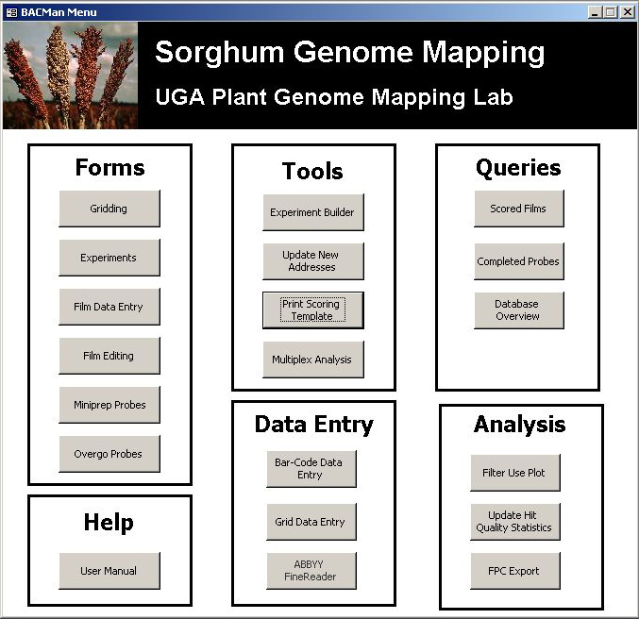
Figure 2-2. BACMan Startup Form

BACMan Menus
A number of functions are also available from the BACMan menu bars (Figure 2-3). These menus will appear at the top of the program window, and the contents of the menu will change depending of the needs of the BACMan Form that is the active window. For example, the menu associated with the Experiments form will contain functions that are specific to BACMan experiments while the menu for the Film Data Entry form will contain commands that are specific to film data entry.

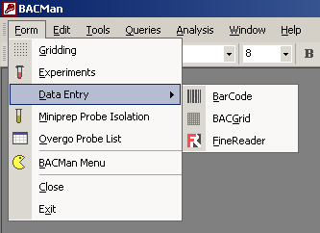
Figure 2-3. Example of a Typical BACMan Pull Down Menu
The general menu commands include the following:
- Form – opens the main BACMan forms
- Edit – allows for the typical ‘Edit’ functions such as cut, copy, and paste
- Tools – Accesses a number of tools for data manipulation in BACMan
- Queries – runs queries of the data in the BACMan database
- Window – allows the user to change the placement of windows in the program
- Help – Opens the Access help file as well as the help file designed specifically for BACMan.

Setting BACMan Properties

When using BACMan for the first time you will need to establish some of the basic information that is used to build a new database. This includes the name and content of the BAC Libraries as well as general project information used to customize BACMan. The properties are set using the Properties dialog that can be accessed by choosing Properties from the Tools Menu as shown in Figure 3-4.

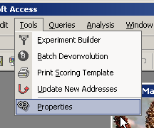
Figure 3-4. Properties Selection in the Tools Menu
Selection of Properties from the tools menu will open the BACMan Properties dialog (Figure 3-5). A number of tabs are available from the top of the dialog that will allow the user to set variables for the Project, Library List, Library Numbers, Library Data and People. These tabs are described in more detail below.

Project Properties
The project properties are a general set of variables that are used in BACMan to personalize your forms and reports. This interface also provides the place to enter the full paths for external programs that are used by BACMan. In this way you can modify where these programs are on your local computer or network without compromising the functioning of BACMan.

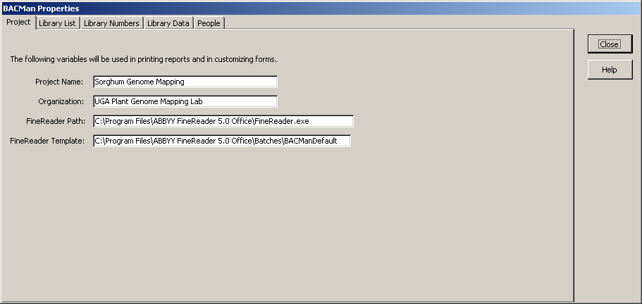
Figure 3-5. Project Properties Tab in the BACMan Properties Dialog
Changes made through this interface affect the table tblVariables. The properties that can be set are:

- Project Name – This textbox is used to set the project name that will be displayed in the main menu (Figure 2-2), printed on scoring templates (Figure 7-37), error checking templates (Figure 10-96) and various printed reports.
- Organization – The organization name as displayed on the main menu as well as printed templates and reports.
- FineReader Path – This is the complete path to the ABBYY Fine Reader program on you local computer or network. This is used by BACMan to open FineReader from the Main Menu. For more information on FineReader see section 8.3.
- FineReader Template – This is the FineReader template that will be opened by default when you activate ABBYY FineReader from within BACMan.
All of the changes that are made to under the properties tab are saved when you press the Close button.

Library List
The library list is the list of BAC libraries that will be processed using the BACMan database. Since some databases will store information on multiple BAC libraries, any number of libraries may be listed here.

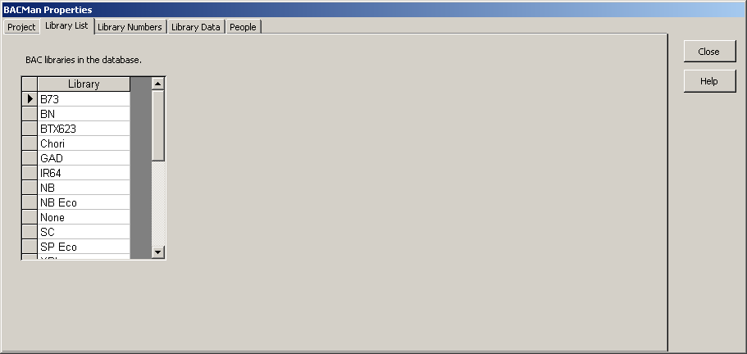
Figure 3-6. Library List Tab in the BACMan Properties Dialog
The library list edits information in the table tblListLibrary. This data is used in a number of places in the BACMan program so it is very important that it be correct.

Library Numbers
The library numbers tab allows you to set the identifying suffix that is used to identify the filter subsets of the library. These are the library subset identifiers that are used throughout the database to reference the library subset. The BACMan automated experiment builder depends on the data in this form to properly design an experiment.

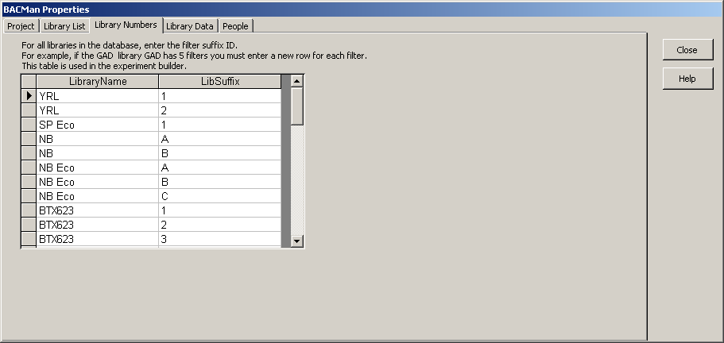
Figure 3-7. Library Numbers Tab in the BACMan Properties Dialog
The library name must be the same as those entered for the Library List. The LibSuffix is the name attributed to each filter representing a portion of the full library. For example, the full NB Eco library shown above is comprised of three filter subsets identified as A–C. The YRL library is gridded on two filters identified as 1 & 2. Modifications made in this interface will change values in the table tblExperimentBuilderLibraryTemplate. The libraries entered in the Library Numbers tab should be the same as the library names shown in the Library Data tab (Section 3.4).

Library Data
This Library Data tab provides a interface to store information for each of the libraries that are referred to in a BACMan database.

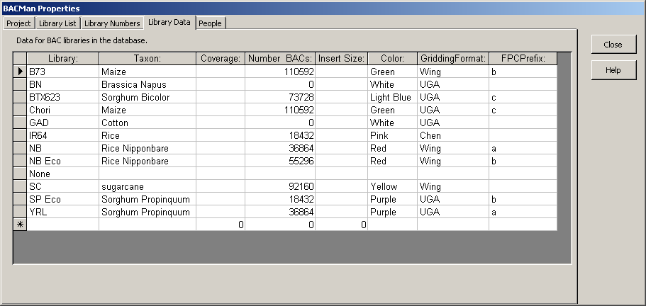
Figure 3-8. Library Data Tab in the BACMan Properties Dialog
The information that may be tracked by this tab includes:
- Library – The short ID name that is used to refer to a specific library. This is the name that will be used to refer to the library throughout BACMan.
- Taxon – The species or cultivar that is represented by the library.
- Coverage – The genomic coverage of the library.
- Number BACs – The number of BACs that are available for the library
- Insert Size – The average insert size for the library
- Color – The color that is used to code binders containing films or results for that library. This is useful for indexing large numbers of films.
- Gridding Format – The gridding format that is used in gridding the library. These formats are defined in the Gridding Formats form described in Section 3.6.
- FPCPrefix – The prefix that is used when exporting data for upload to an FPC database
These data that are modified by this tab are stored in the table tblListLibrary.

People
People may be added or removed from the list in the same way as information is edited for libraries. You can record the initials that will be used to refer to people in the database, their full name, and their position.

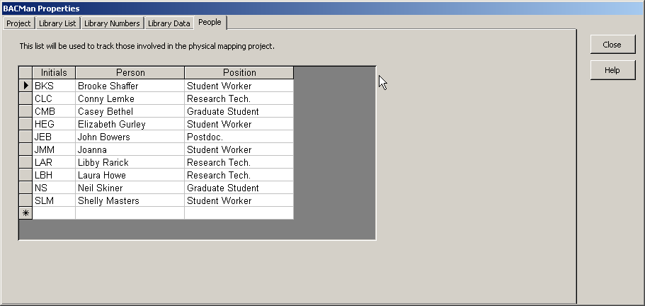
Figure 3-9. People Tab in the BACMan Data Properties Dialog
The initials listed in this tab allow for the identification of people in charge of individual experiments, and help keep track of who scored what films. Tracking this information is helpful in determining who did what in larger projects involving many people, and may be especially useful when used to help track mistakes that were made in scoring films. The data that are modified in this interface affect the table tblListPeopleNames.

Defining Gridding Formats
BACMan allows users to document the gridding format used to array libraries. To open the Gridding Formats form select ‘Gridding Properties’ from the BACMan Tools Menu as shown in Figure 3-10.

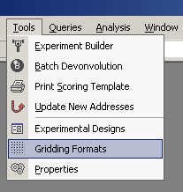
Figure 3-10. Select Gridding Formats from the BACMan Tools Menu
BACMan has three main gridding formats defined by default. These are the ‘UGA’ format and ‘Wing’ format for 4 by 4 gridded hit patterns, and a single ‘TwoByTwo’ format for 2 by 2 gridding patterns. The gridding format name is used to convert hit pattern data to the library plate address that it represents, and to convert data to the format needed for export to FPC. Users can define new hit patterns using the Gridding Formats Form (Figure 3-11).

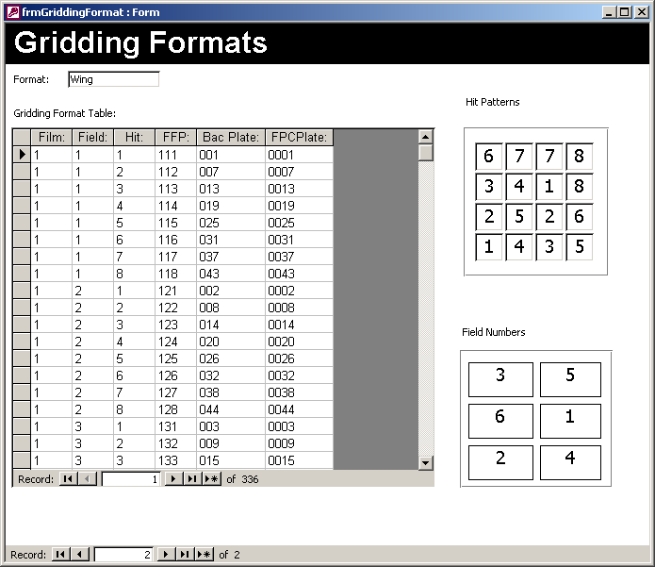
Figure 3-11. Gridding Formats Form
The Gridding Formats form allows the user to set:
- Format Name – The name that will be used to refer to this gridding format. Every gridding pattern must be assigned a unique name.
- Hit Pattern – The gridding hit pattern that was used to double spot the plates. The orientation of the hit pattern is the same as looking at the plate with the A1 address in the top left corner and the P24 address in the bottom right corner.
- Field Numbers – The number format used to name the fields. The orientation is again with the A1 address in the top left corner and the P24 address in the bottom right corner.
- Gridding Format Tables – The table that is used to transform Film, Field, and Hit pattern to the BAC Plate and FPC Plate address.
  - Film – The film number of the hit
  - Field – The field of the hit
  - Hit – The hit pattern of the hit
  - FFP – The concatenation of the Film, Field, and Hit Pattern of the hit
  - BAC Plate – The BAC plate that is represented by a given Film, Field, and Hit Pattern
  - FPC Plate – The name used to export the data in FPC format.

Defining Multiplex Experiment Designs
One of the most useful tools in BACMan is the ability to design and deconvolute pooled probe multiplex design experiments. These multiplex experimental designs increase both the quality and efficiency of data resulting from hybridization experiments. These experimental designs can all be viewed by selecting ‘Experiment Design’ from the Tools Menu (Figure 3-12).
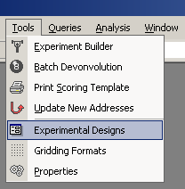
Figure 3-12. Selecting Experimental Design From the BACMan Tools Menu
This selection will open the ‘Multiplex Experimental Design’ form (Figure 3-13). The data model used in BACMan allows users to define new multiplex design formats using this interface. These experimental designs can later be selected in the Experiment Builder tool described in Section 6.2 of this manual.

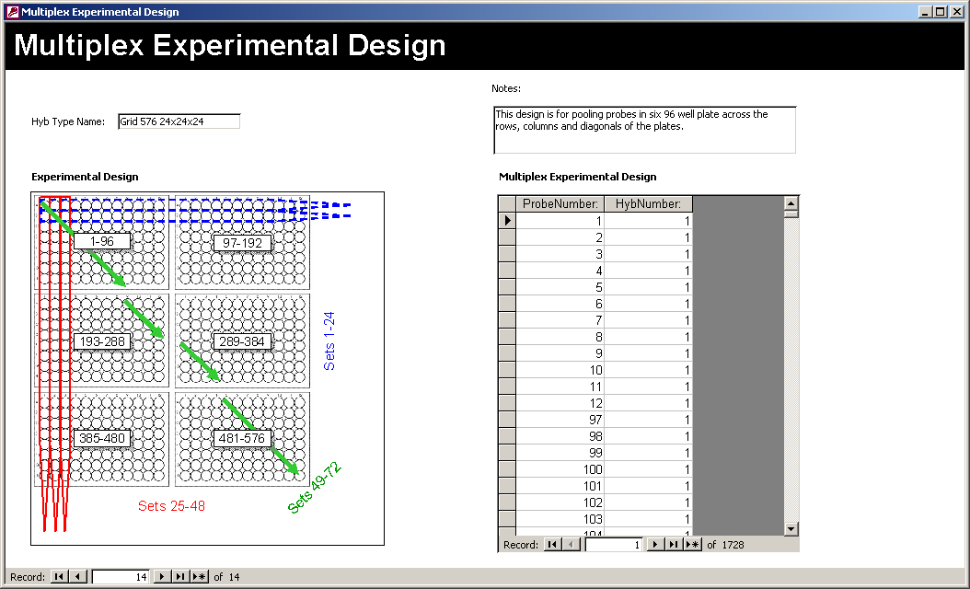
Figure 3-13. Multiplex Experimental Design Form
The Multiplex Experimental Design form allows the user to set:
- Hyb Type Name – The name assigned to the hybridization experimental design. Each Experimental Design must be assigned a unique name.
- Experimental Design – Picture of the experimental design. It is a good idea to have this available as a reference. This is an OLE object field so any you can cut and paste from any image software package you have installed. However the PNG format is the recommended format to use. The size of the field is 4 inches by 4 inches. An images larger than this will be clipped to fit the provided area.
- Multiplex Experimental Design – This table lists the full set of Probe Numbers that are added to each Hyb Number. For example, in the experiment shown above, each probe number appears three times in the list since the design includes three dimensions. Each hyb number includes 24 probes.
- Notes – Any notes that refer to this experimental design. This is a good place to record a longer description of the multiplex design.

Gridding Libraries

When libraries are gridded onto membranes it is often necessary to track information on the libraries used, the filters produced, and the success of the gridding job. This will help to maintain quality control for the gridding process itself, and will facilitate the tracking of problems that may arise later in hybridization experiments using these filters.

The Library Gridding Form displays information for an individual grid job as well as all of the filters generated by that job. The Library Gridding Form is available under the Main BACMan form (Figure 2-2) as well as the BACMan menu (Figure 2-3).

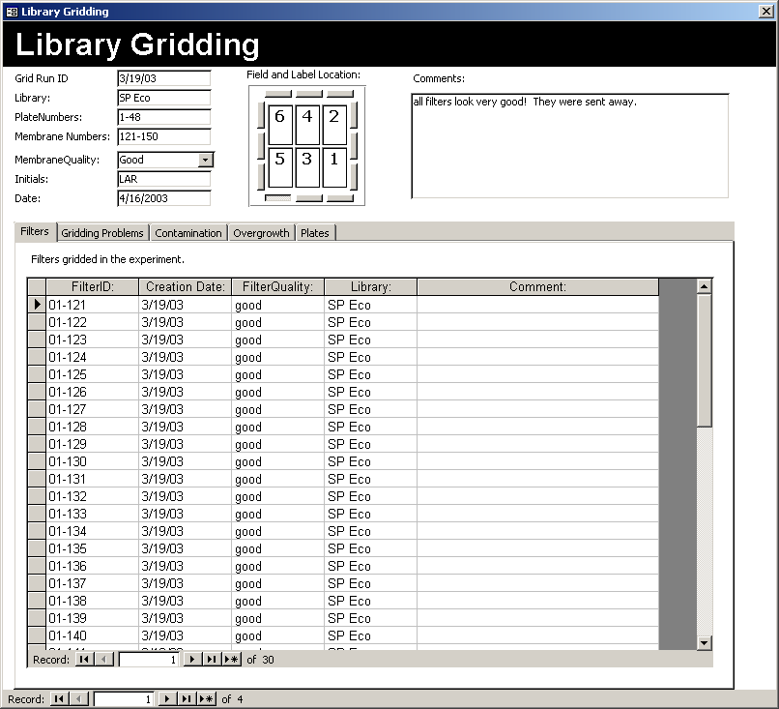
General information about the grid job
Information about individual filters
Figure 4-14. Library Gridding Form

General Grid Job Information
The information that is recorded for each grid job is displayed at the top of the Library Gridding form (Figure 4-14). These data include:
- Grid Run ID – The identification name used for the ID of the grid run.
- Library – The ID of the library that is being gridded. This name must be consistent with the names entered in the Library List of the BACMan properties dialog (Figure 3-6 and Figure 3-7).
- Plate Numbers – The range of plate numbers from the library that were used to grid the library. This does not refer to individual plate IDs, but the general plates of the library that are gridded.
- Membrane Numbers – The numbers used for the membranes
- Membrane Quality – The overall quality of the membranes derived from the gridding job.
- Initials – The initials of the person in charge of the gridding job or the people involved in the experiment. Multiple initials should be separated with commas. These initials should be the same format as those listed in the people tab of the BACMan variables dialog described in Figure 3-9.
- Date – The date that the gridding job was started.
- Field Location – The order in which the fields are gridded. In the example shown above the gridding format is the one used by the UGA Plant Genome Mapping Lab is shown.
- Label Location – The placement of the text label on the filter in relation to the gridding fields. This is indicated by depressing the pushbutton under the ‘Field and Label Location’ section of the form
- Comments – Any general comments you may wish to record for a gridding job

Individual Filter Information
The information that is recorded for each separate filter that results from a gridding job is displayed at the bottom of the Library Gridding form (Figure 4-14). This information is available as a set of clickable tabs. The data that are displayed in these tabs are derived from subforms that are linked to the table tblGridFilters.

Filters
The ‘Filters’ tab is where you record general information about each filter. Data must be entered in this tab for each filter before they can be edited on the other tabs for individual filter information.

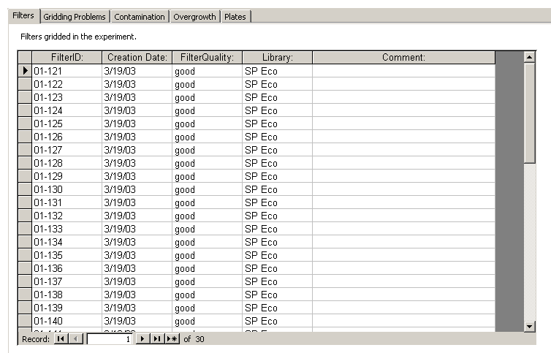
Figure 4-15. Filter Tab in Library Gridding Form
The information that is documented in this tab includes:
- Filter ID – The identification of the filters. This should match the membrane numbers listed above as membrane numbers at the top of the library gridding form.
- Creation Date – The date that the filter was gridded on. This should be the same for all filters in the filter job set.
- Filter Quality – The quality for the individual filter.
- Library – The library that is gridded.
- Comment – General comments for the overall quality for the filter.

Gridding Problems
The ‘Gridding Problems’ tab indicated in Figure 4-16 refers to problems that occur as a result of the gridding process itself or any other problem not related to contamination or overgrowth. This includes ‘blanks’ in fields resulting from empty wells in plates or improper pin height. This also includes the smearing of colonies or any undergrowth that may occur.

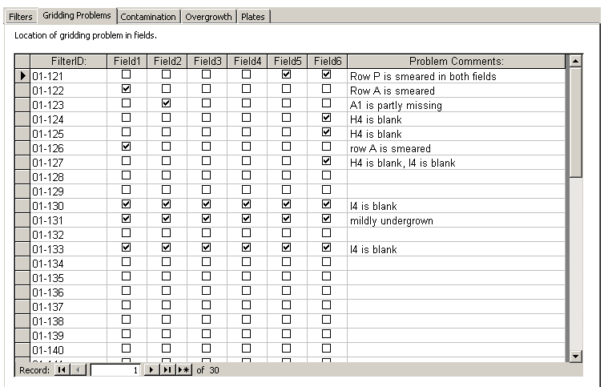
Figure 4-16. Gridding Problems Tab in Library Gridding Form
Checking a box ‘yes’ under a field column indicates that problems exist for that field. The specific nature and well plate address of the problem can then be entered in the ‘Problem Comments’ column.

Contamination
This ‘Contamination’ tab provides a place to indicate any obvious contamination that may have occurred in the gridding process.

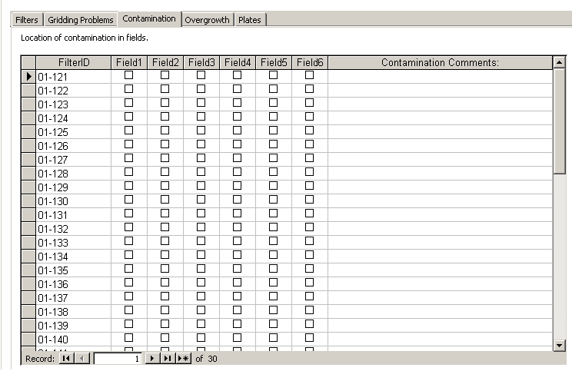
Figure 4-17. Contamination Tab in The Library Gridding Form
Checking a box ‘yes’ under a field column indicates that contamination exist within that Field. The specific nature of the contamination and the well addresses of the contamination can then be entered in the ‘Problem Comments’ column.

Overgrowth
This ‘Overgrowth’ tab provides a way to record the presence of overgrowth among fields in the library.

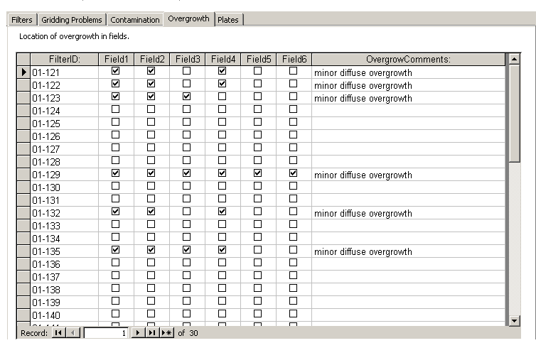
Figure 4-18. Overgrowth Tab in the Library Gridding Form
Checking a box ‘yes’ under a field column indicates that overgrowth exist within that Field. The specific nature of the overgrowth and the well addresses of the overgrowth can then be entered in the ‘Problem Comments’ column.

Plates
The ‘Plates’ tab provides a way to list the entire set of plates that were used in a gridding job (Figure 4-19). This would be easiest when plates are labeled with individual bar codes. A barcode scanner could then be used to enter this data when the plates are being prepared for the gridding job.

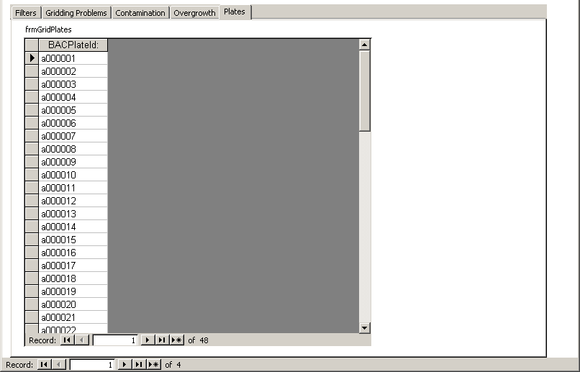
Figure 4-19. Library Gridding Tab in the Library Gridding Tab
Tracking this information would allow you to track usage of all of plates that comprise the BAC library. In this way the number of times that plates were used can be tracked, and the quality of the library used is recorded. The only information displayed in this table is the list of BAC Plate IDs used in the experiment.

Probe Synthesis
The BACMan database schema assumes that every probe in the dataset represents a named locus that is being hybridized against the genomic library. Each locus must be assigned a unique name, although multiple probes may be designed for each locus. The locus can be used as a probe through the isolation of genomic clones of the locus or through synthesis of overlapping oligonucleotides based on nucleotide sequence data for the locus.

Locus Information
BACMan provides an interface for adding data for loci to the database, and monitoring the status of information for the locus.

The data that can be recorded for each locus is:
- LocusName – The unique name used to identify the locus
- TaxSource – The taxonomy of the species/cultivar that the locus was derived from
- SeqDataSource – The data source of the sequence (ie. Genbank, EMBL, Succest)
- SeqID – The identification of the sequence from the data source
- SeqGenBankID – The genbank ID assigned to the sequence
- Status – The status of the hybridization of the locus
- FullSequence – The full sequence of the locus if it is known
- LocusNotes – Any general notes associated with the locus

Genomic Clone Isolation
This is how we can track data

The data that can be recorded for each Genomic Clone are:
- ProbeName – The unique name of the probe
- Isolation Date – The date that genomic clone was isolated on
- Person – The person that isolated the probe
- Conc – The concentration of the isolation of the probe
- Vol – The volume available for the isolated genomic clone
- CloneNotes – The notes concerning the isolation of the genomic clone
- GenLocation – The location of the isolated probe (ie. Freezer 8, Shelf 2)

Overgo Probe Design
The data that are available for the probes that have been designed as overgos is available from the Overgo Probes Form shown in Figure 5-20.

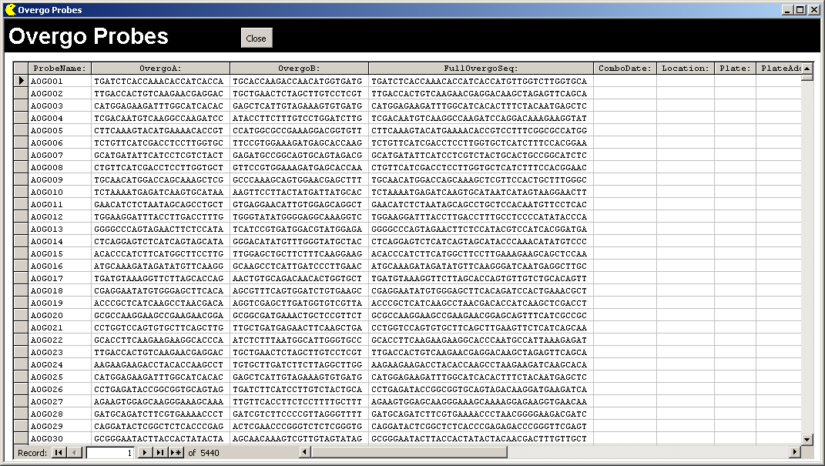
Figure 5-20. Form Displaying the Properties of Overgo Probes
The data that can be recorded for each overgo probe are:
- ProbeName – The unique name assigned to the overgo probe
- OvergoA – The ‘A’ sequence of the overgo probe
- OvergoB – The ‘B’ sequence of the overgo probe
- FullOvergoSeq – The full 5’-3’ sequence of the overgo when the A and B sequences are combined
- ComboDate – The date that the A & B sequences were combined to make the final overgo
- Location – The general location of the combined overgo probe. For example freezer 3.
- Plate – The name of the plate that the overgo is stored in. Every plate should have a unique name. If the overgo is held in a tube this would be the name of the box that the tubes are stored in.
- Plate Address – The well address of the probe within the plate, for example A12
- Dilution – The dilution of the combined overgo probe
- OvergoNotes – General notes associated with the overgo
- LocusName – The name of the locus that the overgo probe represents

Hybridization Experiments

The main overview form for designing hybridization jobs is the Experiments Form (Figure 6-21). The term ‘experiment’ in this context refers to a set of hybridizations that can be deconvoluted to yield a list of clones that contain positive hits each of the set of probes used in the experiment. Since it may take a number of days or weeks to complete all of the hybridizations associated with an entire experiment, the date field used in this form refers to the date that the experiment was started.

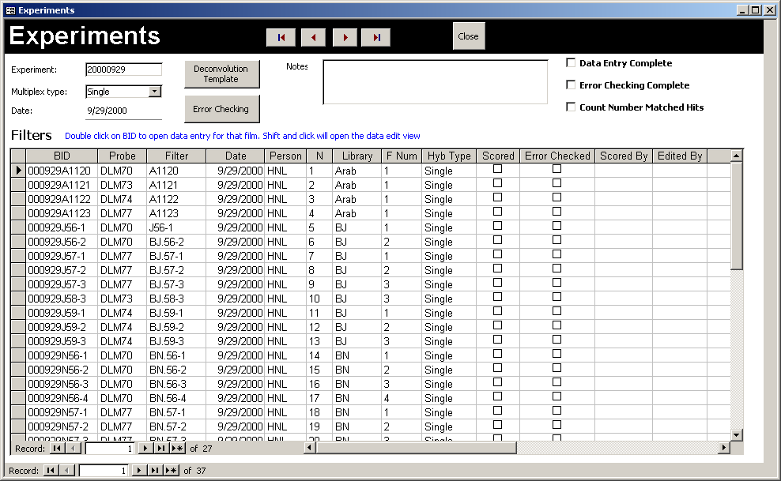
Figure 6-21. Experiments Form
The buttons on the form allow you to view the Error Checking view of the experiment (Figure 10-93) and Deconvolution Template form for the experiment. Navigation buttons at the top of the form allow you to page through the experiments, and the close button will close the Experiments Form.

The main fields associated with each experiment are:
- Experiment – This is the identifying name of the experiment. This can be any string consisting of letters and numbers.
- Multiplex Type – This is the multiplex experimental design that was used in the hybridization experiment.
- Date – The date that the experiment was started on
- Notes – Any notes you wish to record for the experiment. This is often a good place to record general information for the experimental design
- Data Entry Complete – This box is checked when the data entry is complete for the entire experiment.
- Error Checking Complete – This box is checked when error checking is complete for the experiment.

The Filters subform at the bottom of the Experiments form shows all of the filters that were used in the experiment. Each row in the subform represents a filter used in the experiment and thus also indicates the film that results from hybridization of that filter. The values may be entered by hand for each filter, but it is easier to use the BAC Man experiment builder described in Section 6.1 of the manual. The values that are shown from left to right for each of the filters are:
- BID – The unique barcode identification for the filter/film
- Probe – The individual probe or the pooled probe set used for this filter
- Filter – The filter that was used. Since the filters are reused multiple times, this value can be repeated within a single experiment or across experiments
- Date – The date the experiment was started on
- Person – The initials of person in charge of the experiment
- N – The number of the film within the experiment
- Library – The library that this filter represents
- FNum – The filter number of the portion of the library that is represented by this filter.
- HybType – The type of hybridization that this filter was involved in. This should be some type of mutiplex experiment or a single probe experiment
- Scored Checkbox – This box is checked yes when the film for has been scored.
- Error Checked Checkbox – This box indicates if the film has been error checked. For further information on error checking in BACMan see Section 10 of this user manual.

Multiplex Experimental Design
The multiplex experimental designs used in BACMan allow for a large number probes to be assayed in a single experiment. As opposed to single probe hybridization experiments, these experimental designs are a more efficient and cost effective way to use the filters. If a filter is used 10 times in single probe hybridization experiments only 10 probes may be assayed yielding a probe to filter ratio of one. However, if the filter is used 10 times in a series of multiplex experiments the probe to filter ration can be increased to 12. Thus a filter that is used 10 times can be used to assay 120 probes instead of just 10. The multiplex experimental design also results in higher quality data. Since the ‘hits’ must appear and be appropriately scored on at least two filters, false positives are unlikely to be included in the final dataset. Furthermore, the error checking routines included in BACMan allow for the identification of incorrectly scored films, and facilitate the correction of these mistakes through the generation of error checking scoring templates.

BACMan supports two main types of pooled probe multiplex experimental designs. The first type is the ‘grid’ multiplex format which is named for the fact that the experimental design and deconvolution is based on a table where all rows and columns are filled with a unique probe. The grid format is the easiest method for pooling probes by hand since the probes are pooled across rows, columns and the diagonals of probes arrayed in 96 well plates. The second format is the ‘triangle’ multiplex format which is named for the fact that the deconvolution is based on a template that combines all possible unique hyb combinations forming a complete triangle matrix. Since this format makes use of all possible pairwise combinations of hyb sets, it is actually more efficient then the grid format. However, it is much more difficult to pool probes using this format, and automated liquid handling equipment is needed to pool experiments with large numbers of probes.

Grid Multiplex Format
The Grid multiplex format is best visualized as pooling probes across the rows and columns in a 96 well plate as shown below in Figure 6-22.

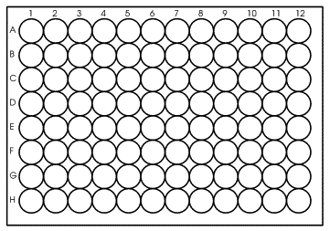
1
2
3
4
5
6
7
8
9
10
11
12
13
14
15
16
17
18
19
20
1
2
3
4
5
6
7
8
9
10
11
12
13
14
15
16
17
18
19
20
21
22
23
24
25
26
27
28
29
30
31
32
33
34
35
36
37
38
39
40
41
42
43
44
45
46
47
48
49
50
51
52
53
54
55
56
57
58
59
60
61
62
63
64
65
66
67
68
69
70
71
72
73
74
75
76
77
78
79
80
81
82
83
84
85
86
87
88
89
90
91
92
93
94
95
96
Figure 6-22. Pooled Probes in Grid Multiplex Format (96 Grid 8x12)
All of the probes in the first row will be pooled and added to a single hybridization solution labeled set 1. This is continued for every row in the plate through rows 1 to 8 such that pooled probe set contains 12 probes. Each column is then pooled in the same manner to yield pooled probe sets 9 to 20 in which each pooled probe set contains 8 probes. The full pooled probe experiment shown above allows 96 probes to be assayed in twenty hybridization sets with 8 rows and 12 columns. This would therefore be referred to as a ‘96 Grid 8x12’. The efficiency of this format can be calculated as the number of probes assayed in the experiment (96) divided by the number of hybridization sets used in the experiment (20). The ‘96 Grid 8x12’ experiment thus has an efficiency of 4.8 probes per hyb.

The method of processing the data that has been mixed together in a pooled probe multiplex format is referred to as ‘deconvolution’. The process of deconvolution is explained in detail in Section 9 of this manual. The essence of this process is that any single probe appears uniquely in only one pair of hybridization solutions. For example, probe 1 is included in pooled probe set 1 and set 9. Therefore any hits which are shared in the films derived from set 1 and 9 are deconvoluted to be derived from probe 1.

Since a hit would have to be incorrectly scored the same way in multiple films to be deconvoluted, multiplex experiment design increases the quality of the hit data by decreasing the type II errors included in the final data set. However, the drawback to this technique is that is also introduces a source of type I error. If the hit is not properly scored in both pooled probe sets, it will not be included in the final list of positive probe hits. The result is that not all positive hits will be included in the experiment. One way to avoid these type I errors is to add a redundancy to the experimental design by adding a third dimension to the experimental design. In the grid format, this is most easily visualized as the diagonal dimension on the 96 well plate (Figure 6-23). These ‘diagonal’ pooled probe sets would be labeled 21 to 32.

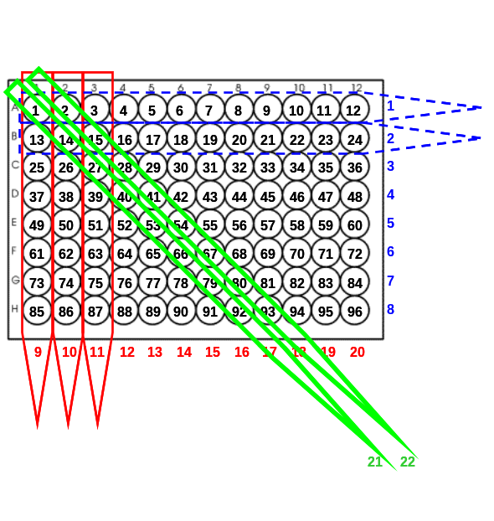
Figure 6-23. Grid Multiplex Format with Redundancy (Grid 96 8x12x12)
The experiment design would be named a ‘96 Grid 8x12x12’ since 96 probes are surveyed in an experimental design that uses 8 rows, 12 columns, and 12 diagonals. The effect of this third ‘diagonal’ dimension is that a hit would need to properly scored in just two of the three possible pooled probe sets to be properly deconvoluted. For example, if a hit for probe 1 could not be resolved in pooled probe set 9, its inclusion in pooled probe sets 1 and 21 would allow for its deconvolution.

In addition to reducing type I errors, the three-dimension multiplex format also allows for the separation of hits that appear in all three dimensions as ‘matched’ hits from those ‘undermatched’ hits that appear in only two dimensions. A disadvantage to this format is that each hit must be scored at least two and possibly three times, thus increasing the scoring effort needed to complete a given experiment. The efficiency of this design is also less than that of a two dimension design. Since the third dimension increases the total number of hybridization sets to 32, the efficiency of the 96 probe experimental design is decreased to 3 probes per hybridization.

One way to further increase the efficiency of multiplex experiments is to increase the number of probes in each of the multiplex dimensions. For example, a two dimension grid multiplex format that includes 24 probes in each of the multiplex dimension can allow for the deconvolution of 576 probes in 48 hybridization experiments. The name of this multiplex format is ‘Grid 576 24x24’. The efficiency of this format is 12 probes per hyb. This is a convenient format since the probes can be pooled across six 96 well plates (Figure 2-2).

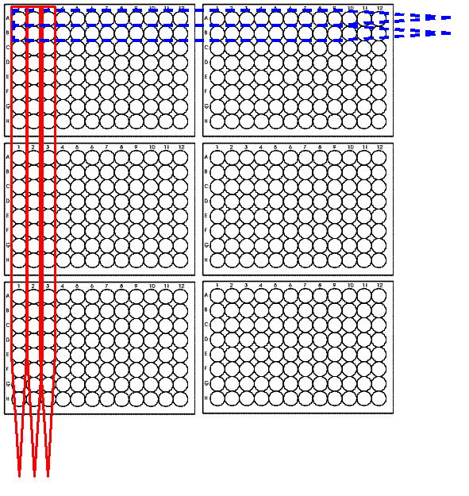
Pooled probe sets 1-24
Pooled probe sets 25-48
Probes 1-96
Probes 97-192
Probes 193-288
Probes 289-384
Probes 385-480
Probes 481-576
Figure 6-24. Pooled Probes in 24 by 24 Grid Multiplex Format (576 Grid 24x24)
In these larger experiments the addition of a third dimension of redundancy in the diagonal dimension reduces the efficiency of the experiment to 576 probes assayed by 72 hybridization solutions yielding an efficiency of 8 probes per hyb. This is the largest Grid multiplex format that is allowed in BACMan since larger experiments are more likely to contain overlap among BAC clones.

193-288
97-192
289-384
385-480
Sets 25-48
Sets
1-24
481-576
1-96
Sets 49-72
Figure 6-25. 576 Pooled Probes in 24 by 24 by 24 Grid Multiplex Format

Triangle Multiplex Format
The second type of multiplex format that can be used by BACMan is the triangle multiplex format. This design maximizes the efficiency of the multiplex experiment in terms of probes per hybridization. The most efficient multiplex format is one in which every possible pairwise combination of pooled probe sets contains a unique probe. This format is referred to as a triangle format since the representation of every possible pairwise combination produces a ‘triangle matrix’ as shown in Figure 6-26.

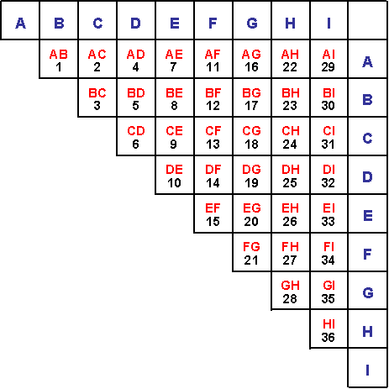
Figure 6-26. Triangle Multiplex Format (36 Triangle 9x9)
This format is not easily visualized in terms of source plates since the source well pattern is more complicated that that used the grid multiplex format. As shown in Figure 6-26, the probe number one will be added to pooled probe sets A and B. Probe two will be added to pooled probe sets A and C while probe three will be added to sets B and C.

The hybridization solutions that the probes are added to are more easily visualized by flipping the triangle along the diagonal axis to list all probes that are added to each pooled probe set in columns as shown in Figure 6-27. For example, the probes added to pooled probe set A are all listed in the column labeled A. Each pooled probe set in this design includes eight probes. Since the 36 total probes can be deconvoluted in 9 hybridization sets, the total efficiency of this experiment design is 4 probes per hyb

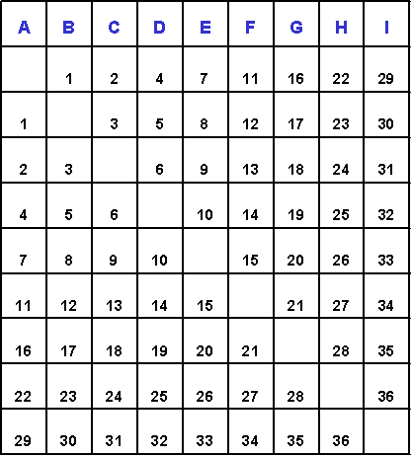
Figure 6-27. List of Probes Added to Each Set in a Triangle Multiplex Design
The efficiency of the triangle multiplex format increases with the number of pooled probe sets that are added to the experimental design. An experiment with 25 filters can be used to assay 300 probes for an efficiency of 12 probes per filter. A list of efficiencies for a number of different multiplex formats is shown in Table 6-1. Notice that the 25x25 format achieves an efficiency of 12 probes/hyb in just 25 filters, where 48 filter sets are needed to achieve this efficiency in the grid format.

Table 6-1. The Probe per Filters Efficiency of Triangle Multiplex Formats
Triangle Format | Filters | Probes | Efficiency
9x9 | 9 | 36 | 4
10x10 | 10 | 45 | 4.5
11x11 | 11 | 55 | 5
12x12 | 12 | 66 | 5.5
13x13 | 13 | 78 | 6
14x14 | 14 | 91 | 6.5
15x15 | 15 | 105 | 7
16x16 | 16 | 120 | 7.5
17x17 | 17 | 136 | 8
18x18 | 18 | 153 | 8.5
19x19 | 19 | 171 | 9
20x20 | 20 | 190 | 9.5
21x21 | 21 | 210 | 10
22x22 | 22 | 231 | 10.5
23x23 | 23 | 253 | 11
24x24 | 24 | 276 | 11.5
25x25 | 25 | 300 | 12

Experiment Builder
BACMan assists in the design of pooled probe multiplex experiments using the Experiment Builder function. This series of dialogs allows you set the values that are needed to design a full multiplex hybridization experiment. The template for the experiment builder is based on the table tblExperimentBuilderLibraryTemplate. A flowchart describing the details of the experiment builder process is shown in Appendix 1.3.

To start the experiment builder you must first select Experiment Builder from the Tools menu.

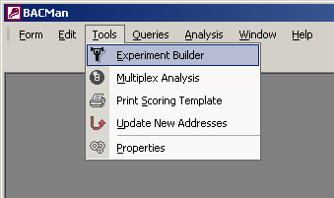
Figure 6-28. Selection of Experiment Builder from the Tools Menu
You may then designate the type of multiplex experiment you are constructing and the libraries you wish to use in the experiment. This is currently limited to four libraries. The mutiplex experiments that are available for use are listed from the table tblListHybType.

The first step in experiment builder is to designate the multiplex type and the libraries that will be screened in the experiment (Figure 6-29). Simply choose the multiplex type using the provided pull-down menu. If the multiplex design you wish to use is not listed, you must first add it to the BACMan database using the Multiplex Experiment Design form described in Section 3.7. The libraries listed in the dialog are derived from the list generated in the library data tab of the BACMan Properties described in Section 3.4 of the manual. Clicking on the next button will moved to the second step of the experiment builder.

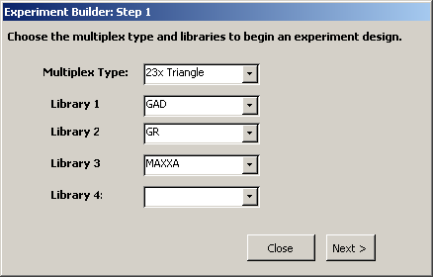
Figure 6-29. Experiment Builder Dialog Step 1
The second step in experiment builder is the identification of the library numbers that are used in the experiment.

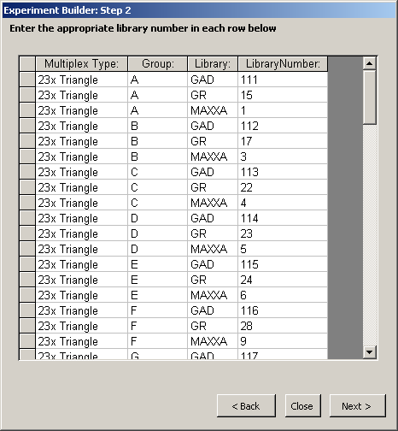
Figure 6-30. Experiment Builder Dialog Step 2
The number of filters within each replicate is automatically filled in using the table tblExperimentBuilderLibraryTemplate. This data is provided by the user using the BACMan Properties: Library Numbers tab described in Section 3.3.

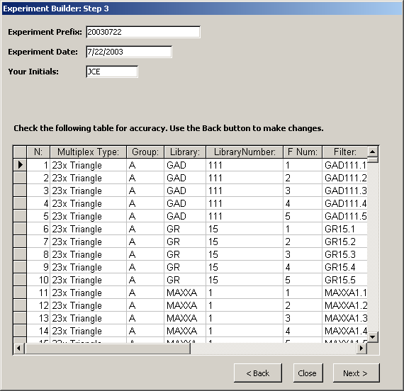
Figure 6-31. Experiment Builder Dialog Step 3
The final table that is produced by Experiment Builder is tblExperimentBuilder03. This table contains all of the information that would need to be pasted to the hybridization table tblHybData. The results are viewable from the last form of the Experiment Builder Process (Figure 6-32)

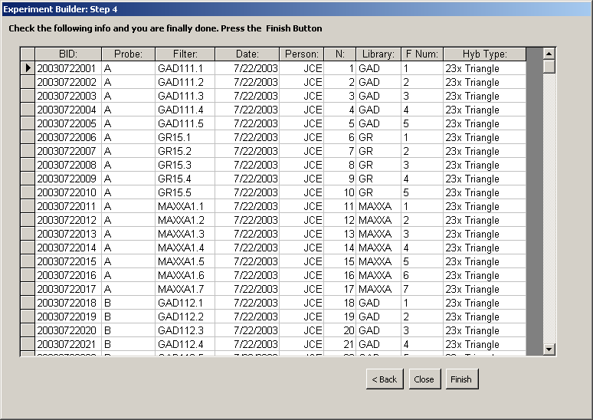
Figure 6-32. Experiment Builder Dialog Step 4
These results can simply be copied from the dialog, and pasted into the main experiments form (Figure 6-21). In the future the Experiment Builder will include the function to create a deconvolution template based on the information provided.

Printing Labels
In order to help keep track of all of the films generated in a large scale hybridization study, BACMan provides the means to assign a unique barcode identification (BID) to each film derived from a hybridization experiment. You may assign this BID manually, or allow it to be set using Experiment Builder in BACMan. The preferred way to designate BIDs is to establish a system where the prefix of the BID represents the name of the experiment, while the suffix represents the individual film number within the experiment. If a single experiment is conducted on a given day, it is often convenient to use a prefix which refers to the day the experiment was started using a concatenation of the year, month, and day. This naming format is illustrated in Figure 6-33 for film number eight from an experiment that was started on December 12, 2001.

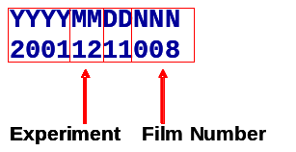
Figure 6-33. Barcode Identification Format
The first four digits represent the year, the next two the month, and the following two the day of the month. The advantages of this format is that sorting on this column in the database will put all films in sequential order by date, and the BID itself makes some sense to the humans as well as the computer.

Since the BID is used as a primary key in the database it is very important that every film in the database have a unique BID. Second exposures of the films that contain overexposed hits are usually assigned the same BID since they represent the same data.

The barcodes produced from BACMan are designed for printing on standard 1” x 2 5/8” self-adhesive paper address labels (Appendix G). The barcode follows the Code 39 barcode format (Citation or appendix), and makes use of a freely available barcode font to print labels using the MS Access report object. The printed labels should appear similar to the image in Figure 6-34 below.

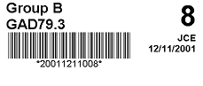
Filter
Probe
Initials
Film Number
Date
BID
Figure 6-34. Example of a Label Generation by BACMan
The information printed on the label includes:
- Hybridization Probe Used – In this case the label comes from pooled probe Group B.
- Filter ID – This example shows a barcode label for filter 3 of the 79th replication of the GAD cotton library (GAD79.3). This information is necessary to make sure that the correct label is placed on the filter following the wash after hybridization.
- Barcode Identification – Presented in both the barcode font for the computer and a numerical font for humans.
- Film Number – The number of the film within the experiment. In this example the film is number eight.
- Initials – This is the initials of the person in charge of the experiment. In this case it is JCE.
- Date – This is the date on which the experiment started.

It is recommended that these labels be printed using a laser printer. The UGA Plant Genome Mapping Lab places these labels on the film developing cassettes prior to their placement in a -80C freezer. After exposure in the freezer for two weeks the cassettes are thawed, and the films are developed. The labels are then peeled off the cassettes and placed on the developed film. These labels are permanent and are left on the film for identification in archival storage.

The barcode labels on the films can be scanned to quickly jump to Film Data Entry (Figure 8-39) or Film Data Editing (Figure 10-97) forms for entering or changing data associated with the film. This functionality requires barcode scanners that have been programmed using the programs in the Appendix C & D of this user manual.

Scoring Films

The strategy that BACMan follows for scoring hybridization films is to manually score the positive ‘hits’ by writing the hit pattern on scoring templates that are placed on top of the films. These templates are typically printed on standard transparency film. The transparency film may be the standard letter size (8.5” x 11”) or the larger tabloid size (11” x 17”). Tabloid size scoring templates are usually cropped to 11”x11” to make them easier to use. Scoring templates may be printed directly from BACMan, or they may be downloaded from the PGML website (http://www.plantgenome.uga.edu/bioinformatics). Further information on the gridding and scoring format that BACMan expects to be used is provided in Appendix A.

Printing Scoring Templates
The scoring templates can be printed from within the BACMan program by selecting ‘Print Scoring Template’ from the Tools Menu (Figure 7-35).

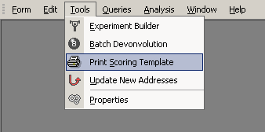
Figure 7-35. Selection of Print Scoring Template From the Tools Dropdown Menu
The dialog that you are then presented with (Figure 7-36) offers the flexibility to print scoring templates with or without a number of common elements.

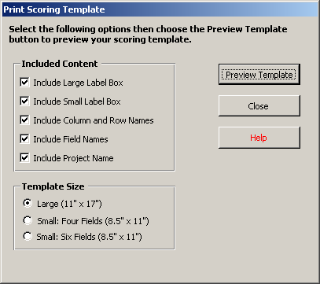
Figure 7-36. Print Scoring Template Dialog
The content that can be included in the scoring template includes (Figure 7-37):
- Large Label Box – Suitable for putting paper labels on the scoring templates. For further information on labels used at PGML see Appendix G.
- Small Label Box – Suitable for writing the ID of the film on the scoring template
- Column and Row Names – The column and row labels from the 384 well plate
- Field Names – The name of the field
- Project Name – The name of the project that the template is used in. This may be included in the template to keep scored templates from different projects separate.
All boxes listed under the included content option group that are checked yes will be included in the scoring template that is printed. An example of the layout of these objects in a scoring template is shown in Figure 7-37.

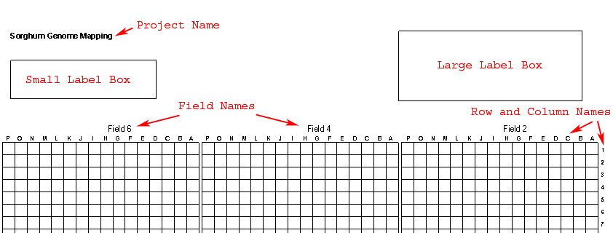
Figure 7-37. Example of the Top Portion of a Scoring Template
The scoring templates can be printed in three sizes available as the ‘Template Size’ option list at the bottom of the Print Scoring Template Dialog (Figure 7-36). The layout of the gridding fields in these formats is illustrated below in Figure 7-38.

Small: Six Fields (8.5” x 11”)
Large (11” x 17”)
Small: Four Fields (8.5” x 11”)
Figure 7-38. Scoring Template Layouts Available From the BACMan
When printing the small six field templates on letter size paper (8.5” x 11”), the printer must be able to print to the edge of the paper. This can be done by setting a nonexistent paper size such as 10” x 11” and loading letter size paper or transparencies. Printing all size fields on letter size transparencies has the advantage of allowing the stack of transparencies to be scanned on batch document scanners that use letter size paper. Batch scanners that can scan sizes up to 11” are often much more expensive than those that are limited to letter size.

Film Data Entry
Once the films have been scored a number of different methods are provided in BACMan for data entry. For films containing a moderate number of hits, it is usually quickest to write the full address of the hits directly on the film and then hand enter the data in the database using the Film Data Entry Form. For films containing twenty or more hits it is much easier to score films by writing the hit pattern on a scoring template as described in Section 7 of this manual. Data can be transferred from these scoring templates to the BACMan database using the BACGrid program available from PGML (Section 8.2). BACGrid makes use of scanned images of scoring grids in a Visual Basic for Applications Macro implemented in a combination of Microsoft Word and Microsoft Excel. A second alternative for the entry of scoring grid data is to us the ABBYY FineReader optical character recognition program to automate the recognition of observed hit patterns. This data may then be exported as comma delimited text files, and then imported to BACMan using the BACEater conversion software. BACEater is a stand alone Visual Basic.Net application available from PGML.

When new hit data have been entered in the database, it is important to refresh the database by clicking on the Update New Addresses button on the Main BACMan Form (Figure 2-2). This will transfer the film identification data into the hit data table tblHitDataRaw, and will fill in the full address of the hit in tblHitDataRaw.

Manual Data Entry
If only a few hits are present on a film, the most efficient way to score the film is to manually determine the full hit address using a scoring template placed under the film. The full address of any positive hits may then be directly written on the film and then entered into the database using the Film Data Entry Form (Figure 8-39).

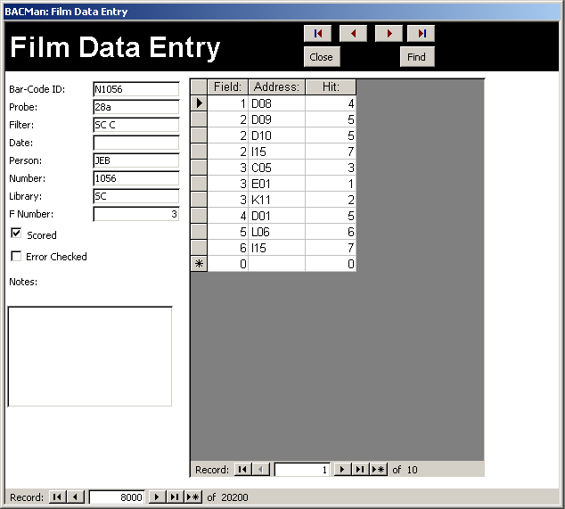
Figure 8-39. Film Data Entry Form
The quickest way to navigate to the correct record for entering the film hit data is to make use of the barcode label on the film (Section 6.3). You will first need to program the barcode scanner using the Zebex barcode scanner program attached in Appendix 1.1. Scanning the film’s barcode label will then open the Film Data Entry Form to the appropriate record for entering the data for that film.

BACGrid Data Entry
Note: The BACGrid program is no longer under active development since the PGML has switched from using BACGrid to using the optical character recognition program FineReader. However, since BACGrid represents a free alternative to the commercial product it will continue to be available from the PGML website.

BACGrid is a program designed to speed up data entry from hand scored scoring templates. Although BACGrid is designed to be used as a component of BACMan, it can be used as a stand alone application. BACGrid is composed of a series of Visual Basic for Application Modules that run in Microsoft Word and Microsoft Excel. BACGrid therefore requires the installation of Microsoft Office 98 or higher.

The generalized steps for using BACGrid to digitize scored overlay data are:
- Change necessary options
- Import scanned image of grid.
- Align grid image with red overlay grid using the mouse and keyboard arrow keys.
- Type numerical hit data in cells.
- Run the BacAutoScore function to automatically transfer scored data to Excel.
The newly scored data will be appended to an Excel spreadsheet, and the scored grid image will be moved to the scored folder. Once the data has been transferred, all typed data will be erased from the red scoring grid, and the image will be removed from the scoring template. You should save your data in Excel periodically to avoid any loss of data due to a system crash.

BACGrid Menu and Toolbar

BACGrid Menu
The BACGrid Menu should appear in the upper right hand corner of the Microsoft Word menu bar. This menu contains all of the necessary functions for using BACGrid. Many of these options are also available from the BACGrid toolbar.

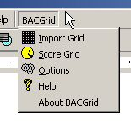
Figure 8-40. BACGrid Pull Down Menu

BACGrid Toolbar
The BACGrid Toolbar shown in Figure 8-41 contains the same options as the BACGrid menu. If the BACGrid toolbar is not shown, you should be able to access it by choosing View then Toolbars from the Word Menu. From the Toolbars list, you then click on BAC Tools to activate the toolbar.

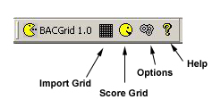
Figure 8-41. BACGrid Toolbar

Setting BACGrid Options
BACGrid options are available from the BACGrid pull-down menu (Figure 8-42). Selecting ‘Options’ under the BACGrid menu will open the BACGrid options dialog shown in Figure 8-43.

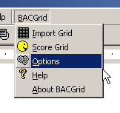
Figure 8-42. Selection of Options from the BACGrid Menu
The following options must be set properly for BACGrid to work. It is always a good idea to check these settings before you begin a scoring session since a previous user may have changed them.

- File Name Length – BACGrid will not work if this value is not set correctly. This represents the number of characters that make up the file name of the grid images. For example, the image 20011005012.TIF is fifteen characters in length while the file M1036.TIF is nine characters in length. The default setting is 15.
- User Initials –The initials of the person that scored the film. These initials will be transferred to the Excel Spreadsheet. BACGrid can work properly if this option is left blank, and the default setting is blank
- Grid Pattern – This refers to the gridding of BAC arrays on the blot. The options are (1) UGA Format and (2) Wing Format. The default setting is UGA Array.

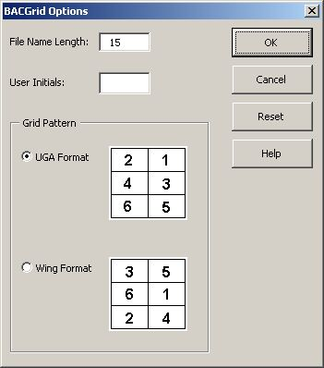
Figure 8-43. BACGrid Options Dialog
The functions available as buttons from the BACGrid Options Dialog are:
- OK – Sets the variables to the new user input values and closes the BACGrid options dialog
- Cancel – Closes the dialog with no change in values
- Reset – Resets all variables to default values
- Help – Activates help. The help file for BACGrid is a compiled HTML help file.

Scanning and Naming Grid Images

Scanning Images
Although you may scan images directly into BACGrid, it is recommended that a separate application be used to scan grid images. Any image file format that is compatible with MS Word can be used for the application. You can not rotate the grid image from within BACGrid. Therefore, it is very important that the scanned image be aligned properly when scanned or that the image rotation can be modified within the software used to scan the image. Software such as Adobe Photoshop allows this sort of image manipulation.
The recommended parameters for scanning images are:
- Image Format: TIF
- Resolution: 200 dpi
- Image Type: A black and white "line-drawing" scan is recommended since this will reduce image size

Naming Images
The name of the image will be used to fill in the film identification column in the MS Excel datasheet. Therefore, it is important that all scanned images follow the same naming convention where the length of the file name is consistent, and the name refers to the identification of the film. For example, the image named 20011210045.TIF is 15 characters long and refers to film number 45 from the experiment on December 10, 2001. Film 78 from the same date would be saved as 20011210078.TIF. You must use the options menu to change the name length of the image file.

Importing and Aligning Grid Image
The import grid command will insert a grid image behind the red scoring grid. It must then be aligned as described below.

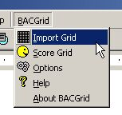
Figure 8-44. Selection of Import Grid From The BACGrid Pull Down Menu

Initial View of Red Scoring Grid
The initial image on the scoring template should look like the image below. Here the red scoring grid is shown, with the cursor indicating the insertion point for a scanned grid image. To insert a hand scored grid into the template, simply choose Import Grid from the BACGrid pull down menu, or click on the Import Grid Button from the BACGrid toolbar.

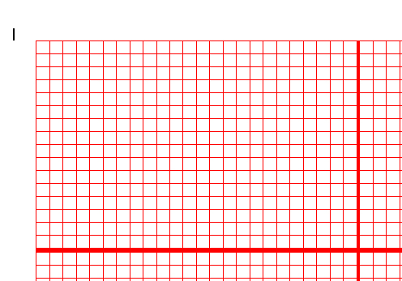
Figure 8-45. Initial View of Red Scoring Grid in the BACGrid Program

Imported Image to Scoring Desktop
When the image is initially inserted into the background it will not be aligned and will look similar to the image below.
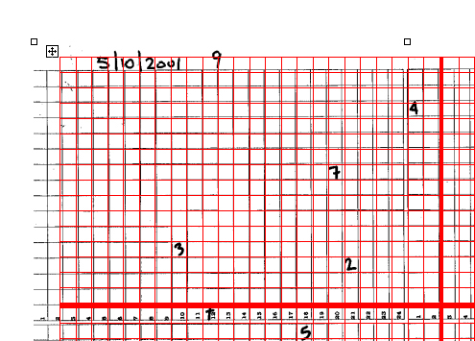
Figure 8-46. Imported Image Behind BACGrid Scoring Grid

Align Top Left Corner of Hand Scored Image
It is easiest to first align the upper left hand corner of the image as shown below. In order to do this, first move the image to the nearest possible correct position by moving the mouse while holding down the left mouse button and the Alt key on the keyboard; an alternative to this is to simply use the Arrow keys on the keyboard to move the image to roughly the correct location. The image can then be moved one pixel at a time by holding down the Ctrl key while using your keyboards four arrow keys. The finished position should look like the image in Figure 8-47.

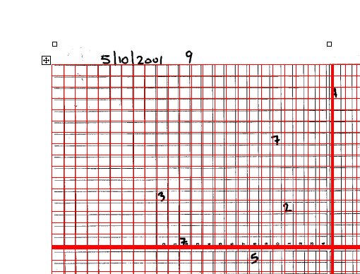
Figure 8-47. Top Left Corner Alignment in BACGrid

Final Alignment of Image
Once the upper left hand corner of the image is aligned as shown above, modify the size of the image by dragging the sides of the image into their proper location. This is done by holding down the Alt key while moving the mouse with the left mouse button held down. The final aligned image behind the Red Scoring Grid should look like the image in Figure 8-48.

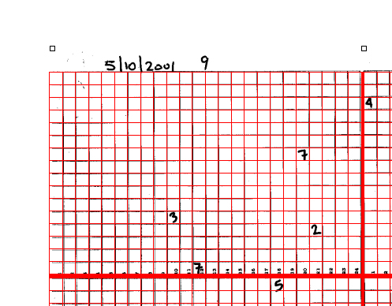
Figure 8-48. Finished Alignment in BACGrid

Type Numbers Representing Hit Pattern
The number representing the hit pattern can then be entered into the appropriate cell by moving the cursor over the correct cell and typing in the number. The numbers will appear in blue over top of the hand scored number. When this process is complete, you can move on to the auto-score process.

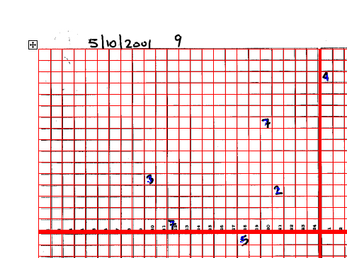
Figure 8-49. Scored BACGrid Image

Score Grid
The score grid command should only be used after a grid has been imported, aligned, and the data entered for that grid. This command will copy the data in the grid, and send the data to Excel.

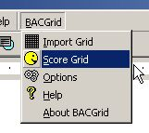
Figure 8-50. Selection of Score Grid From the BACGrid Pull Down Menu

The data that are sent to the Excel file and are converted to BAC hit addresses suitable for upload to the BACMan database.

ABBYY FineReader Data Entry

The ABBYY FineReader program available from the ABBYY Software Company (http://www.abbyy.com) provides a way to use optical character recognition to automate data entry from scoring templates. FineReader is used to ‘Read’ the information that is written on the scoring templates, and BACEater is used to convert this information into the format suitable for upload to the BACMan database.

The major steps of reading scoring templates in FineReader are: (1) initialize a ‘batch’, (2) scan the scoring templates, (3) read the scanned templates, (4) check the resulting data, and (5) convert data to the BACMan format using the BACEater application. These steps are described below.

Initializing a FineReader Batch

In FineReader, scanning jobs are stored in ‘batches’. These batches are folders that contain the images of the documents that are scanned, the text associated with those images, and the text pattern file for the person that did the scoring.

Open an Existing Batch

- Select File: Open Batch from the FineReader menu as shown in Figure 8-51.
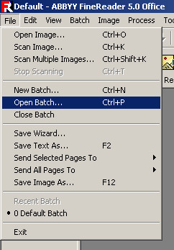
Figure 8-51. Open Batch in the FineReader Menu
- Find the batch you want to open from the list in the open batch dialog (Figure 8-52). All of the valid batches will have the ‘stack of documents’ icon associated with the folder name.

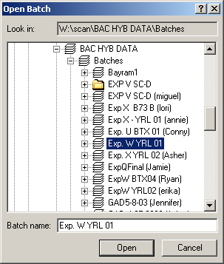
Figure 8-52. Open Batch Dialog in FineReader

To Create a New Batch

- If you have previously processed a set of images using FineReader, open a batch that you have previously processed that contains your pattern editor. If you have not used FineReader before, you can start in the default FineReader batch.
- Click on File : New Batch in the FineReader Menu bar.

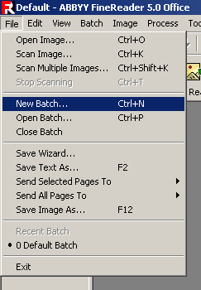
Figure 8-53. Selecting New Batch From the FineReader Menu Bar
- Give the batch a name. Usually this will be some combination of the Experiment Name and the Library that you have scored (Figure 8-54).

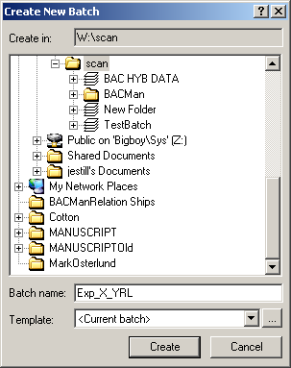
3
4
5
Figure 8-54. Create New Batch Dialog in FineReader
- If you are using a batch that contains your pattern editor confirm that you have selected <Current Batch> for the template. Select <Default Settings> if you are creating a batch for the first time.
- Click on the Create button to start the new batch
- Select Tools : Options in FineReader to open the Options Dialog

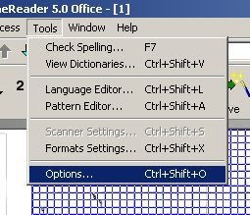
Figure 8-55. Selecting Options Under the Tools Menu
- Click on the ‘Recognition’ tab to select recognition options as shown in Figure 8-56.
If you need to set a new recognition language, see steps 8-12 otherwise skip to step 13 after setting the following options:
Recognition Language: BAC Numbers.
Document Type: Plain Text Formatted With Spaces
Print Type: Dot Matrix Printer
Tables: One line of text per Cell is Checked
Tables: No merged cells in table is Checked
Training: Use user pattern

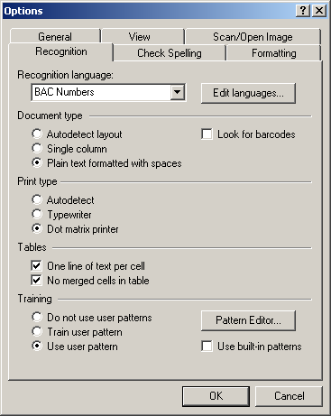
7
8
13
Figure 8-56. Recognition Settings in FineReader
- If you have not defined the BAC Numbers Language Click on the ‘Edit languages ..’ button to open the Language Editor Dialog shown in Figure 8-57.

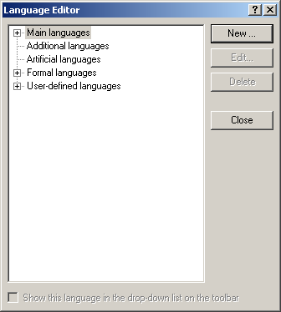
Figure 8-57. FineReader Language Editor Dialog
- Click on the ‘New’ button in the Language Editor Dialog (Figure 8-57). This will open the ‘New Language or Group’ Dialog shown in Figure 8-58.

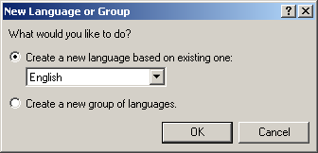
Figure 8-58. FineReader New Language or Group Dialog
- Select ‘English’ under the ‘Create a new language based on existing one’ selection (Figure 8-58), then click on the OK button. This will activate the ‘Simple Language Properties’ dialog illustrated in Figure 8-59.

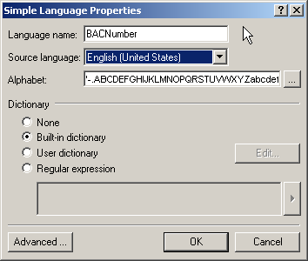
Figure 8-59. FineReader Simple Language Properties Dialog
- In the ‘Simple Languages Properties’ set the following properties:
Language Name: BAC Numbers
Source Language: English
Alphabet: Type in the numbers 12345678 to restrict the alphabet to the possible numbers of a ‘hit’ pattern
Then click the OK button. This will return you to the FineReader Language Editor Dialog where your user pattern should now appear under the ‘User-defined languages’ list as shown in Figure 8-60.

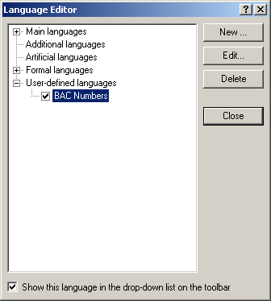
11
12
Figure 8-60. Language Editor with The New User Defined Language
- Click on the Close button under the ‘Language Editor’ dialog to save the changes that were made.
- Click on the OK button on the Options Dialog (Figure 8-56) to save the option settings you made.

Scanning Scoring Templates
Typically scoring templates are scanned using a batch document scanner such as the Fujitsu fi-4110CU (Appendix H). The FineReader program can automatically insert the images as they are scanned by the scanner.

- Place templates in the scanner with the text facing down
- Select ‘Scan Multiple Images’ from the FineReader File Menu. This will open the Twain Driver dialog to scan images.

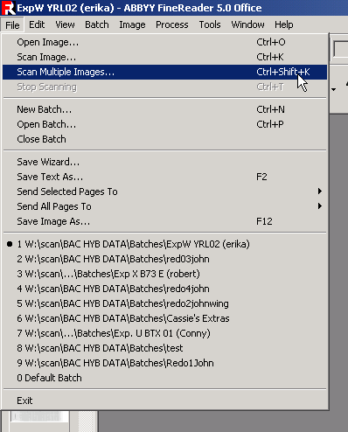
Figure 8-61. Select ‘Scan Multiple Images’ From the FineReader File Menu
- Set the settings for the Twain Driver to those shown below (Figure 8-62).
Resolution: 300x300
Scan Type: ADF (Front Side)
Paper Size: Custom…
Scanning Area: Left = 0, Top = 0, Width = 216mm, Length = 316mm
Image Mode: Grayscale
Brightness: 128
Contrast: 128

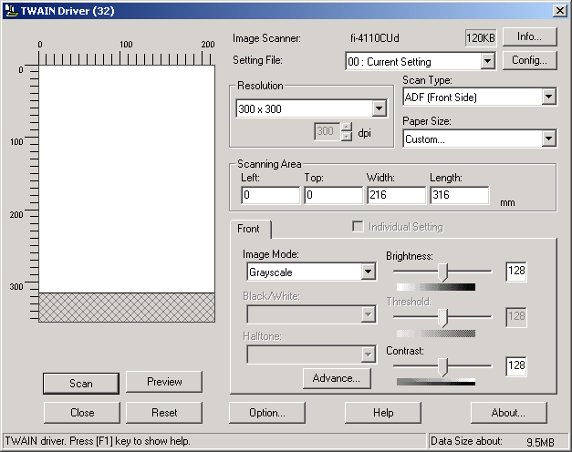
Figure 8-62. Twain Driver Dialog in Fine Reader for Setting the Image Scan Settings
- Once the settings have been set, click on the Scan button to begin scanning templates.
- All newly scanned films will be added to the list of films on the left hand side of the FineReader program window (Figure 8-63) and thus added to the current batch.

Formatting Scanned Templates

Once the scored grids have been scanned, you will need to format the regions that FineReader will attempt to read. In FineReader these regions are referred to as blocks. There are blocks that are recognized when scanning scoring grids. The first of these is a green textbox block that represents the film label, and the second is the blue table block that represents the grid data table. The green textbox must always be labeled block one, and the blue table block must always be labeled block two. Once these blocks have been defined and aligned you may proceed to reading your scoring templates.

- Click on the image that you want to format on the left menu bar in FineReader (Figure 8-63). If the image needs to be rotated, click on the Rotate Clockwise or Rotate Counterclockwise under the Image menu to get the proper orientation.

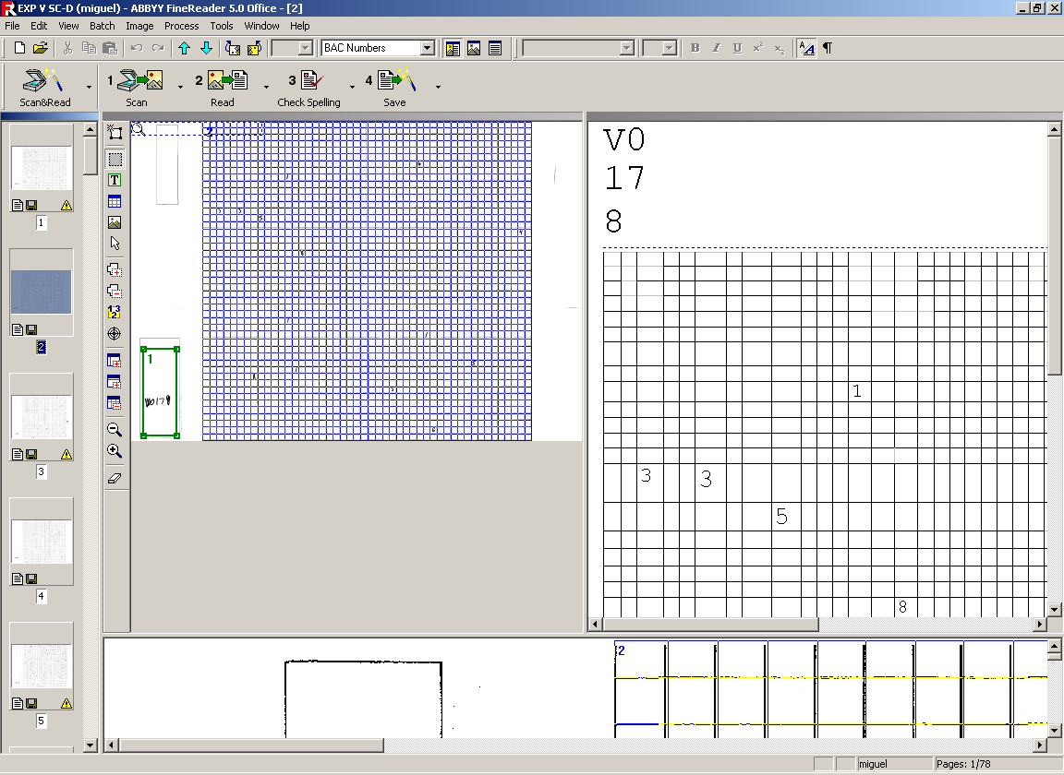
1
4
5
Figure 8-63. Reading Templates in FineReader
- Select Image : Load Blocks from the FineReader menu bar (Figure 8-64).

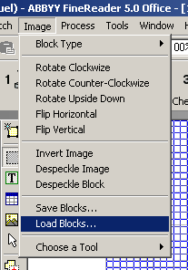
Figure 8-64. Selecting Load Blocks from the Image Menu Bar
- Select the blocks that you want to load from the list of block templates in the ‘Load Blocks’ dialog. Block files will have the .blk extension.
- Use the mouse pointer to align the green text box around the label box on the template.

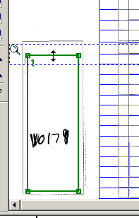
Figure 8-65. Editing the Position of the Label Box
- Use the mouse pointer to align the upper left corner and lower right corner of the blue table box to the upper and lower right corner of the template scoring grid.
- Move the mouse arrow on top of the blue grid table box, then click on the right mouse button and select ‘Analyze Table Structure’ from the pull down menu (Figure 8-66). This operation will automatically align the sides of the blue table box, and will identify the rows and columns of the table.

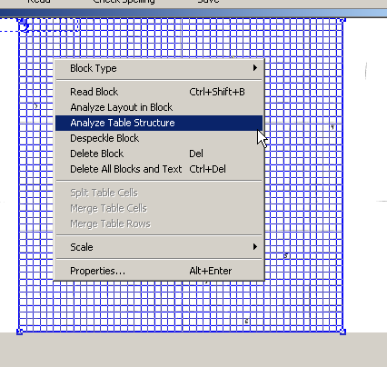
Figure 8-66. Selecting Analyze Table Structure for the Selected Table
- You should check to make sure that FineReader properly identified all of the rows and columns in the scoring grid. If rows are columns are missing, you will first need to click on the ‘Add Row Separator’ or the ‘Add Column Separator’ to activate the appropriate tool as shown in Figure 8-67.

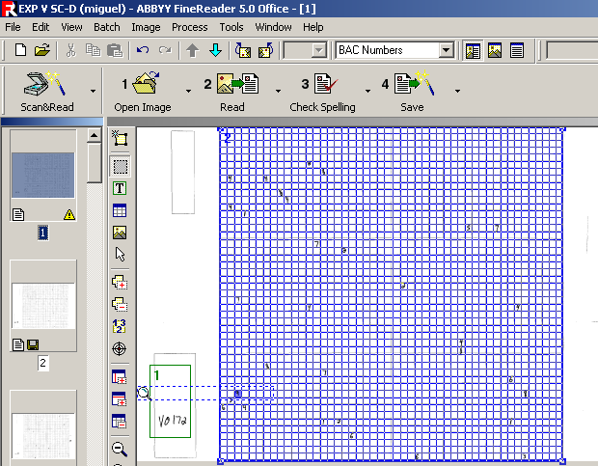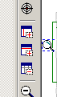
Add Vertical Separator
Add Horizontal Separator
Delete Separator
Figure 8-67. Table Editing Tools in Fine Reader
- Once you have activated the Add Separator tool, a Cross will appear that you can use to click on the position in the table where new separators need to be added (Figure 8-68).

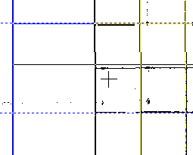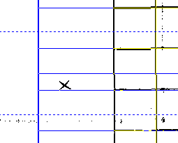
Add Separator Icon
Remove Separator Icon
Figure 8-68. Adding and Removing Table Separators in FineReader
- If a row or column separator needs to be removed, click on the Delete Separator button (Figure 8-67). A delete mouse icon will appear which you can use to delete separators that need to be removed. The delete separator tools can remove both Horizontal and Vertical separators.

Training a User Pattern

If you are using FineReader for the first time, you will need to train the software to recognize your handwriting. In FineReader terminology this is referred to as training your user pattern. The more consistent your handwriting is, the better FineReader will be a recognizing your handwriting.

- Select Tools : Options to open the Options dialog in FineReader. This will open the FineReader Options dialog illustrated Figure 8-70.

Figure 8-69. Selecting Options Under the Tools Menu Bar
- Click on the ‘Recognition’ Tab of the FineReader Options Dialog as shown in Figure 8-70.

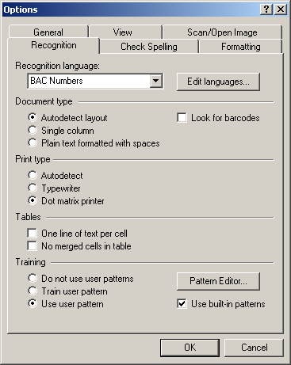
2
3
5
6
Figure 8-70. Fine Reader Options Dialog
- Click on the ‘Pattern Editor’ button (Figure 8-70) to select the user pattern you will be editing. This will open the Pattern Editor Dialog shown in Figure 4-15.
- For a previous user, click on the name of the user and click on the ‘Set Active’ button (Figure 8-71). For a new user, click on the ‘New’ button and enter the new user name and then click on the ‘Set Active’ button.
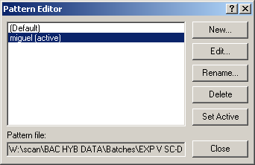
5
Figure 8-71. Pattern Editor Dialog in FineReader
- Click on the ‘Close’ in the pattern editor dialog to close dialog (Figure 8-71).
- Select ‘Train User Pattern’ radio button at the bottom of the options menu (Figure 8-70).
- Click on the OK button to begin training your user pattern.
- Since your user pattern will be trained when you are ‘reading’ the text in the images. You will first have to click on the ‘Read’ button on the FineReader toolbar.

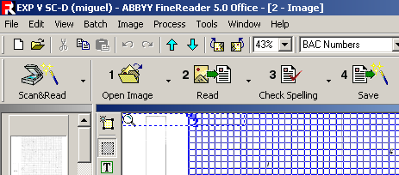
8
Figure 8-72. Read Button on the FineReader Toolbar
- When training a user pattern, you should ‘skip’ any queries for which the number is unclear (Figure 8-73). If these unclear numbers are included in your user pattern, you will have a low recognition rate when you later attempt to use the pattern editor to read your handwriting.

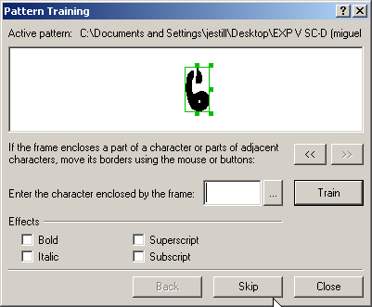
9
Figure 8-73. Skip Numbers Where the Pattern is Unclear.

- For all numbers which are clearly identifiable, type in the correct number and hit the ‘Enter’ key on the keyboard or the ‘Train’ button on the Pattern Training Dialog as shown in Figure 8-74.

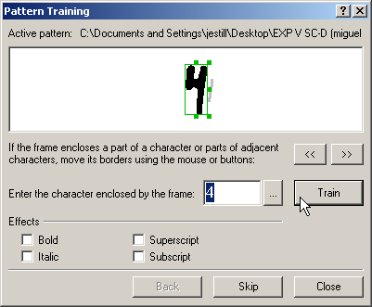
3
4
Figure 8-74. Train Those Numbers That are Clearly Identifiable
- If the entire number is not highlighted in the pattern training program, click on the green box around the number to properly highlight the entire character.
- Continue this process until the entire template has been read. You will then be asked to “Continue onto Next Page?” If you wish to continue reading templates click ‘Yes’, otherwise select ‘No’.

Reading a Template

The process of recognizing the characters that are written in the green textbox label or in the blue table grid is referred to as ‘reading’ the image.

- Click on the ‘Read’ button on the FineReader toolbar.

1
Figure 8-75. Read Button on the FineReader Toolbar
- If you are training a user pattern, see the directions above in section 8.3.4.
- If you want to read multiple pages, you can select the pages that you want to read

Check Spelling

Once all of the pages in the FineReader batch have been read, you will need to check the data that was produce by FineReader. Since FineReader is designed to read text documents, this is referred to as checking the spelling of the images you have read.

- Click on the ‘Check Spelling’ button on the FineReader toolbar (Figure 8-76). FineReader will then highlight all numbers on the screen in blue.

1
Figure 8-76. Check Spelling Button in the FineReader Toolbar
- For each number in question, FineReader will show the number in at the top of the Check Spelling dialog (Figure 8-77) and will also highlight the number in enlarged form near the bottom of the screen.
- If the number is incorrectly identified, you can type the correct number into the text box in the FineReader Check Spelling Dialog. You should also delete all incorrectly identified numbers or markings when spell checking. If the ^ character is left in the text, it will automatically be removed by the BACEater data conversion program as described in section 8.3.7.

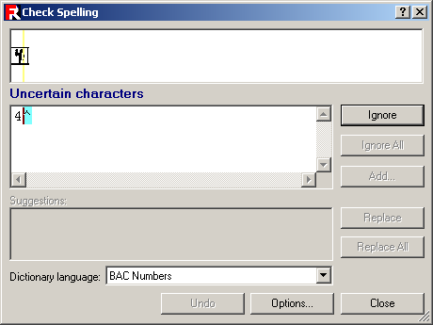
2
3
4
Figure 8-77. Check Spelling Dialog in FineReader
- Click on the ‘Ignore’ or ‘Replace’ buttons on the right side of the Check Spelling dialog to ignore the questionable.

Data Conversion Using BACEater

The BACEater application converts data that has been entered in ABBYY FineReader to the standard BACMan format. This converted data can then be uploaded to the BACMan database.

- Read and spell check the scoring templates in ABBYY Fine Reader (see above).
- Select File : Save Text As .. from the menu to open the Save Text As Dialog shown below in Figure 8-78.
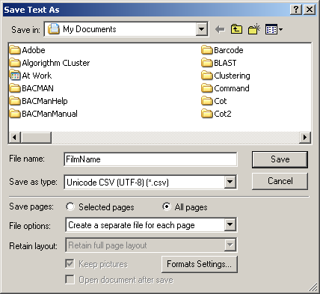
3
4
5
6
8
7
Figure 8-78. Save Text As Dialog in ABBYY FineReader
- Select the folder you want to place your files in selecting the file in the Save in: drop down menu. This MUST be an empty folder. Any other *.csv files that are in this folder will be treated as part of the same batch and will be scored. You may also make a new folder by clicking on the folder icon.
- Type in the file name that you will use for the output files.
- From Save as type select Unicode CSV (UTF-8)(*.csv) as shown above.
- Click the All pages option
- Select Create Separate File For Each Page under File Options
- Click on the Save button. At this point all of the pages that you read will be exported as csv files to the folder that you selected in step 3.
- Close ABBYY FineReader
- Open BACEater.exe. This will be located in C:/Program Files/PGMLSoft/BACEater/
- Select File : Process Folder to open the Process Folder dialog show in Figure 8-79.
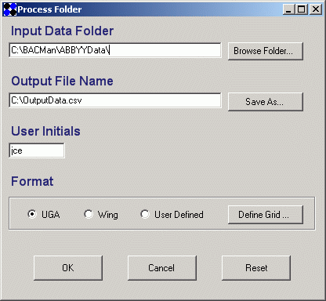
12
13
15
14
16
Figure 8-79. Process Folder Dialog
- Select the folder that you want to process by clicking on the Browse Folder button. The folder that you select should be the folder name you used in step 3.
- Click on the Save as button to create the name of a file that you will save your results as. This name must include the *.csv extension.
- Type in the initials of the person that scored the films in the User Initials text box.
- Click on the gridding format that is appropriate for the films that you scored. You may select a non-standard gridding format by selecting user defined. You must then define the gridding format by clicking on the Define Grid button. This will open the Set Grid dialog shown below. You may select the gridding format that you use.
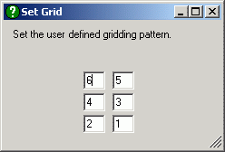
Figure 8-80. BACEater Set Grid Dialog
- Click the OK button in the Process Folder Dialog.
- The Status dialog will open showing the file that is being processed.
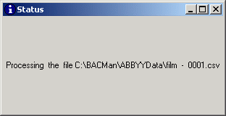
Figure 8-81. BACEater Status Dialog
- When the entire folder has been processed and no errors have been detected in your input file you will see a message box that tells you that your file has been processed in the gridding format that you choose.
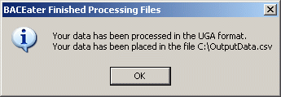
Figure 8-82. BACEater Finished Processing Files Message Box
- If errors were detected in any of the files that you processed, you will get the Errors Detected message box shown in Figure 8-83. All files that contained errors were not included in the data output. The files with errors will have a copy with the *.ERROR extension in Input Data Folder selected in Step 11. The files with the ERROR name should be reprocessed in ABBYY Fine reader before being processed with BACEater.
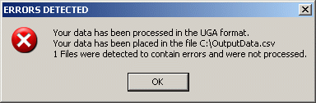
Figure 8-83. Errors Detected Message Box

Uploading Data to BACMan
Once the data have been processed in BACEater, it is then necessary to upload the data to the BACMan database. Open the BACMan database that you want to upload you BACEater data to. The interface for uploading hit data in BACMan is activated by selecting ‘Upload Hit Data’ from the BACMan Tools Menu.

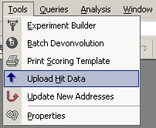
Figure 8-84. Select Upload Hit Data From the BACMan Tools Menu
Once the ‘Upload Hit Data Raw’ form has been opened (Figure 8-85), you can directly open the csv data output from BACEater by selecting the ‘Open CSV File’ button. This will activate a dialog that will allow you to select the csv file that you want to open. Once a csv file has been selected, the data will be displayed on the form. You may then edit the data as needed before uploading the data to the tblHitDataRaw table. This provides a good way to error check the data before they are permanently added to the database. Alternatively, you may choose to edit the data in a separate spreadsheet program such as MS Excel and then copy and paste the data into the ‘Upload Hit Data Raw’ form. One disadvantage to using the copy and paste method is that transfers are limited to 65,000 records. It is therefore suggested that previewing and editing the BACEater output take place by directly opening the csv file as described above.

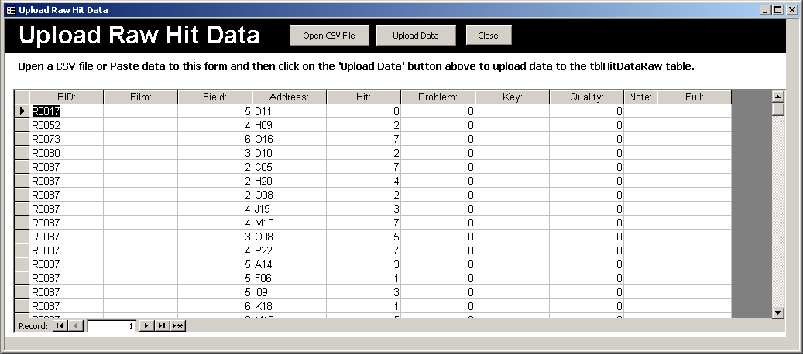
Figure 8-85. Upload Raw Hit Data Form
Once the data that are displayed represent what you want to upload to the tblHitDataRaw table, you can upload the data by clicking on the ‘Upload Data’ button shown above (Figure 8-85). This will move all the data in the temporary table to the tblHitDataRaw table to the table tblHitDataRaw.

Experiment Deconvolution
Once all of the data have been entered in a database for a given experiment and library, the experiment can be deconvoluted. The flowchart for the algorithm for the deconvolution process is shown in Appendix E, and the process of deconvoluting multiplex experiments is described below.

Single Library Deconvolution
If you wish to deconvolute a single library in a single experiment, you should select the ‘Single Deconvolution’ option from the BACMan Tools Menu (Figure 9-86).

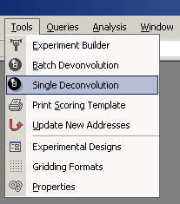
Figure 9-86. Select Single Deconvolution from the BACMan Tools Menu
This selection will open the ‘Deconvolution’ dialog where the user can set the Experiment and Library to deconvolute in the Deconvolution Dialog (Figure 9-87).

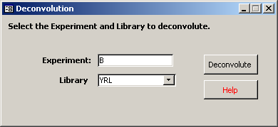
Figure 9-87. Dialog For Single Experiment Deconvolution
Clicking on the Deconvolute button will launch the deconvolution algorithm, and open the ‘Deconvolution Status’ dialog (Figure 9-88). The dialog displays the current status of the deconvolution process, and will be updated as the deconvolution progresses.

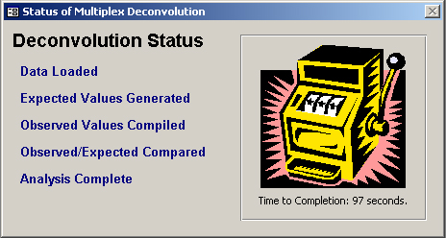
Figure 9-88. Deconvolution Status Dialog
Once the deconvolution has been completed the time it took to complete the deconvolution will be reported, and buttons will appear on the deconvolution status dialog to allow you to choose the next step you wish to take (Figure 9-89).

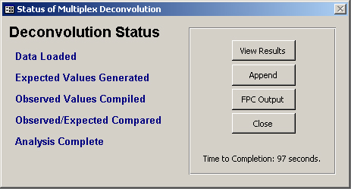
Figure 9-89. Completed Deconvolution Dialog
When the deconvolution is completed you may choose one of the following options:
- View Results – To get a preview in a form of the results of the deconvolution as described in Section 9.2.
- Append – To append the results of the deconvolution to the table tblHitDataDeconvoluted.
- FPC Output – To export the deconvoluted data to an FPC database. This process is described further in Section 13.
- Close – To close the Deconvolution Status form.

Deconvolution Results
If the View Results option is chosen after deconvolution, you will be able to see the list of probes and hits that resulted from the deconvolution, as well as some basic statistics concerning the deconvoluted data (Figure 9-90).

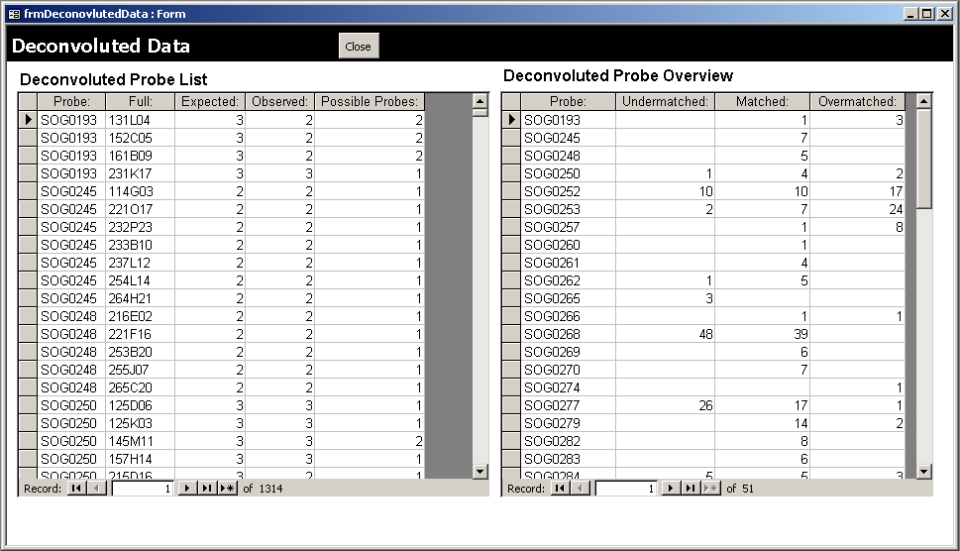
Figure 9-90. Deconvoluted Data Form
NOTE: In order to halt a deconvolution at any point during the process, simply press the Function and Break keys simultaneously.

Batch Deconvolution
If you would like to deconvolute more than a single Experiment and Library at one time, you can select the Batch deconvolution from the BACMan tools menu.

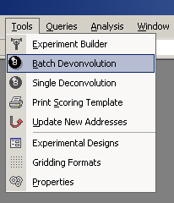
Figure 9-91. Select Batch Deconvolution From the BACMan Tools Menu
This selection will activate the ‘Batch Deconvolution’ Dialog (Figure 9-92). Input the experiment and library combinations that you would like to deconvoluted and click on the run button.

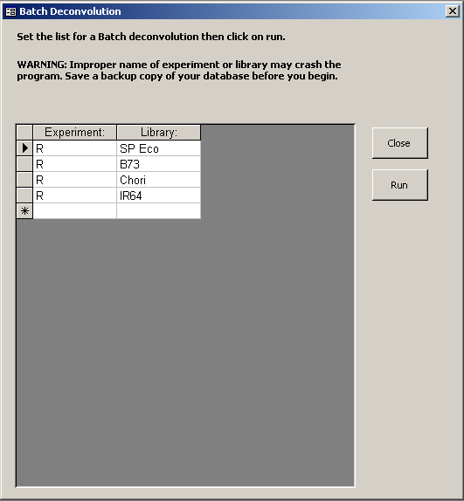
Figure 9-92. Batch Deconvolution Dialog
The batch deconvolution process will automatically cycle through the entire list of deconvolution targets, and will append the deconvoluted hit data to the table tblHitDataFiltered. It is recommended that you only deconvolute less then ten items at a time since the deconvolution process will increase the size of the Access database, and the database will need to be compacted and repaired before proceeding further.

Error Checking
BACMan provides a set of tools to aid in error checking films that may have been scored incorrectly. This process begins with the calculation of error statistics in terms of the number and proportion of hits that are properly matched on a film within a multiplex experiment. The films that contain a high number of incorrect hits may then be printed on Error Checking Templates. These templates may be then compared to the original film, and the errors may be edited in the database.

Flagging Films that Need to Be Error Checked
An advantage of pooled probe multiplex experimental design is that it facilitates error checking of the hits that are produced from an experiment. This is due to the fact that the pooled probe design requires hits that match across hybridization sets to be properly scored in both sets to be included in the database. When films have been scored and deconvoluted, matched hits will fall into one of the following categories:
- Unmatched – No matching hits were found during deconvolution of the experiment.
- Undermatched – Only a subset of the expected number of hits were found to match during deconvolution of an experiment. This is essentially when the observed number of matched hits is less than the expected number of matched hits. For example two hits were found to match of an expected three from a three dimension multiplex experiment.
- Matched – The expected number of matches were found during deconvolution.
- Overmatched – More than the expected number of matching hits were found during deconvolution.
- Expected – A hit that was expected based on an undermatched pair.

Once an experiment has been scored and deconvoluted, the numbers of hits in each film that fall into these hit quality categories may be calculated by clicking on the ‘Update Hit Quality Statistics’ button under the Main BACMan Menu (Figure 2-2). The results of this calculation can then be viewed under the Experiment Error Checking form shown in Figure 10-93. This form is available as a button on the BACMan Startup Form (Figure 2-2) or as an option under the ‘Form’ category of the BACMan pull-down menu (Figure 2-3).

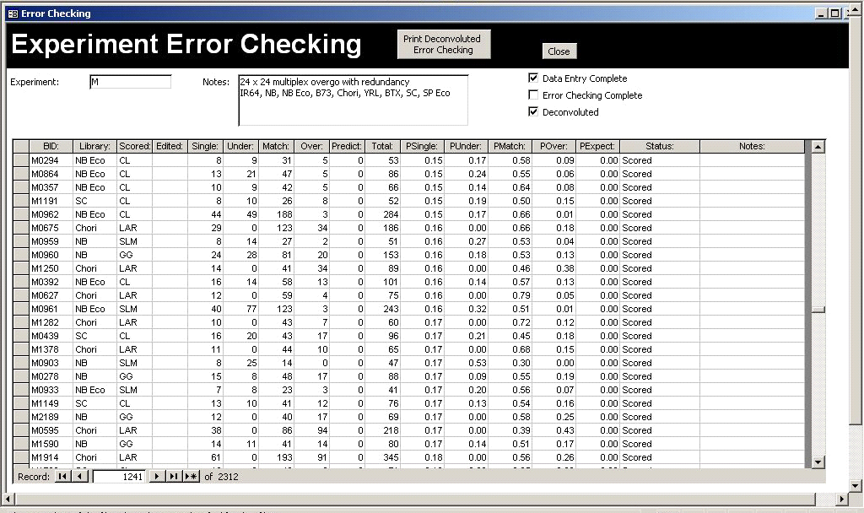
Figure 10-93. Experiment Error Checking Form
The fields listed for the film data quality are:
- BID – The barcode ID for the film
- Library – The library that the film represents
- Scored – The person that scored the film
- Edited – The person that edited the data
- Single – The number of single hits on the film
- Under – The number of undermatched hits on the film
- Match – The number of matched hits on the film
- Over – The number of overmatched hits on the film
- Predict – The number of predicted hits on the film
- Total – The total number of observed hits and predicted hits on the film
- PSingle – The proportion of single hits on the film (Single/Total)
- PUnder – The proportion of undermatched hits on the film (Under/Total)
- PMatch – The proportion of matched hits on the film
- POver – The proportion of overmatched hits on the film
- PExpect – The proportion of expected hits on the film
- Status – The status of the film in the data editing process. This field is used to flag films that need to have error checking sheets printed. The possible values for this field are:
  - Need to Print – The error checking sheet needs to be printed for this film. Films that are flagged ‘need to print’ will be printed when the user clicks on the ‘Print Deconvoluted Error Checking’ button.
  - Printed – After films have been printed, BACMan will changed their status to printed
  - Checked – Film has been rescored using the error checking template and has been edited in the database
  - Scored – The film has been scored but has not been deconvoluted or processed for error checking
  - Deconvoluted – The film has been deconvoluted but has not been error checking
  - Okay – The film has been scored and deconvoluted but does not need to be error checked
- Notes – The notes associated with the film. This can be used to record specific problems with the film.

Printing Error Checking Templates
Once films have been flagged for printing, clicking on the ‘Print Deconvoluted Error Checking’ button on the Experiment Error Checking Form (Figure 10-94) will activate the ‘Batch Print Error Checking Sheets’ dialog shown in Figure 10-94.

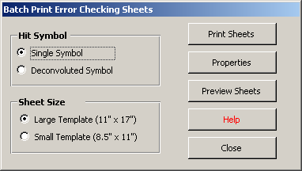
Figure 10-94. Batch Print Error Checking Sheets Dialog
The user can then select the size of the error checking sheet that is printed, and the hit symbol notation that will be used. If the Single Symbol option is selected a single symbol will be drawn for all of the hits on the film. If the deconvoluted symbol is selected, then a symbol representing the quality of the hit will be drawn for each hit on the film.

Clicking on the properties button on the Batch Print Error Checking Sheets Dialog will allow the user to set a number of properties that are associated with each error checking template. These elements are drawn according to user preferences that are set under the Error Checking Sheets Properties Dialog (Figure 2-2). These settings allow for the exclusion of content such as Field Names or Project name. This dialog also allows the user to specify the type of symbol that is drawn for each hit category.

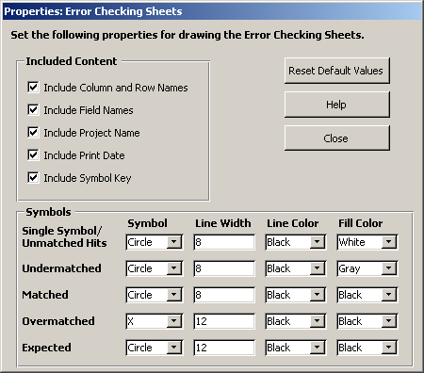
Figure 10-95. Error Checking Sheets Properties Dialog
The content that can be included in the error checking sheet is similar to that printed on the Scoring Templates. The fields that are listed under the included content list are labeled in Figure 10-96 and include:
- Included Column and Row Names – Includes the plate row and column names. It is recommended that these be included in error checking sheets since these are usually entered by hand and the user will need to determine the hit address visually.
- Included Field Names – Includes the field names for the six fields in the film
- Include Project Name – Includes the name of the project that the BACMan database represents. The name of the project name is set under the Properties Dialog as described in Section 3.1.
- Included Print Date – Indicates the date that the error checking template was printed on
- Include Symbol Key – This includes the key that describes the symbols that are drawn on the error checking template. It is recommended that this be included since the symbols and colors of the error checking template can be set different from one print job to the next.
A number of variables can be set for each of the symbols that are drawn:
- Symbol – The symbol that is drawn to indicate the hit. This can be a circle, point, or x.
- Line Width – The line width that is used to draw the symbol
- Line Color – The color of the line for the symbol
- Fill Color – The color that is used to fill circles. The list of colors is derived from the table tblListColorNames. Users can define new colors by filling in the appropriate information in this table.

Film Data Editing
A single error checking sheet should be produced for each of the films that have been flagged ‘Need to Print’ under the Experiment Error Checking Form (Figure 10-93). These sheets can be printed on plain paper or transparency overlays. The printed sheets will look similar to the error checking sheet shown in Figure 10-96 below.

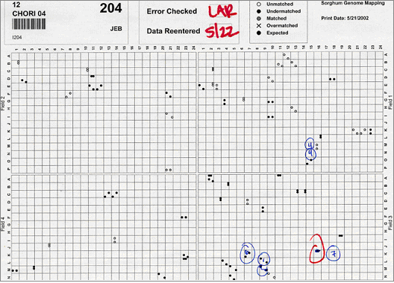
Symbol Key
Print Date
Project Name
Field Name
Column and Row Names
Figure 10-96. Error Checking Template Used To Correct Data
The error checking templates can be compared to the film that the data were derived from. New hits can be added to the matrix, hits that are incorrect can be marked for removal, and the presence of expected hits can be checked. Once this has been done, the user will need to update the data in the database. The easiest way to the do this will be to program a barcode scanner for data editing using the Data Editing Barcode Program in Appendix-1.2. The barcode that is printed on the error checking template can then be scanned to open the appropriate record in the Film Data Editing Form (Figure 10-97).

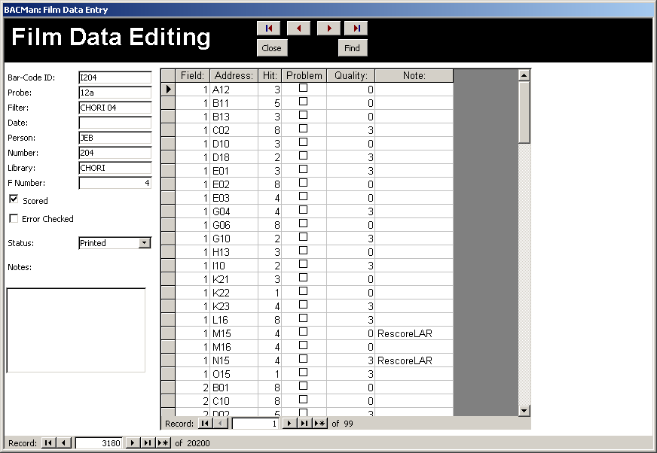
Figure 10-97. Film Data Editing Form
Hits that need to be removed can be flagged as ‘Problem’ hits or can be entirely removed from the database. New hits can also be added. If you wish to indicate that these hits represent new ‘rescored’ hits then this can be entered under the notes column for the hit. Once the data has been edited the status of the film should be changed from ‘Printed’ to ‘Checked’.

Another alternative is to find films that should be rescored using the Experiment Error Checking Form, and then completely rescore them with a new scoring template. The data can be processed in the normal manner and then added to the database. The previously scored hits could be deleted from the database, or the new data could be appended to the existing data in tblHitDataRaw. While not elegant, this ‘brute force’ approach can be tolerated by the BACMan deconvolution algorithm.

Database Queries

A number of general database queries are available from the BACMan startup menu (Figure 2-2). This includes a general overview of the database as well as information on the films that have been scored and the probes that have been assayed.

Scored Films Query
The Scored Films Query is available from the Main BACMan form and the BACMan pull down menu. This query allows you to see an overview for all of the films that have been scored and entered in the database. This query may take a few minutes to run depending of the size of the database that is being queried. You may preview the results in the form as shown below, or click on the Preview Report button to open a printable report of these results.

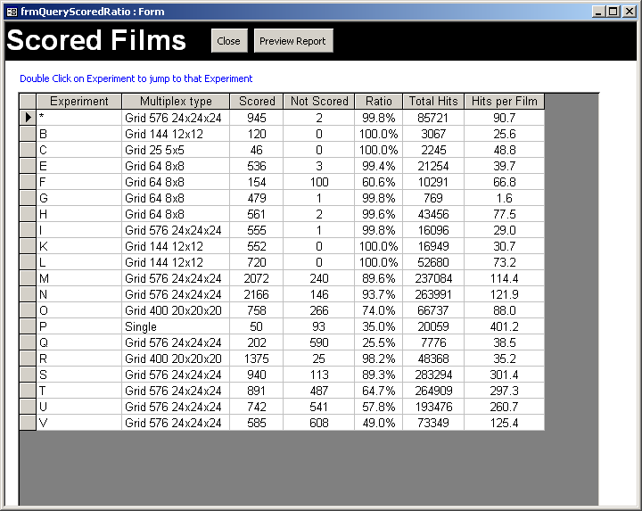
Figure 11-98. Results of Scored Films Query
The Scored Films query reports the following information:
- Experiment – The name of the experiment
- Multiplex Type – The type of multiplex design used in the experiment
- Scored – The total number of films that have been scored and entered for a given experiment
- Not Scored – The total number of films that are not yet scored
- Ratio – The percent of films that have been scored
- Total Hits – The total number of hits that were scored for the entire experiment
- Hits Per Film – The average number of hits per film for the experiment.
Double clicking on the name of an experiment will open that experiment in the ‘Experiments’ Form.

Database Overview Query
The database overview query is available from the BACMan Startup form and the BACMan dropdown menu. This query opens a window that reports the total number of hits as well as the total number of films in the database. It also reports when information was last added to the raw hit data table (tblHitDataRaw) and the filtered hit data table (tblHitDataFiltered). The results of the query are illustrated in Figure 11-99.

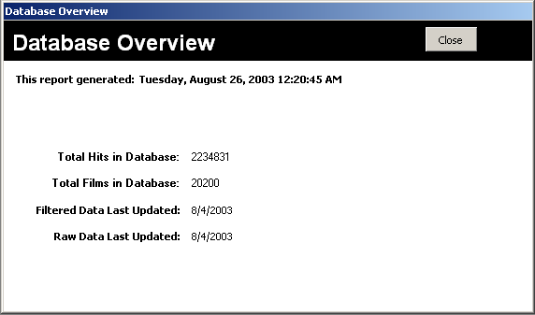
Figure 11-99. Results of Database Overview Query
This query is useful for getting a idea of the overall progress of the project.

Completed Probes
The Completed Probes form provides a way to see which probes have been assayed for the libraries in the database (Figure 11-100). If a probe was applied to a library on multiple dates, the most recent experiment date will be shown. This form is available from the BACMan Startup form and the BACMan menu.

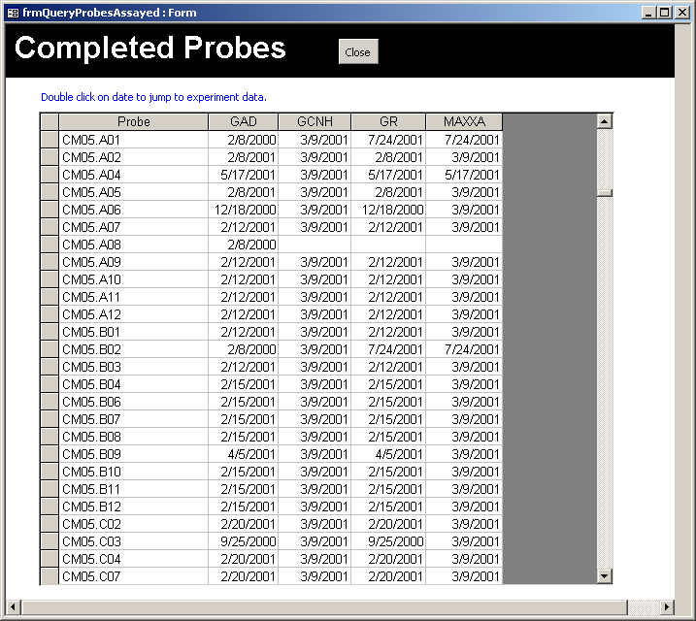
Figure 11-100. The probes that have been assayed
Double clicking on the date will open the Experiments Form to the experiment that the probe was assayed in.

Filter Hits Plot
The filter hits plot form provides a way to see how many hits have been recorded for each filter over time (Figure 11-101). This form is available from the BACMan startup form and the BACMan menu. You need to select a valid value for the library and filter set that you want to display data for, and then click on the ‘View Chart’ button. This will launch the query that calculates the number of hits for the filter set over time, and then updates the image of the plot that displays this data.

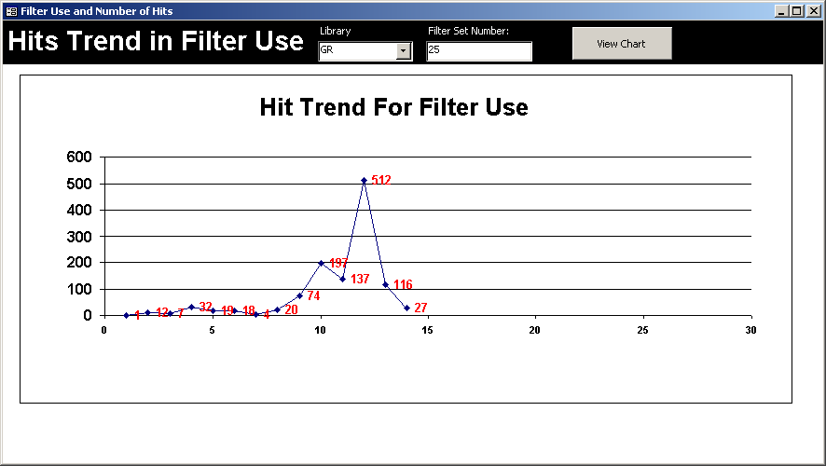
Figure 11-101. Hits Trend in Filter Use Form
This form makes use of the Microsoft Graph 2000 Chart OLE class available with MS Access 2000 and later. These plots are useful for visualizing blots that contained too few or too many hits and diagnosing problems that arise when using older filters. The MS Access name for this form is frmFilterUsePlot.

Web Publication of Database
When library screening data are not associated with FPC databases, it may still be helpful to publish the hybridization data online. BACMan allows for this via publication of a subset of the BACMan tables online as PHP pages that may be queried to search for data by probe or library. This interface allows for timely publication of hybridization as they become available, and may even be linked to the primary database itself so that data are immediately available as they are deconvoluted as described in section 14.1. The base PHP and MySQL code needed to generate these online query pages are included in the distribution of BACMan and are available online from PGML: http://www.plantgenome.uga.edu/projects.htm#Bioinformatics.

Web Query Interface
The BACMan data schema may be uploaded to a MySQL database for online publication via PHP pages that can be accessed on the internet. This online query allows users to access deconvoluted hybridization data in the tblHitDataFiltered table by searching for probes by the Locus Name, Genbank Number or the locally used probe code (Figure 12-102).

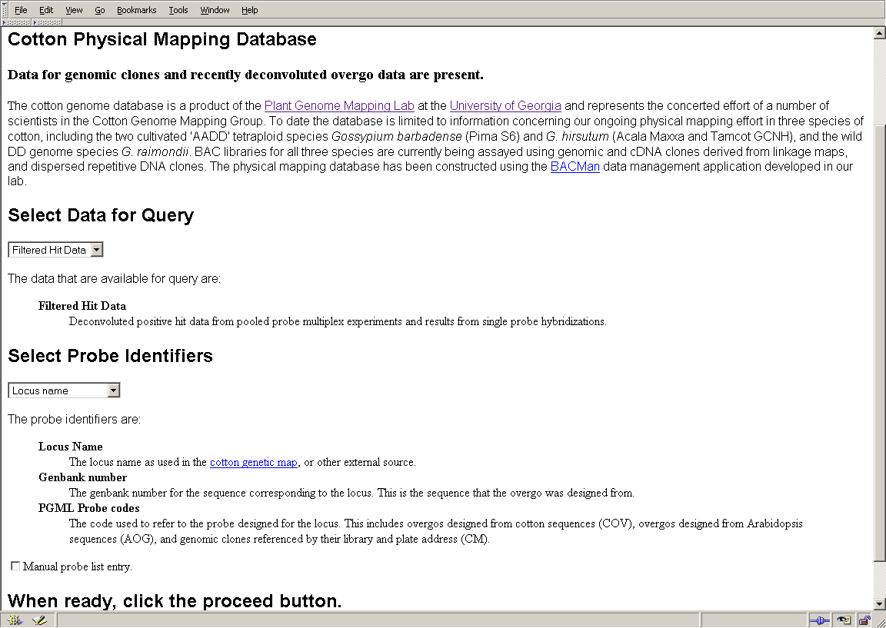
Figure 12-102. Online Database Query Start Page
Once the user selects the probe identifier to use for the query, they are able to either select the probe and library to return hits for, or they can choose to view the entire list of probes that gave positive hits of the library that they are interested in. This query page for the cotton database is shown below in Figure 12-103.

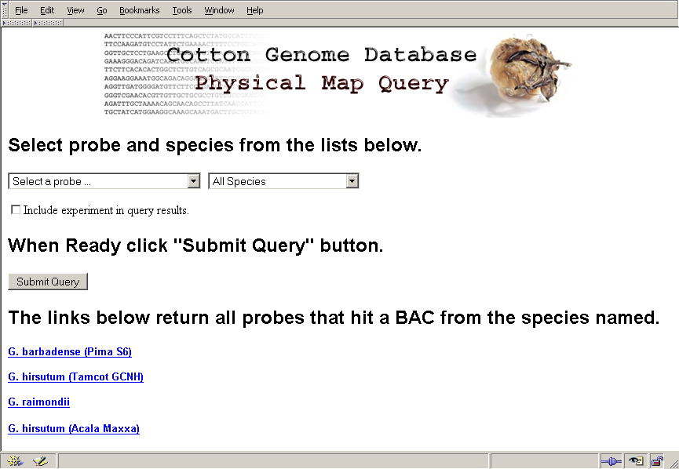
Figure 12-103. Physical Map Query PHP Page
The results of the query will display the query name that was used along with the list of information for that probe including Genbank ID and sequence data of the probe when available. The list of hits for the library that was selected will be displayed (Figure 12-104).

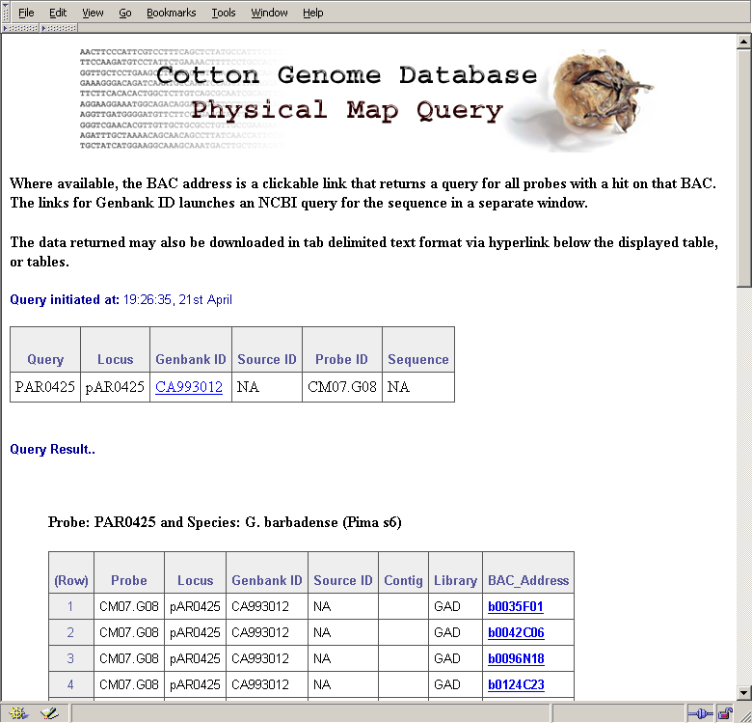
Figure 12-104. Online Database Query Results
The information that is displayed for each positive hit in the database includes the probe name and associated ID along with the BAC Address of the positive hit. Selecting on the hyperlink for the BAC Address will list all of the other probes that shared hits with this BAC clone. For example, selecting the first BAC Address in the list shown above in Figure 12-104, will yield the results shown below in Figure 12-105. Furthermore, the entire list of query results may be downloaded as a tab delimited text file by clicking on the hyperlink at the bottom of the query results page (Figure 12-104). This allows online users to save the results in a format that are suitable for use in spreadsheet software or other analysis routines.

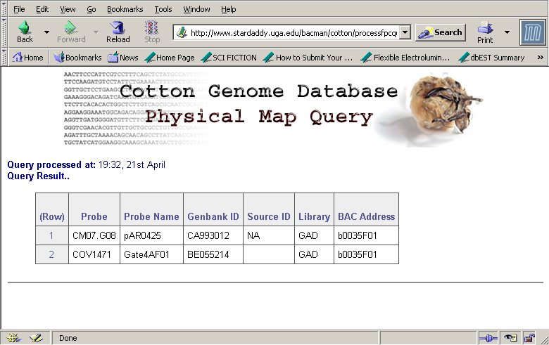
Figure 12-105. List of Probes Sharing BAC Addresses.
Summary data for the entire database are also made available online. These static html pages are generated by perl scripts operating on __ the database server. The generation of these pages may be set as a scheduled task on your database server, or may be set to update as the online users need the data.

It is expected that additional PHP interfaces to the database will be made available at PGML as the need for additional query options become known to us. Additional work will be available at http://www.plantgenome.uga.edu/projects.htm#bioinformatics.

Uploading Data to MySQL Database Server
The first step that you will need to take to make the BACMan data available on the web is to create a database in a MySQL database server that is available. Once you have created the BACMan MySQL database, it may be necessary to update the data in the MySQL tables as data are added to the database. The basic steps in this process are: (1) create text files of the data tables from within BACMan, (2) transfer the text files to a location that is accessible to the MySQL server, and (3) upload text files to the appropriate table in the MySQL database. Once the data are available in the MySQL database, you will then need to upload the PHP pages to your web server.

Creating Text Files From Within BACMan
The dialog to create the text files needed for upload to the MySQL database is available from the frmExportTextFiles form in BACMan. Select ‘Export Tables as Text’ from the BACMan tools menu (Figure 12-106) to open the dialog for selection of the files to export.

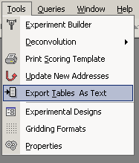
Figure 12-106. Select Export Tables as Text
Simply select the specific text files to export and then set the folder to hold the text files. Clicking on the Export button will then create all of the text files from the current version of the tables in your database. These text files will need to be moved from this export folder to a location that is accessible from the MySQL database folder so that they can be uploaded to the MySQL database as described in section 12.2.2.

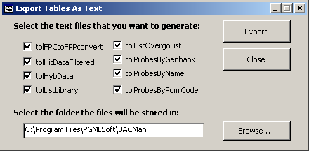
Figure 12-107. Export BACMan Text Files Dialog

Uploading Data to MySQL Database
The code to create and update the MySQL database is a perl script that is included in the distribution of BACMan in the folder: ‘C:/Program Files/PGMLSoft/MyBACMan’. To start you will need to launch a MySQL session and then create the database using the create database command if you have not already done so. Next you will need to return to the Linux shell and run the perl program ‘MyBACMan.pl’ which will create the tables needed for the database, and will fill the tables with data. In addition to creating a new database, this program may also be used to append data to tables in a database that already exists by using the –o n option as described below.

The program MyBACMan.pl is a perl script that has a number of switches that must be defined at the command line. A number of variables must be correctly set by the user in the bacvar.pl file. The variable file can be edited in any text editor to set the correct variables. The MyBACMan.pl script uses the DBI module from perl to connect to the MySQL database, so the information for connecting to the database must be invoked at the command line. These include:
- d – database for the DBI connection
- h – database host name for the DBI connection
- u – username for the DBI connection
- p – password for the DBI connection
- o – optional, include this flag to overwrite data in tables
An example of a session where the database is created and the MyBACMan.pl program is run is shown below:

shell>mysql –u username –p
Enter password *********
mysql>create database dbBACMan;
mysql>exit;
shell>ls -l
drwxr-xr-x 6 jestill users 232 Apr 14 16:14 NCBI
drwxr-xr-x 2 jestill users 736 Mar 23 12:26 RData
-rw-r--r-- 1 jestill users 253 Apr 22 12:33 MyBACMan.pl
shell>./MyBACMan.pl –d dbBACMan –h localhost –u jestill –p pass –o
shell>
Figure 12-108. Example Session Uploading BACMan to MySQL Table
The above session will create all of the tables needed to upload the data, and will establish the overall schema of the database. Since the –o switch was used, the data will be uploaded to the tables in the database, and existing data in the tables will be overwritten. This session also assumes that you have already created the text tables needed and that they are located in the directory that is specified in the bacvar.pl file.

Once the data have been loaded into the MySQL database you may want to use the SHOW TABLES command just to check that all of the tables are present. The SHOW TABLE STATUS command may be used to make sure that the tables contain the number of records that you expect, and the DESCRIBE ‘TableName’ command may be used to verify that tables contain the fields that are expected. A session showing some of these basic MySQL commands is illustrated in Figure 12-109.

shell>mysql –u username –p
Enter password *********
mysql>use dbBACMan;
mysql>SHOW TABLES;
+---------------------+
| Tables_in_dbBACMan |
+---------------------+
| tblFPCtoFPPconvert |
| tblHitDataFiltered |
| tblHybData |
| tblListLibrary |
| tblListOvergoList |
| tblProbesByGenbank |
| tblProbesByName |
| tblProbesByPgmlCode |
+---------------------+
mysql>DESCRIBE tblListLibrary;
+----------------+---------+------+-----+---------+-------+
| Field | Type | Null | Key | Default | Extra |
+----------------+---------+------+-----+---------+-------+
| Library | text | YES | | NULL | |
| Taxon | text | YES | | NULL | |
| Coverage | int(11) | YES | | NULL | |
| NumberBACs | int(11) | YES | | NULL | |
| InsertSize | int(11) | YES | | NULL | |
| Color | text | YES | | NULL | |
| GriddingFormat | text | YES | | NULL | |
| FPCPrefix | text | YES | | NULL | |
+----------------+---------+------+-----+---------+-------+
8 rows in set (0.01 sec)
mysql>SHOW TABLE STATUS;
-------------------+--------+------------+--------+----------------+-------------+-----------------+--------------+-----------+----------------+---------------------+---------------------+---------------------+----------------+---------+
| Name | Type | Row_format | Rows | Avg_row_length | Data_length | Max_data_length | Index_length | Data_free | Auto_increment | Create_time | Update_time | Check_time | Create_options | Comment |
+---------------------+--------+------------+--------+----------------+-------------+-----------------+--------------+-----------+----------------+---------------------+---------------------+---------------------+----------------+---------+
| tblFPCtoFPPconvert | MyISAM | Dynamic | 350208 | 33 | 11870208 | 4294967295 | 2447360 | 0 | NULL | 2003-10-10 17:37:39 | 2003-10-10 17:37:41 | 2003-10-10 17:37:42 | | |
| tblHitDataFiltered | MyISAM | Dynamic | 28996 | 50 | 1462408 | 4294967295 | 308224 | 0 | NULL | 2003-10-10 17:37:43 | 2003-10-10 17:37:43 | 2003-10-10 17:37:44 | | |
| tblHybData | MyISAM | Dynamic | 12740 | 71 | 917268 | 4294967295 | 1024 | 0 | NULL | 2003-10-10 17:37:44 | 2003-10-10 17:37:44 | NULL | | |
| tblListLibrary | MyISAM | Dynamic | 4 | 59 | 236 | 4294967295 | 1024 | 0 | NULL | 2003-10-10 17:37:36 | 2003-10-10 17:37:36 | NULL | | |
| tblListOvergoList | MyISAM | Dynamic | 3135 | 172 | 541108 | 4294967295 | 43008 | 0 | NULL | 2003-10-10 17:37:44 | 2003-10-10 17:37:44 | 2003-10-10 17:37:44 | | |
| tblProbesByGenbank | MyISAM | Dynamic | 3135 | 30 | 96072 | 4294967295 | 16384 | 0 | NULL | 2003-10-10 17:37:44 | 2003-10-10 17:37:44 | 2003-10-10 17:37:44 | | |
| tblProbesByName | MyISAM | Dynamic | 3135 | 30 | 96072 | 4294967295 | 25600 | 0 | NULL | 2003-10-10 17:37:44 | 2003-10-10 17:37:44 | 2003-10-10 17:37:44 | | |
| tblProbesByPgmlCode | MyISAM | Dynamic | 3135 | 30 | 96072 | 4294967295 | 22528 | 0 | NULL | 2003-10-10 17:37:44 | 2003-10-10 17:37:44 | 2003-10-10 17:37:44 | | |
+---------------------+--------+------------+--------+----------------+-------------+-----------------+--------------+-----------+----------------+---------------------+---------------------+---------------------+----------------+---------+
Figure 12-109. Display Tables in the BACMan MySQL Database
Once the data are in the MySQL database you will need to upload the PHP pages that connect to the database.

Uploading PHP Pages to the Web Server
This is where I will describe what will be needed to make the PHP pages available from the web.

FPC Interoperability

When the hybridization data have been scored and deconvoluted, they may be exported to a FPC database. This is available from the main BACMan Startup Form (see Figure 2-2) as well as from the deconvolution results form. You must first designate the Library and Experiment that you want to export to FPC using the Export FPC File dialog shown in Error: Reference source not found.

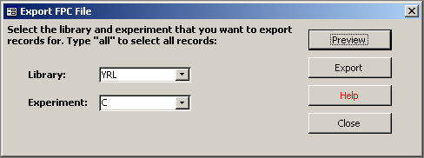
Figure 13-110. Export FPC Dialog
Click on the preview button to preview the results of the export function. This will open the ‘FPC Export Preview’ form as show below in Error: Reference source not found.

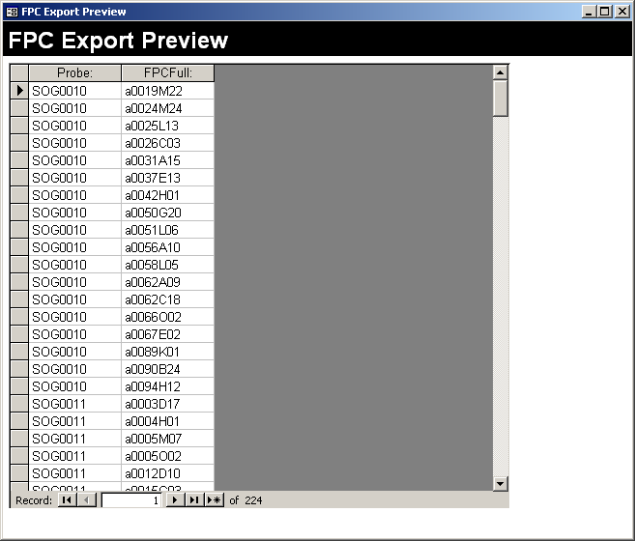
Figure 13-111. FPC Export Preview Form
Once you have previewed the data, it can be exported by clicking on the ‘Export’ button on the ‘Export FPC File’ dialog. This will open the ‘Export File Name’ dialog where the data can then be exported as a text file suitable for upload to an FPC database.

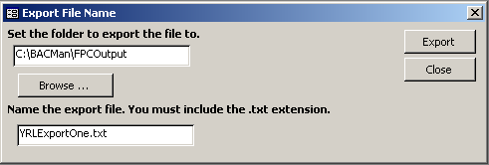
Figure 13-112. Export FPC File Name Dialog

Additional Topics

The BACMan database may be changed in a number of ways to better fit the needs of individual projects

Using External RDBMS for Data Tables
When the amount of data that will be stored in any table exceeds one-million records you may want to think about using another relational database management system as the ‘back end’ to the Access database. Essentially the tables in the Access database will be replaced by linked tables that point to the tables in your external relational database. These external database tables may be stored in MySQL, SQL Server, PostgreSQL or Oracle. This may be the database that you are using to serve PHP pages as described in section 12, or it may be a separate database. The procedure to link an external database table to your BACMan database is described below.

Updating Your Version of BACMan
If you want to update the version of BACMan that you are using as new versions of BACMan become available, you will need to transfer your data tables to the new BACMan version. Since this could be a tedious task, I have written a routine that could make this easier. This routine assumes that you have not modified the data tables in any way. If you have modified tables by adding fields or changing data connections, then you will need to do this update process by hand.

Gridding and Scoring High-Density Grids
BACMan assumes that the filter gridding format is high-density double spotted grids of libraries arrayed in 384 well plates. The BACMan data schema is relatively robust and can handle any double spotted hit pattern in a 96 or 384 well formats as long as the gridding format is defined in the Gridding Format form. The error checking templates currently generated by BACMan assume that the gridding format shown below has been used.

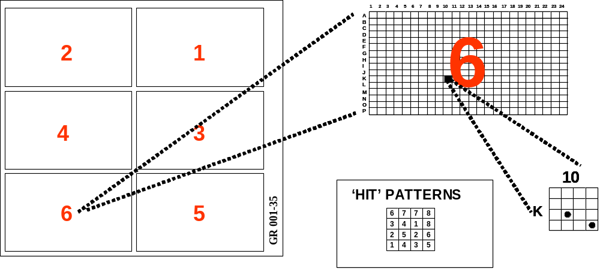

The gridding format illustrated is the UGA format. In this format the first eight plates are gridded in field one; the next eight are gridded on field 2 on up to field six. Therefore a hit pattern of one in field one represents the first plate while a hit pattern of two in field one represents the second plate. A hit pattern of one in field two will represent plate nine and a hit pattern of two in field two will represent plate ten. In this way, data for forty-eight plates representing 18,432 BACs can be gridded on a single membrane.

The example above shows the first filter of the 35th replication of the Gossypium raimondii library. This yields the filter label GR 001-35. The example shows a positive hit in field number six for pattern number five. Therefore this data would be recorded in the BACMan table tblHitDataRaw as shown below.

Film | Field | Address | Hit
1 | 6 | K10 | 5

This data could late be translated by tblAddress2BAC to represent the K10 address of plate 38 of the BAC library.

BACMan Database Schema

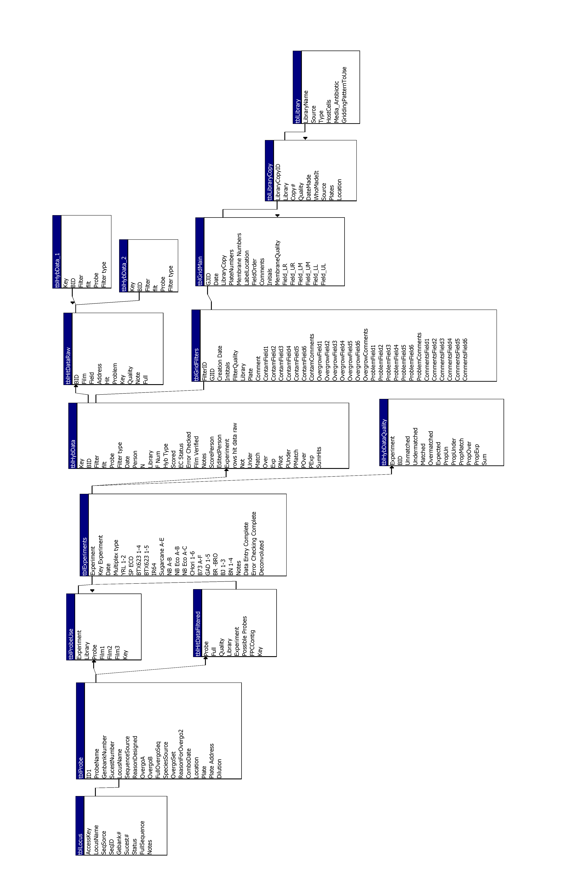

Data Entry Barcode Program
The following barcode program is used to program the Zebex programmable wedge barcode scanner. This program will initialize the scanner to open the Film Data Entry form when barcodes are scanned.

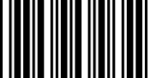 Start of Configuration

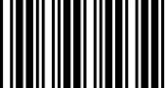 Reset Scanner to Default Parameters

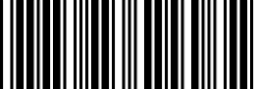 Function Key On

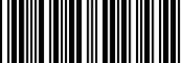 No message terminator

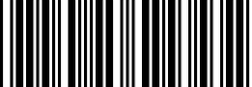 Header Optional Settings

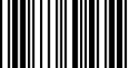 SYN (F6 emulation) 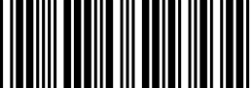 Beeper set MED

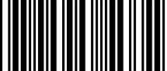 Set Header 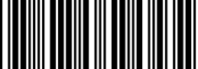 Beeper set LOW

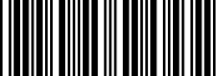 Trailer 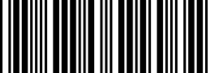 Beeper set OFF

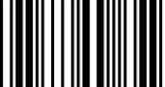 ETB (F7 emulation) 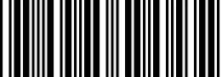 Terminator is Return

Set Trailer 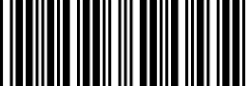 Autoscan ON

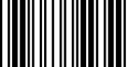 End of Configuration 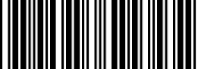 Autoscan OFF

Data Editing Barcode Program
The following barcode program is used to program the Zebex programmable wedge barcode scanner. This program will initialize the scanner to open the Film Data Editing form when barcodes are scanned.

Start of Configuration

Reset Scanner to Default Parameters

Function Key On

No message terminator

Header Optional Settings

SYN (F6 emulation) Beeper set MED

Set Header Beeper set LOW

Trailer Beeper set OFF

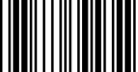 CAN (F8 emulation) Terminator is Return

Set Trailer Autoscan ON

End of Configuration Autoscan OFF

Data Flow Diagrams
The flow of data throughout various components of the BACMan application is shown below. Since I want to show the flow of data as well as the interactions provided by the user interfaces and the output from these functions, I have used a hybrid diagramming technique that is part Data Flow Diagramming and part Process Flowcharting.
My use of flowcharting symbols is as follows:
START
Terminator: The start or end of the component I am describing.
ProcessName

Description of the process
Process: This may be a named Access query, an SQL statement executed in code, or a sub function.
UIName

Description of the User Interface
User Interface: This indicates a user interface object such as an Access form or dialog. This could be a dialog that requires user input or a status dialog that indicates the current status of a function.
A
Connectors: Circles are on page connectors, arrows are off page connectors.
Choice
Direction: The arrow indicates the direction of data flow or process. If the direction requires a user choice the name of the choice is shown in text.
DataObjectName
Description of the
Data Object
Data Object: Objects that store data within the database. This is usually a named table object.
Document: This indicates a document that is intended to be printed or used bay an external program. In Access this will almost always refer to reports. However, exported text files are also indicated by this symbol
ReportName
Description of the
Report
H

Experiment Builder

frmExperimentBuilder01
Select the libraries used and the experiment type
qryExperimentBuilder01
Generate table of library information
tblExperimentBuilder01
Next
Table of library sets used in the experiment
frmExperimentBuilder02
Add the identification numbers of the blots used
Back
qryExperimentBuilder02
Combine information supplied with data from tblExperimentBuilder-
LibraryTemplate to generate full list of filters.
Next
END
END
START
tblExperimentBuilder02
Full list of filters used in the experiment.
Close
frmExperimentBuilder03
Add experiment prefix, experiment date and experimenter initials
qryExperimentBuilder03
Add three columns:
prefix & film number
experiment date
experiment initials
Next
END
tblExperimentBuilder03
Final table of all data that will go into tblHybData
A
A
Close
Close
B
B
Back
frmExperimentBuilder04
Preview the outcome and allow the user a chance to backtrack if necessary.
C
C
Need to add a function that will add this information to the experiment list and will create a new experiment if necessary. Currently user must copy and paste
Back
Close
END
Finish
END
Update New Addresses

Update Hit Quality Statistics

Pooled Probe Multiplex Deconvolution

frmDeconovlutionSetup
Select the library and experiment to deconvolute
Select all records from tblHitDataRaw where the Experiment and Library are equal to the values selected in frmDeconvolutionSetup
tblHitsToDeconvolute
Data from the library and experiment to deconvolute
START
Help
frmDeconvolutiontSatus

Displayed status is:
Generating Expected Hit Number

Load Expected Hits

Select values from the table tblProbeUse where the Experiment and Library are equal to the values selected

tblIntersectionsExpected

Full list of intersections expected in the multiplex experiment.

A
A
B
Open BACMan Help File
Load Data
frmDeconvolutiontSatus
This form is opened and the displayed status is:
Loading Data
Deconvolute
frmDeconvolutiontSatus

Displayed status is:
Generating Expected Values

Generate Expected Values

Determine the number of expected hits and then generate the expected merged values

tblExpectedMerge

The expected merge values for hits at the intersections
B
C
frmDeconvolutiontSatus

Displayed status is:
Compiling Observed Triples

Compile Observed Triples

Determine all of the possible sets of three films that share the same hits from the table tblHitsToDeconvolute

tblTempObservedHits

All possible ‘triples’ from the table tblHitsToDeconvolute
C
D
frmDeconvolutiontSatus

Displayed status is:
Compiling Observed Doubles

Compile Observed Doubles

Determine all of the possible pairs of films that share hits from the table tblHitsToDeconvolute

tblTempObservedDoubleHits

All possible pairs of films that share hits from the table tblHitsToDeconvolute
D
E
frmDeconvolutiontSatus

Displayed status is:
Comparing Doubles to Triples

Compile Observed Doubles

Determine which of the pairs are not represented by triple hits by comparing tblTempObservedDoubleHits to tblTempObservedHits

tblTempObservedHits

All of the possible triples and double hits that are not represented by triples
E
F
frmDeconvolutiontSatus

Displayed status is:
Comparing Expected to Observed

Compare Expected/Observed

Determine which of the observed merge values in tblTempObservedHits match some expected value in tblExpectedMerge

tblDeconvolutedData

All of the possible triples and doubles that match an expected value
F
G
frmDeconvolutiontSatus

Displayed status is:
Identifying Overmatched Hits

Count Deconvoluted Hits

Count the number of probes that give a valid deconvoluted hit for each probe
tblTempDeconvProbeCount

The number of probes that can be a valid hit for each full hit address
G
H
frmDeconvolutiontSatus

Displayed status is:
Identifying Overmatched Hits

Update Count Data

Update the count of the Possible Probes table with the data from tblTempDeconvProbeCount

tblDeconvolutedData

All possible doubles and triples with the probe count data
H
I
END
frmDeconvolutiontSatus

Displayed status is:
Scoring Hit Quality

Determine Hit Quality

Assign all hits a quality score based on the number of hits expected and the number observed

tblDeconvolutedData

The hit and count data with the quality data appended
I
J
frmDeconvolutiontSatus

Displayed status is:
Updating tblHitDataRaw

Update Hit Quality

Update the hit quality data in the raw hit data
tblHitDataRaw

tblHitDataRaw

Raw hit data with the hit quality data updated
J
K
frmDeconvolutiontSatus

Displayed status is:
Appending Expected Hits

Add Expected Hits

Add expected hits to the raw hits table. This will allow these to be included in film editing templates.

tblHitDataRaw

Raw hit data with the expected hits added

K
L
frmDeconvolutiontSatus

The buttons are made visible and the displayed status is:
Time to Completion in Seconds

L
Close
frmDeconvolutionResultsOverview

Displays the list of results for each probe and the number of hits for all of the probes in the experiment

View
Append Deconvoluted Hits

First remove any preexisting deconvoluted hits for this library/experiment combination and then add the newly deconvoluted hits to the table tblHitDataFiltered
Append
tblHitDataFiltered

The list of all of the deconvoluted hit data.
Compile Data

Compile the data needed to export file to FPC format
FPC Output
Contains the full list of positive hit addresses and the information needed to convert these to FPC format

tblFPCExport01

Convert Format

Convert the Film, Field, Hit and Pattern format to the format needed for export to FPC
All of the deconvoluted hit data in the format needed for export to FPC
tblFPCExport02

FPC Text File

A file of probes along with associated clones suitable for upload to FPC

BACMan Forms
All of the MS Access forms used in the BACMan database are listed below. All form names begin with the ‘frm’ prefix to designate them as form objects. There are three main types of form objects used in BACMan: (1) Form: A main form that provides links to data tables and user interfaces for working with the data, (2) Subform: A form that is viewable as a linked subform window within a main form, (3) Dialog: a dialog box where the user can set database properties. The type of form object is indicated at the beginning of each description as form, subform, or dialog. For forms that are linked to data, the objects that are the data sources are listed in italics as the Record Source. Record sources named with the ‘tbl’ prefix are Access tables while record sources with the ‘qry’ prefix are Access queries.

Selected forms and dialogs are illustrated in order to provide a reference for programmers. The major form objects are numbered in red and are listed following the figure using their Visual Basic object name reference. The Visual Basic code that the object launches is described following the object name. The object names follow the prefix naming conventions of: (1) ‘but’ for button, (2) ‘com’ for combo box, (3) ‘txt’ for textbox, (4) ‘opt’ for option list, (5) ‘chk’ for checkbox, (6) ‘frm’ for linked subform, (7) ‘lbl’ for label. Data sources for the objects are shown in italics following the convention of tblTableName.FieldName. For example, tblExperiments.Date refers to the Date field in the table tblExperiments.

These may be gory details, but this is useful for me to have around, so I included it in the documentation. Forms that are included in the database but are currently under development or have been deprecated are not listed below.

frmAboutBACMan
Dialog: This is the ‘About BACMan’ dialog available from the help menu.
This dialog provides information about the authors and copyright information as well as the hyperlink to the PGML BACMan web site.

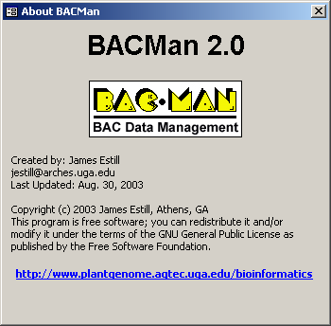

frmBacManMenu
Form: Main form for Physical Mapping Database that allows access to all of the major components of BACMan. This form is not linked to a data table.
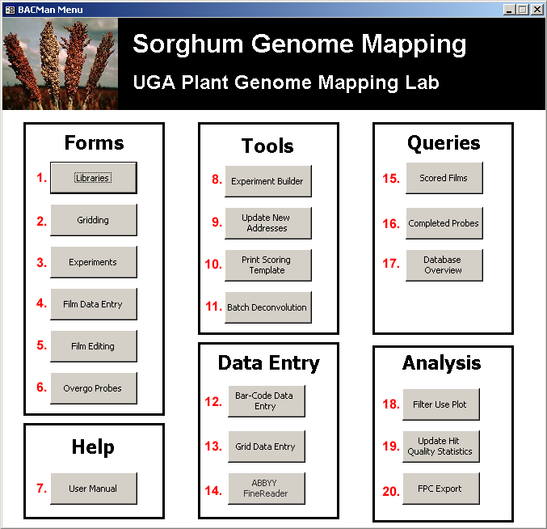

The major objects in frmBacManMenu are:
- butLibraries – Opens the form frmLibrary
- butGriddingForm – Opens the form frmGridMain
- butExperimentsForm –Opens the form frmExperiments
- butDataEntry – Opens the form frmProbeOvergo
- butFilmEditing – Opens the form frmFilmDataEntry
- butOvergoProbes – Opens the form frmProbeOvergo
- butHelp – The button opens the BACMan Online help to the startup page
- butOpenExperimentBuilder – Opens the form frmExperimentBuilder01. This form is the first dialog for the Experiment Builder function in BACMan.
- butUpdateNewAddresses – Runs the ‘Update Addresses’ Macro. This updates the information in the tblHitDataRaw table by entering the information for the film number and creating the ‘Full’ address by concatenating the value for Film, Field, Address, and Hit pattern.
- butPrintScoringTemplate – Opens the form frmPrintTemplate
- butMultiplexAnalysis – Opens the form frmBatchDeconvolution
- butOpenBarcodeDataEntry – Opens the form frmFilmDataEntry
- GridDataEntry – Opens the BACGrid macro in MS Word
- butOpenFineReader – Opens the ABBYY Fine Reader program using the path to FineReader and the FineReader template that the user defines in the Properties dialog.
- butScoredFilms – Opens the form frmQueryScoredRatio
- butCompletedProbes – Opens the form that gives you the overview of when probes were assayed for each of the libraries in the database frmQueryProbesAssayed
- butDatabaseOverview – Opens the form frmOverviewDatabase
- butFilterUsePlot –Opens the form frmFilterUsePlot that shows the use of filters over time
- butUpdateHitQuality – Runs the Visual Basic Function UpdateHitQualityStats in the Menu Commands module which runs the query qryHitQualityProportions and then the query qryHitQualityUpdate to update the information on hit quality for each of the films in an experiment
- butFPCExport – Opens the form frmFPCLargeExport

frmBatchDeconvolution
Dialog: Dialog used for batch deconvolution of multiplex hybridization experiments.
Record Source: tblListBatchDeconvolution

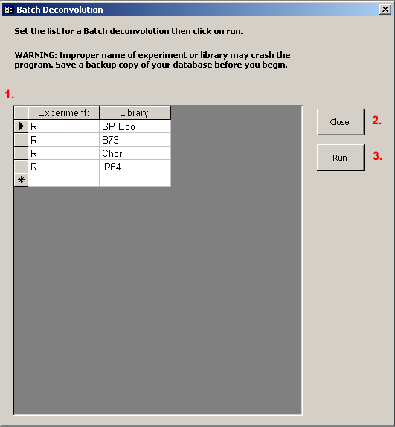
The major objects of frmBatchDeconvolution:
- frmBatchDeconvolutionSubform– This subform links to the form frmBatchDeconvolutionSubform. This lists the Experiments and Libraries that the user wants to deconvolute and append to the table tblHitDataFiltered.
- butClose – The close button will close the form.
- butRun – The run button will launch the deconvolution process by running the Visual Basic function ‘BatchDeconvolution’ in the ToolsDeconvolution module.

frmBatchDeconvolutionSubform
Subform: Subform of the frmBatchDeconvolution form. This subform provides the list of experiments and libraries that the user wants to deconvolute. The default view of this form is the datasheet view that is shown above nested in the form frmBatchDeconvolution.
Record Source: tblListBatchDeconvolution

frmBIDInput
Dialog: This user does not use this dialog manually, but the dialog is used as a data input device to fetch data from the barcode reader.

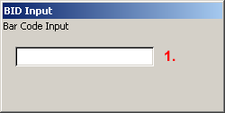

The single object of this dialog is:
- BarCodeInput – Textbox where the information in the barcode string is entered. This data is read by the BIDStep2 macro to find the correct record to open in the form frmFilmDataEntry.
frmDataEntrySubform
Subform: This subform is used for data entry of the films. This lists the field, address, and hit pattern for the hits on the film and is viewed from the form frmFilmDataEntry as shown below.
Record Source: tblHitDataRaw

frmDeconovlutedData
Form: Provides a preview of deconvoluted data.
Record Sources: The Deconvoluted Probe List is linked to the table tblDeconvolutedData and the Deconvoluted Probe Overview data is linked to the query qryDevonResultsOverview.

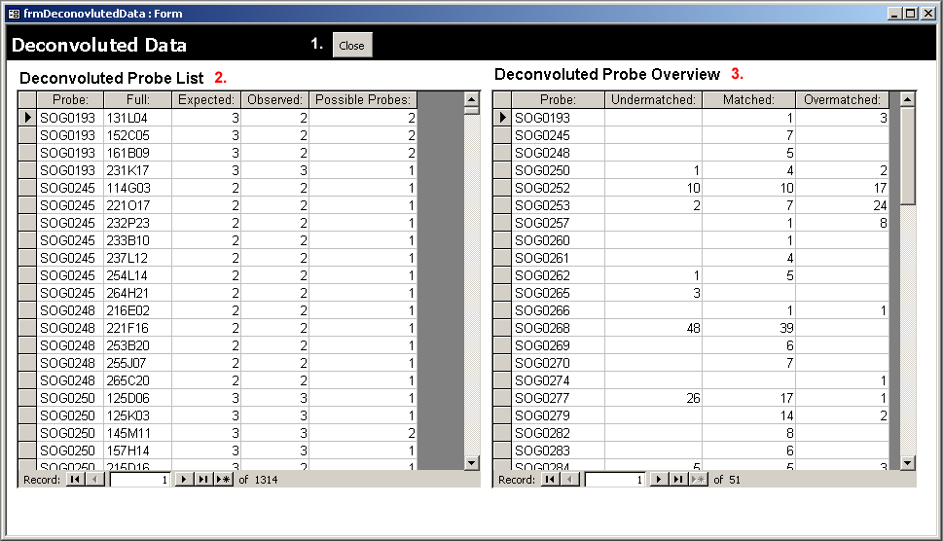

The major objects of frmDeconovlutedData are:
- butClose – This button will close the Deconvoluted Data form.
- frmDeconvolutedDataSubform – This subform links to the form frmDeconvolutedDataSubform. This displays the completed list of hits resulting from a deconvolution job for a single experiment and library. This views the form frmDeconvolutedDataSubform in the datasheet view.
- frmDeconvResultsOverviewSubform – This subform links to the form that displays and overview of the hit statistics for a deconvolution job for a single experiment and library. This is linked to the form that the object is name from which is the frmDeconvResultsOverviewSubform.

frmDeconvolutedDataSubform
Subform: Subform of the Deconvoluted Data form. This lists the complete lists of hits resulting from a deconvolution job for a single experiment and library. This object is shown in its subform context under the frmDeconovlutedData heading shown above.
Record Source: tblDeconvolutedData
frmDeconvolutionSetup
Dialog: Setup info for the deconvolution of a single probe in a single experiment. This subform allows the user to select a library and experiment for deconvolution.
Record Source: The dropdown menu for the library is derived from the table tblListLibrary

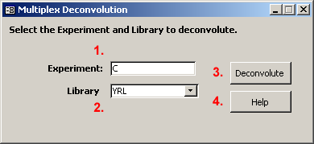

The objects of this dialog are:
- txtExperiment – Textbox to provide input for the experiment that the user wants to deconvolute
- comLibrary – Combo dialog that allows the user to enter the library that they want to deconvolute, this list is derived from the table tblListLibrary
- butDeconvolute – Button that launches the deconvolution process by running the Visual Basic function ‘DeconvolutionCounter’ in the ToolsDeconvolution module.
- butHelp – This opens the section of BACMan help that refers to this dialog.

frmDeconvolutionStatus
Dialog: This dialog allows the user to see the current status of the deconvolution routine. When the deconvolution is complete this also buttons that launch views of the deconvoluted results, append data to tblHitDataFiltered, and save data in the format needed for upload to an FPC database.

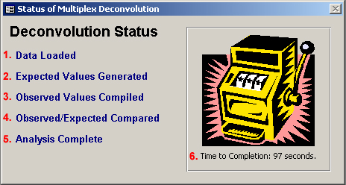

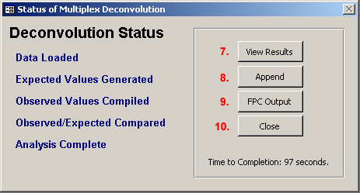

The major components of frmDeconvolutionStatus are:
- lblStep1 – This label will become visible when the data are loaded for the deconvolution.
- lblStep2 – This label will become visible when the expected values have been generated.
- lblStep3 – This label will become visible when the observed merge values have been compiled.
- lblStep4 – This label will become visible when the observed values have been compared to all of the expected values
- lblStep5 – This label will become visible when the deconvolution analysis is complete.
- lblStatus – This label updates the user to the current status of the multiplex deconvolution.
- butResults – This button will open a preview of the results of the deconvolution. This opens the form frmDeconovlutedData.
- butAppend – This button will append the results of the deconvolution to the table tblHitDataFiltered. This launches the Visual Basic Function AppendFilteredData .
- butFPCOutput – This button opens the dialog that allows the user to produce the output in the format suitable for upload to a FPC database. This launches the Visual Basic Function ExportToFPC.
- butClose – This button will close the form without any changes being made.

frmDeconvResultsOverviewSubform
Subform: This subform is viewed in the datasheet view as a linked subform under the heading Deconvoluted Probe Overview as shown above in the form frmDeconovlutedData.
Record Source: qryDevonResultsOverview

frmErrorCheckBatchPrint
Dialog: Provides user interface for batch printing error checking sheets
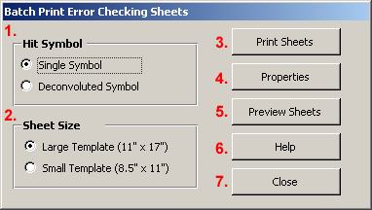

The objects of frmErrorCheckBatchPrint are:
- optSymbol – This option group allows the user to set the type of symbol that will be drawn on the error checking sheets. The ‘Single Symbol’ selection has an option value of 1 and the ‘Deconvoluted Symbol’ selection has an option value of 2.
- optSheetSize – This option group allows the user to select the size of the sheet that the error checking sheet will be drawn on. For the large (11 x 17 “) sheets to be printed, a printer must be available that can print to this size paper.
- butPrintSheets – This button will print the sheets.
- butProperties – This button allows the user to set the properties for the symbols that will be drawn on the error checking sheets. This is done by opening the form frmErrorCheckDraw where the user can set these properties.
- butPreviewSheets – This button is currently not functional. This will in the future allow the user to preview what one of the error checking sheets will look like
- butHelp – This button opens the BACMan help file to the appropriate page to receive help for this object.
- butClose – This button closes the form without any changes being made to the database.

frmErrorCheckDraw
Dialog: Sets the options for drawing error checking sheets. This form is open by default when BACMan starts up, but it is hidden. If this form is closed, BACMan will not be able to draw error checking sheets since it requires this form be available in order to fetch the drawing variables.
Record Source: The combo box that list the symbols to be drawn comes for the table tblListSymbolNames, and the combo box that lists the color names for the Line Color and Fill Color combo boxes come from the table tblListColorNames.

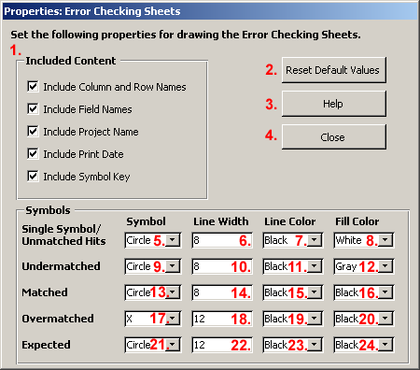

The major objects of this form are:
- Included Contents Options Group – These checkboxes allow the user to modify the appearance of the error checking forms that are printed. For illustrations of the content that is being referred to see Figure 10-96.
- butResetDefaults – This button resets all values to their default settings.
- butHelp – This will open BACMan HTML Help to the file referring to this dialog.
- butClose – This button will hide the form and keep all changes made to the variables. Note that this hides but does not actually close the form since the form must be open for the variables to be available to the function that draws the error checking templates.
- comUnmatchedSymbol – This combo box allows the user to select the symbol that will be drawn for hits that are unmatched
- txtUnmatchedWidth – This textbox allows the user to set the line width for the drawing of the symbol that is drawn for hits that are unmatched
- comUnmatchedLineColor – This combo box allows the user to set the color of the line that will be used for drawing hits that are unmatched
- comUnmatchedFillColor – This combo box allows the user to set the fill color for circles drawn for hits that are unmatched
- comUndermatchedSymbol – This combo box allows the user to select the symbol that will be drawn for hits that are undermatched
- txtUndermatchedWidth – This textbox allows the user to set the line width for the drawing of hits that are undermatched
- comUndermatchedLineColor – This combo box allows the user to set the color of the line that will be used for drawing the symbol that is drawn for hits that are undermatched
- comUndermatchedFillColor – This combo box allows the user to set the fill color for circle symbols for hits that are undermatched
- comMatchedSymbol – This combo box allows the user to select the symbol that will be drawn for hits that are matched
- txtMatchedWidth – This textbox allows the user to set the line width for the drawing of the symbol that is drawn for hits that are matched
- comMatchedLineColor – This combo box allows the user to set the color of the line that will be used for drawing the symbol that is drawn for hits that are matched
- comMatchedFillColor – This combo box allows the user to set the fill color for circle symbols for hits that are matched
- comOvermatchedSymbol – This combo box allows the user to select the symbol that will be drawn for hits that are overmatched
- txtOvermatchedWidth – This textbox allows the user to set the line width for the drawing of hits that are overmatched
- comOvermatchedLineColor – This combo box allows the user to set the color of the line that will be used for drawing the symbol that is drawn for hits that are overmatched
- comOvermatchedFillColor – This combo box allows the user to set the fill color for circle symbols for hits that are overmatched
- comExpectedSymbol – This combo box allows the user to select the symbol that will be drawn for hits that are expected
- txtExpectedWidth – This textbox allows the user to set the line width for the drawing of the symbol that is drawn for hits that are expected
- comExpectedLineColor – This combo box allows the user to set the color of the line that will be used for drawing hits that are expected
- comExpectedFillColor – This combo box allows the user to set the fill color for circle symbols for hits that are expected

frmExperimentBuilder01
Dialog: Experiment Builder Step 1.
Record Source: The data for listing multiplex type comes from tblListHybType, and the data for the selected libraries is derived from tblListLibrary.

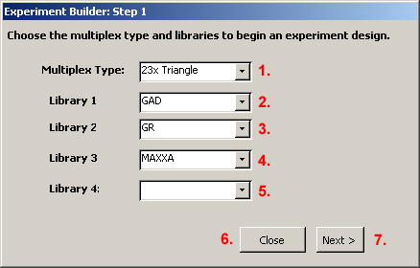

The objects of the form are:
- combMultiplexType – The type of multiplex experiment that is being designed. This is needed to allow the software to look up the structure that will be used to design the placement of the probes. The source table for the list is tblListHybType.
- combLibrary01 – The first library that will be used in the multiplex experiment. The source table for the list is tblListLibrary.
- combLibrary02 – The second library that will be used in the multiplex experiment. .The source table for the list is tblListLibrary.
- combLibrary03 – The third library that will be used in the multiplex experiment. .The source table for the list is tblListLibrary.
- combLibrary04 – The fourth library that will be used in the multiplex experiment. .The source table for the list is tblListLibrary.
- butClose – This button closes the form.
- butNext – This button proceeds to the next step in the experiment design process. This button opens the form frmExperimentBuilder02.

frmExperimentBuilder02
Dialog: Experiment Builder Step 2.
Record Source: The data source for the subform is tblExperimentBuilder01

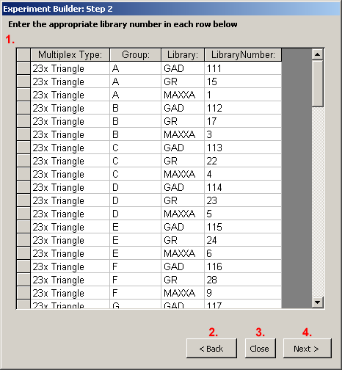

The main objects of this form are:
- frmExperimentBuilder02Subform – This subform objects displays the datasheet view of the form frmExperimentBuilder02Subform.
- butBack – Button steps back in the process of building a multiplex experiment. This button closes the current form and opens the form frmExperimentBuilder01.
- butClose – This button closes the currently open form frmExperimentBuilder02 and ends the experiment builder process.
- butNext – This button navigates to the next step in the process of building a multiplex experiment. This is done by closing the currently open form and opening the form frmExperimentBuilder03.

frmExperimentBuilder02Subform
Dialog Subform: This form is used as a subform in the form frmExperimentBuilder02. The contents of this are thus illustrated above under frmExperimentBuilder02. The objects of this form are links to the records (1) Multiplex Type, (2) Group, (3) Library, and (4) Library Number in the table tblExperiments.
Record Source: tblExperimentBuilder01
frmExperimentBuilder03
Dialog: Experiment Builder Step 3.
Data Source: The data source for the subform is tblExperimentBuilder03B

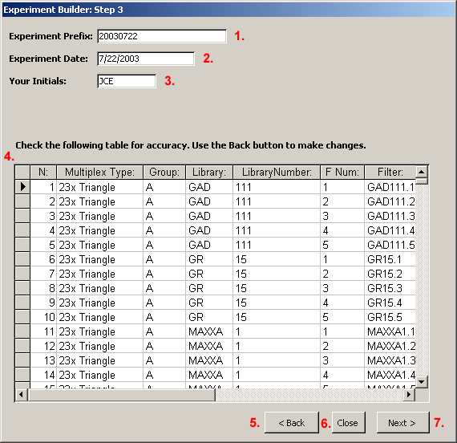

The objects of this form are:
- txtPrefix – This textbox allows the user to set the prefix name for the experiment. This will be the experiment name used for the experiment, and it will be the prefix that is used for the BIDs of all films that are generated for the experiment.
- txtDate – This textbox allows the user to set the date that the experiment is started on.
- txtPerson – This is the initials of the person that is in charge of the experiment.
- frmExperimentBuilder03Subform – This subform links to form frmExperimentBuilder03Subform.
- butBack – This button allows the user to step back one step in the experiment. This is done by closing the current form and opening the form frmExperimentBuilder02.
- butClose – This button closes the current form. This essentially abandons the experiment builder.
- butNext – This button proceeds to the next step in the building of a multiplex experiment. This is done by closing the current form and opening the form frmExperimentBuilder04.

frmExperimentBuilder03Subform
Dialog Subform: The subform is viewed in the Experiment Builder Step 3 dialog.
Record Source: tblExperimentBuilder02B

frmExperimentBuilder04
Dialog: Experiment Builder Step 4.
Data Source: The data source for the subform is the query qryExperimentBuilder03

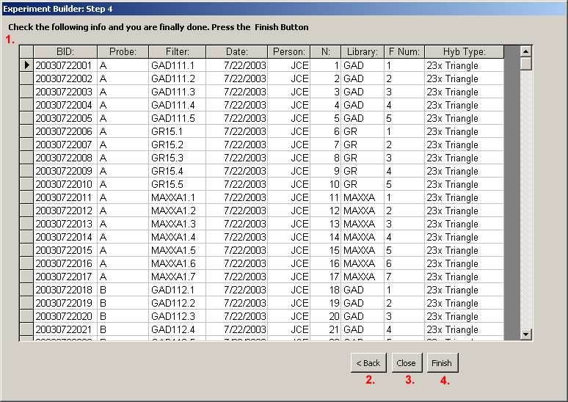

The objects of frmExperimentBuilder04 are:
- frmExperimentBuilder04Subform – This subform object displays the form frmExperimentBuilder04Subform
- butBack – This button goes back to the previous form frmExperimentBuilder03
- butClose – This button closes the form
- butFinish – This button closes the form.

frmExperimentBuilder04Subform
Dialog Subform: viewed as a subform in the ‘Experiment Builder Step 4’ dialog as shown above under frmExperimentBuilder04..
Record Source: qryExperimentBuilder03

frmExperiments
Form: Overview of the information for each experiment.
Data Source: tblExperiments

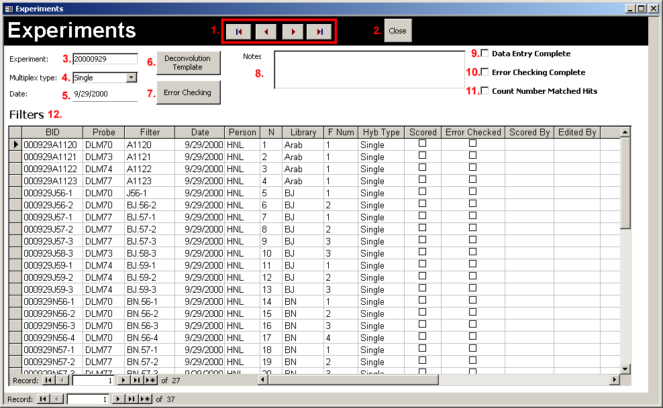

The objects of this form are:
- Navigation buttons – These buttons allow for navigation through the experiments. These allow for navigation to the First, Previous, Next, and Last records.
- butClose – This button closes the experiments form.
- Experiment – This textbox displays the experiment name (tblExperiments.Experiment).
- Multiplex type – This combo box displays the type of experiment. The data source is tblExperiments. Multiplex type. The table source for the list of experiment types is tblListHybType.
- Date – This textbox displays the date on which the hybridization experiment was started (tblExperiments.Date).
- butDeconvTemplate – This button opens the Deconvolution Template form.
- butOpenErrorChecking – This button opens the form frmExperimentsEC.
- Notes – This textbox displays notes for this experiment (tblExperiments.Notes).
- Data Entry Complete – This field is checked when the data entry is complete for the experiment (tblExperiments.[Data Entry Complete]).
- Error Checking Complete – This checkbox (tblExperiments.[Error Checking Complete]).
- Deconvoluted – This checkbox (tblExperiments.Deconvoluted).
- Hyb Data subform – This subform links to frmExperimentsFilmSubform.

frmExperimentsEC
Form: Browser to view status of error checking.
Data Source: The main form data is linked to tblExperiments while the subform displays data from tblHybData

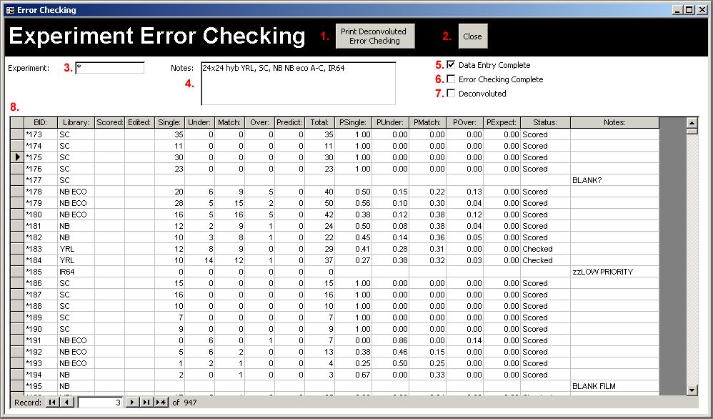

The objects of this form are:
- butPrintDeconvoluted – This button will print Error Checking Sheets for the films in the subform that are flagged ‘Need to Print’ in the Status field.
- butClose – This button closes the form.
- Experiment – This textbox links shows the name of the experiment (tblExperiments.Experiment).
- Notes – This textbox displays notes for this experiment (tblExperiments.Notes
- Data Entry Complete – This checkbox is checked yes when data entry is complete for the experiment (tblExperiments.[Data Entry Complete]).
- Error Checking Complete – This checkbox is checked yes when error checking is complete for the experiment (tblExperiments.[Error Checking Complete]).
- Deconvoluted – This checkbox is checked yes when the experiment has been deconvoluted and appended to tblHitDataDeconvoluted (tblExperiments.Deconvoluted).
- frmExperimentsECSubformObject – This subform object displays a datasheet view of the form frmExperimentsECSubformObject.

frmExperimentsECSubform
Subform: Subform of the error checking form which provides an overview of error checking information for each film in the experiment. The display of this subform is shown above under the form frmExperimentsECSubform.
Data Source: tblHybData

frmExperimentsFilmSubform
Subform: Used in the ‘Experiments’ form to show all films for an individual experiment. The display of this data is shown above under the form frmExperiments.
Data Source: tblHybData

frmExportTextFiles
Dialog: This dialog is used to select the text files to generate for export to a MySQL database.
Data Source: There is no data source associated with this dialog.

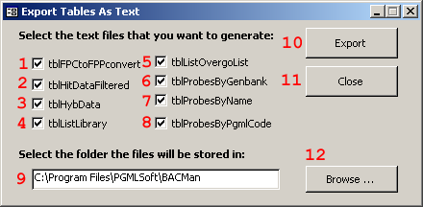

The objects of this form are:
- chkFPCtoFPPConvert – This is checked yes to export the table which can convert data between the FPC and FPP format. This allows people online to see the status of the placement of BACs into FPC contigs.
- chkHitDataFiltered – When checked yes, the export function will export data from the table tblHitDataFiltered to the text file tblHitDataFiltered.txt.
- chkHybData – When checked yes, the export function will export data from the table tblHybData to the text file tblHybData.txt.
- chkListLibrary – When checked yes, the export function will export data from the table tblListLibrary to the text file tblListLibrary.txt.
- chkListOvergoList – When checked yes, the export function will export the probe data for overgos that yielded hits, and will create the text file tblListOvergoList.txt.
- chkProbesByGenbank – When checked yes, the export function will export the probe data for probes that yielded hits and that have Genbank data associated with them. This will create the text file tblProbesByGenbank.txt.
- chkProbesByName – When checked yes, the export function will export the probe data for probes that yielded hits and will sort the table by the Names of the probes. This will create the text file tblProbesByName.txt.
- chkProbesByPgmlCode – When checked yes, the export function will export the probe data for probes that yielded hits and will list the probe by their PGML code. This will create the text file tblProbesByPgmlCode.txt.
- txtFolderPath – The path of the folder that the exported text files will be saved in.
- butExport – The export button fetches the variables from the form and launches the function ExportDataTables.
- butClose – Closes the form.
- butBrowse – This will launch a dialog that will set the text that is displayed in txtFolderPath and thus allows the user to interactively select the folder for export of the text files

frmFilmDataEditing
Form: Shows all information for individual films to allow for data entry. The barcode scanner will open this form when it is programmed for data editing.
Data Source: The data source for the main form is tblHybData, and the subform shows data from the table tblHitDataRaw

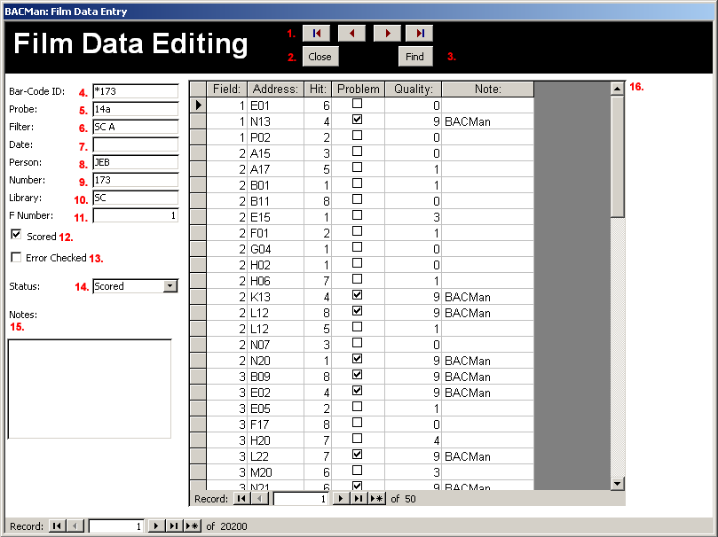

The major objects of this form are:
- Navigation Buttons – These buttons allow for navigation to the first, previous, next and last records in the table tblHybData.
- Close BC Data Entry Form – This button closes the form
- BC Find Record – Find records in the database
- BID – The barcode ID of the film. This is the field that links the main form displaying data from tblHybData to the subform displaying data from tblHitDataRaw
- Probe – The probe or probe mix that was used for the film
- Filter – The filter that was used for the experiment
- Date – The date that the experiment was started on
- Person – The person that was in charge of the hyb
- N – The film number within the experiment. For example if a total of 240 films are used in a single multiplex experiment then N for that experiment will range from 1 to 240.
- Library – The library this is gridded for this film. This should be a valid value from tblListLibrary.
- F Num – Textbox that represents the film number within the library. For example if a library requires 5 filters to grid then entire library then this value will range from 1 to 5.
- Scored – This checkbox is checked yes when the film has been scored
- Error Checked – This checkbox is checked yes when the film has been error checked
- EC Status – The status of error checking. This pull down menu lists the data in the table tblListErrorCheckStatus
- Notes – Any notes associated with the film
- Data Entry Subform – This subform links to the form frmFilmDataEditingSubform

frmFilmDataEditingSubform
Subform: Subform for Film data editing form that shows the data for each hit occurring on a film. The display for this form is shown under the form frmFilmDataEditing above.
Data Source: tblHitDataRaw

frmFilmDataEntry
Form: This data entry form shows all information for individual films to allow for data entry. The barcode scanner will open this form when it is programmed for data entry.
Data Source: The data source for the main form is tblHybData while the data source for the subform is tblHitDataRaw

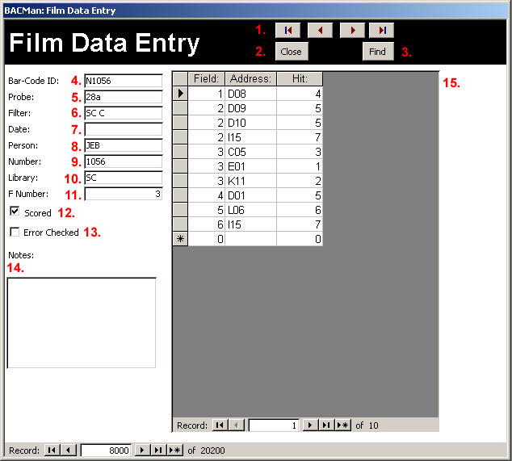

The major objects of this form are:
- Navigation Buttons – These provide the ability to navigate through the records.
- butClose – Closes the form
- butFind – Finds film records for film data entry
- BID – The barcode ID of the film/filter record
- Probe – The probe or probe mix that was used for the film
- Filter – The filter that was used
- Date – The date that the experiment was started on
- Person – The person that was in charge of the hybridization
- N – The number of filter/film in the database. For example if a total of 240 films are used in a single multiplex experiment then N for that experiment will range from 1 to 240.
- Library – The library this is gridded for this film. This should be a valid value from tblListLibrary
- F Num – Textbox that represents the film number within the library. For example if a library requires 5 filters to grid then entire library then this value will range from 1 to 5
- Scored – This checkbox is checked yes when the film has been scored
- Error Checked – this checkbox is checked yes when the film has been error checked
- Notes – The notes for the filter
- Data Entry Subform – The subform from frmDataEntrySubform

frmFilterUsePlot
Form: This form plots the number of hits for individual filters over their usage history.
Data Source: The data source for the Library pull-down menu is the table tblListLibrary. The data for the plot is derived from the query qrySelectForHitPlot and takes advantage of Microsoft Graph 2000 Chart OLE class available with MS Access 2000 and later.

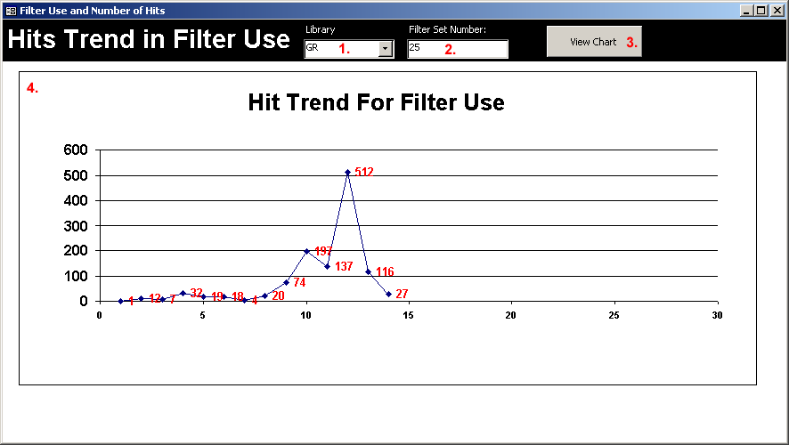

The major objects of this form are:
- comLibrary – This combo box allows the user to select the library that they want to draw a filter use plot for. This list shows data from the table tblListLibrary.
- txtFilterSet – This textbox allows the user to select the filter set that they wish to draw a plot for.
- butViewChart – Runs the Visual Basic Program butViewChart_Click that draws the chart for the select library and filter set.
- frmFilterUsePlotSubform – This subform is linked to the form frmFilterUsePlotSubform showing a visualization of the data from qrySelectForHitPlot

frmFilterUsePlotSubform
Subform: Contains the actual plot that is viewable from frmFilterUsePlot. The view of this subform is shown above for the form frmFilterUsePlot
Data Source: The plot is drawn from data that are derived from the query qrySelectForHitPlot.

frmFPCExport
Dialog: Provides a dialog to set the file name and folder for files exported from BACMan to FPC.
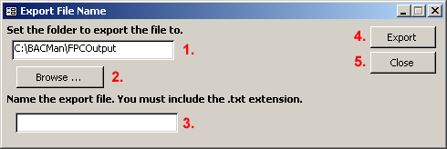

Major objects of this dialog are:
- txtFolder – This textbox provides a place to input the path of the folder
- butBrowseFolder – Opens the folder browser control. The resulting path is written to the txtFolder textbox. This is currently a custom dialog but will later be changed to a native windows interface through an API call.
- txtFPCExportName – The name of the file that will be saved
- butExport – Runs the Visual Basic function ExportToFPCTxt which transforms the data to the proper format needed for export to FPC
- butClose – This button closes the form

frmFPCLargeExport
Dialog: Provides a dialog to set the parameters for an export from BACMan to the FPC format.
Data Source: The data source for library combo box is tblListLibrary and the data source for the Experiment combo box is tblExperiments.

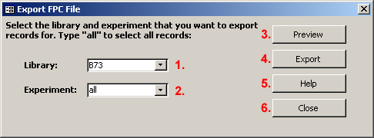

Major objects of this dialog:
- comLibrary – The library that the user wants to export data for. This list is derived from the table tblListLibrary.
- comExperiment – The experiment that the user wants to export data for. This list is derived from the table tblExperiments.
- butPreview – This button runs the Visual Basic Function FPCLargeExportFilter which is under the FPCInteroperability module and then opens the form frmFPCPreview.
- butExport – This button runs the Visual Basic Function FPCLargeExportFilter and then opens the form frmFPCExport where the user can set the file name and folder.
- butHelp – The help button will open the HTML help file to the appropriate page for this dialog.
- butClose – This button closes the form

frmFPCPreview
Form: Provides a preview of data that will be exported to FPC. This form is opened by clicking on the preview button in the dialog frmFPCLargeExport.
Data Source: The data source for the subform is tblTempFPCExport02

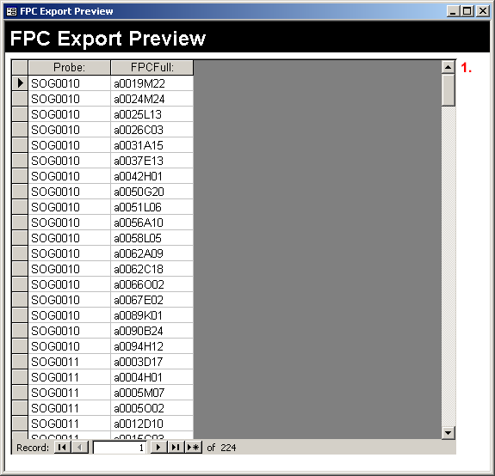

The single object in this form is:
- frmFPCPreviewSubform – A subform that is linked to frmFPCPreviewSubform this subform displays data from the table tblTempFPCExport02.

frmFPCPreviewSubform
Subform: Provides a preview of data that will be saved as a text file suitable for upload to FPC. The view of this form is shown above under the form frmFPCPreview.
Record Source: tblTempFPCExport02

frmGridFilters
Subform: This subform is displayed under the filters tab of the form frmGridMain.
Data Source: tblGridFilters.

frmGridMain
Form: Form that provides an overview of the information on grid jobs.
Record Source: The main record source for the form is the table tblGridMain while the subforms list data from the table tblGridFilters.

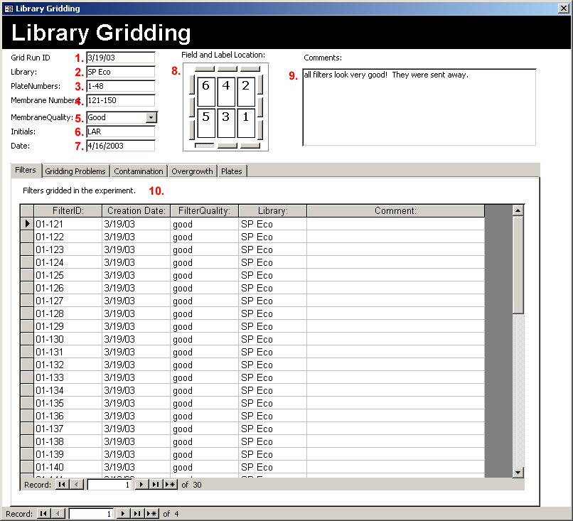

The major objects of this form are:
- GID- The Grid Job ID
- Library – The library that the grid job is gridding. Valid values are those listed in the table tblListLibrary
- PlateNumbers – The range of plate numbers that were used in the grid job
- Membrane Numbers – The range of membrane numbers that were assigned to the grid job
- MembraneQuality – The general quality of the membranes resulting from the grid job
- Initials – The initials of the person in charge of the grid job
- Date – The date that the gridding started
- Field and label Location – This actually refers to two separate sets of objects. The label location on the membrane as selected with the push button and the location of the fields as displayed in the numbers typed in the interior of the textboxes.
- Comments – Any general notes or comments associated with the gridding job
- tabGridData – This list of tabs provides links to a number of subforms that displays data for the individual filters derived from the gridding job.

frmGridSubformContamination
Subform: Available as a subform selected by a tab on the frmGridMain form. This subform contains information on field contamination on a grid.
Record Source: tblGridFilters

frmGridSubformOvergrowth
Subform: Available as a tab on frmGridMain and displayed in datasheet view. This subform contains information about overgrowth in fields.
Record Source: tblGridFilters

frmGridSubformProblems
Subform: Available as subform tab on the form frmGridMain. This subform contains information about gridding problems.
Record Source: tblGridFilters

frmOverviewDatabase
Form: Provides overview statistics for the database.

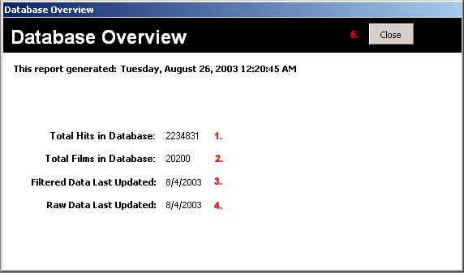

The objects of this form are:
- subfrmTotalHitsInDatabase – Subform that links to the form indicating the total number of hits in the database (frmOverviewDatabaseTtlHitsSub)
- subfrmTotalFilmsInDatabase – Subform that links to the form indicating the total films in the database (frmOverviewDatabaseTtlFilmsSub)
- txtDateLastUpdated – This is the date the that tblHitDataFiltered table was last updated. This data if fetched using a query that is embedded in the text box itself.
- txtRawLastUpdated – This is the date that the tblHitDataRaw table was last updated. This data if fetched using a query that is embedded in the text box itself.
- butClose – This button closes the form

frmOverviewDatabaseTtlFilmsSub
Subform: This subform shows the total hits that are in the database and is viewed in the Database Overview form frmOverviewDatabase shown above.
Data Source: qryCountTotalFilms

frmOverviewDatabaseTtlHitsSub
Subform: This subform shows the total number of hits that are in the database. This data is viewed in the Database Overview form frmOverviewDatabase shown above.
Data Source: The qryCountTotalDeconvolutedHits which runs a query on the data in the table tblHitDataRaw.

frmPrintTemplate
Dialog: Used to print scoring templates. This dialog allows for the selection of the size of the scoring template as well as the objects that are included. The placement of these objects on a scoring template is shown in Figure 7-37.

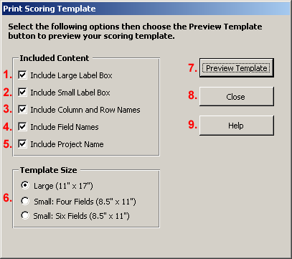

The major objects of this form are:
- chkIncludeLargeLabel – If this checkbox is checked yes the large box for placing 1”x 2 5/8” paper labels will be included on the scoring template.
- chkIncludeSmallLabel – If this checkbox is checked yes, the smaller box for handwriting the film name will be printed on the scoring template.
- chkIncludeColRowLabels – If this checkbox is checked yes, the row and column numbers of the plates will be included in the scoring template.
- chkIncludeFieldLabels – If this checkbox is checked yes, the field names for the six gridding fields will be included in the scoring template.
- chkIncludeProjectName – If this checkbox is checked yes the project name will be printed on the scoring template.
- optGrpTemplateSize – This option group allows the user to select the size of the scoring template that will be drawn.
- butPreviewTemplate – This button will open the appropriate report that displays the scoring template. The report that will be opened is selected based on the information that is provided in the Template Size option group (optGrpTemplateSize), and the elements that are included is based on the information provided under the ‘Included Content’ group.
- butCloseForm – This button closes the currently open form.
- butHelp – This button will open the BACMan help file to the help file for this dialog.

frmProbeGenomicClones
Form: This form allows the view of the genomic probe data table
Data Source: The data source for the subform is the query qryProbeGenClone which ties together data from the tables tblProbe and tblProbeGenomicCloneData

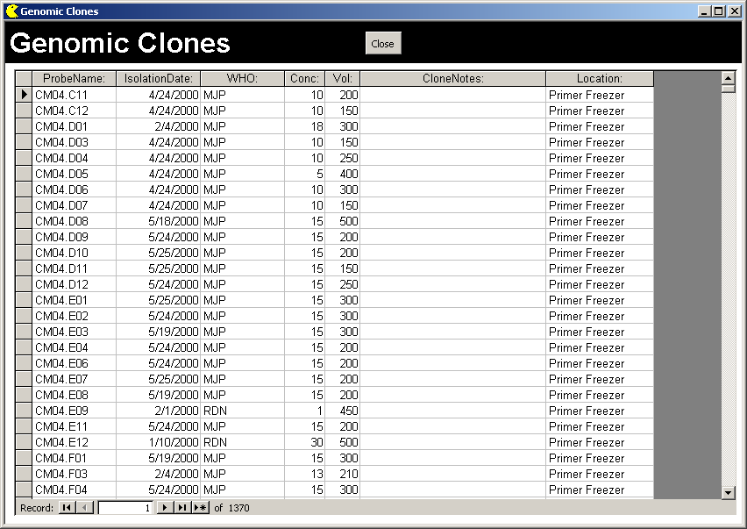

The major objects of this form are:
- butClose – Button closes the form.
- subGenomicClonesData – Subform that displays a datasheet view of the subform fpmProbeGenomicClonesSubform

frmProbeGenomicClonesSubform
Subform: Provides a datasheet view of the data for a single date of the miniprep preparations.
Data Source: The data source for the subform is the query qryProbeGenClone which ties together data from the table tblProbe and the table tblProbeGenomicCloneData

frmProbeOvergo
Form: Provides a template to show the data for overgo probes
Data Source: The data source for the subform is the query qryProbeOvergo which ties together data from the table tblProbeOvergoData and the table tblProbe

The major objects of this form are:
- butClose – Button closes the form.
- OvergoListSubfrom – Subform that displays the frmProbeOvergoSubform

frmProbeOvergoSubform
Subform: The subform is displayed in a datasheet view on the form frmProbeOvergo as shown above
Data Source: The query qryProbeOvergo which ties together data from the table tblProbeOvergoData and the table tblProbe

frmProbesUsed
Form: This is the deconvolution template for how the probes were used in pooled probe hybridizations.
Data Source: This subform displays the data from the table tblProbeUse.

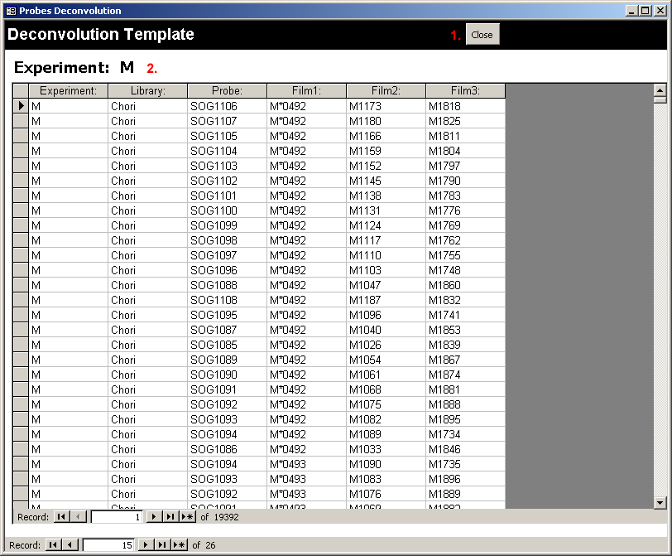

The two major objects of this form are:
- butClose – Button to close the form
- frmProbesUsedSubform – Link to the subform frmProbesUsedSubform

frmProbesUsedSubform
Subform: This is the subform for frmProbesUsed that actually shows the data list. The display of this subform is shown above under frmProbesUsedSubform.
Record Source: tblProbeUse

frmProperties
Dialog: This dialog should never be opened without first warning the user. It provides the user an interface from which the main lists and variables for the entire database can be changed.
Data Source: The data sources for the subforms shown from the tabs are derived from a number of different subforms as listed below.

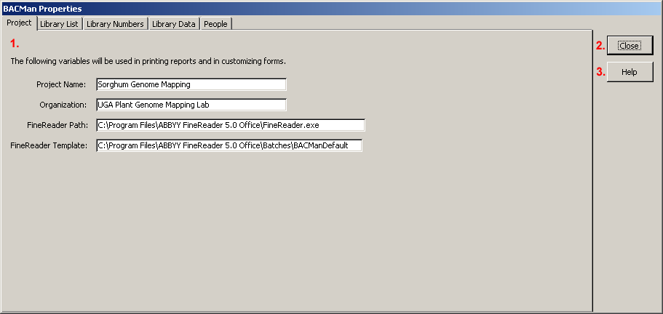

The major objects of this form are:
- TabCtl1 – This tab object connects to a separate subform for each of the tabs listed. These are all listed below with the frmProperites prefix.
- butClose – Closes the form
- butHelp – Opens the appropriate section of the help file for help with this dialog

frmPropertiesExpBuilderSubform
Subform: Displays the library suffix that is used in building experiments. This is displayed by clicking on the ‘Library Numbers. Tab under the form frmProperties.
Record Source: tblExperimentBuilderLibraryTemplate

frmPropertiesLibraryDataSub
Subform: This subform allows the user to modify information for each library. This subform is a available under the ‘Library Data’ tab under the form frmProperties.
Record Source: tblListLibrary

frmPropertiesLibraryListSubform
Subform: List of genomic libraries used in the physical mapping project. This is available to be modified from the properties form frmProperties. This form allows users to modify BACMan to fit their own library list.
Record Source: tblListLibrary

frmPropertiesPeopleNamesSubform
Subform: List the names of people involved in the physical mapping project. This subform is available from the ‘People’ tab on the form frmProperties. The purpose of this form is to help keep track of people that are involved in a large scale project.
Record Source: tblListPeopleNames

frmPropertiesVariablesSubform
Subform: These are the general properties for the database that can be set from the properties form. This is the first tab that is shown when the form frmProperties is opened.
Data Source: tblVariables

frmUploadHitDataRaw
From: This form allows for an interface to upload data to the table tblHitDataRaw. This allows for editing the tblHitData raw table without having to open the entire table at once.
Data Source: Displays the subform frmUploadHitDataRawSubform which displays data from tblTempHitDataRawUpload
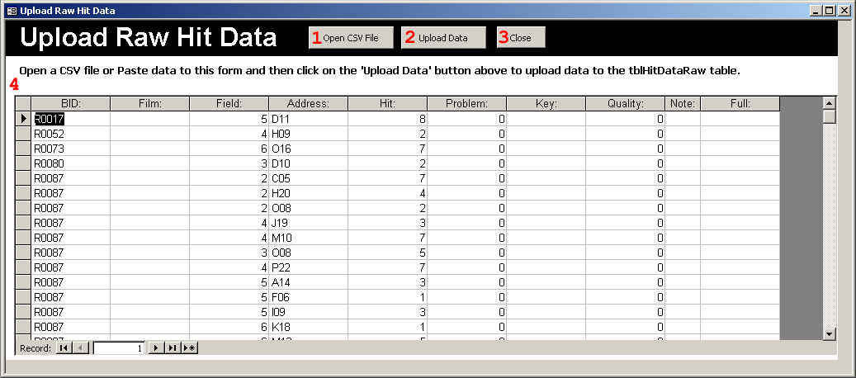
The major objects of this form are:
- butClose – Closes the form
- butUploadData – This will upload that data shown to the table tblHitDataRaw
- butClose – This will close the form frmUploadHitDataRaw
- frmUploadHitDataRawSubform – This subform links the form frmUploadHitDataRawSubform and
frmQueryProbesAssayed
Form: This form allows for a view of probes that have been assayed.
Data Source: The data source for the subform is the query ‘Query: When Probes were assayed’

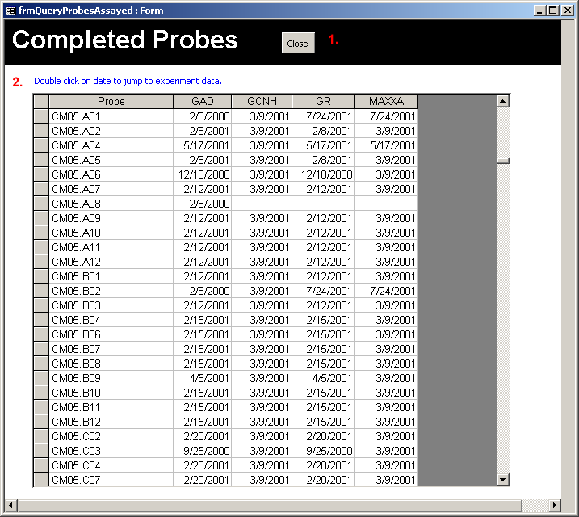

The major objects of this form are:
- butClose – Closes the form
- frmQueryProbesAssayedSubform – This links to the subform frmQueryProbesAssayedSubform.

frmQueryProbesAssayedSubform
Subform: Displays the information for the "When Probes Were Assayed" query view.
Data Source: The query ‘Query: When Probes were assayed’

frmQueryRatioScoredByExperiment
Subform: This subform shows the number of films scored by each experiment and is displayed in the form frmQueryScoredRatio.
Data Source: The query ‘Query: Ratio Scored by Experiment’

frmQueryScoredRatio
Form: Allows for an overview of the number of films scored along with the hit information for all experiments.
Data Source: The data source for the subform is the query ‘Query: Ratio Scored by Experiment’

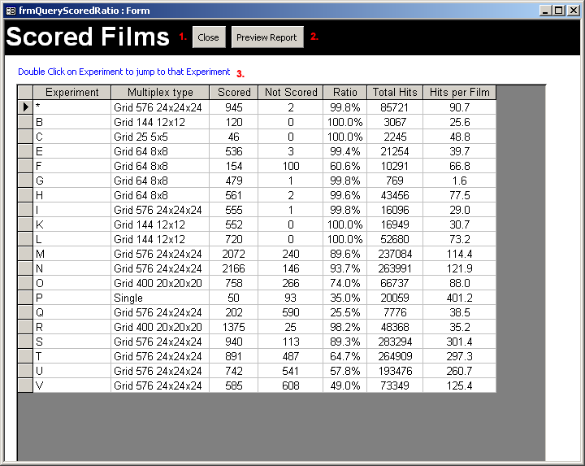

The major objects of this form are:
- butClose – Closes the form
- butPreview – Opens the report ‘Report Query: Ratio Scored by Experiment’ in preview format. This shows a printable version of the results of this query.
- ScoredFilmsSubform – This subform links to the form frmQueryRatioScoredByExperiment

frmTemplate
Template: This form is not used directly in BACMan, but it is used in development of new forms as a template when generating new forms. This is left in the distributed copy of BACMan to make it easier for developers to add additional components to BACMan that will have the same design style as the existing BACMan forms.

BACMan Tables
All of the data tables used in BACMan are listed and described below. All table names are prefixed with ‘tbl’ to designate table objects from other objects used in the BACMan database. Tables that are used as list box elements are named with the ‘tblList’ prefix. Temporary tables that are used in the functioning of BACMan have the ‘tblTemp’ prefix. Unfortunately these temporary tables are responsible for the bloat in database size that occurs in Access databases over time. Therefore, future versions of BACMan will create these tables in temporary external Access databases.

The field information is listed for selected tables. Field name, data type, and size are indicated in the first three columns. The description column contains a short description of the field content as well as information on external dependencies. Fields that represent the primary field for the table are designated with an asterisk and boldface type in the name column.

WARNING: Renaming any of the tables or changing existing field properties will have adverse effects on the functioning of BACMan.

tblAddress2BAC
This table converts the full hit pattern as recorded in BACMan to the BAC plate and well address that it refers to. This table can also be used to convert the BAC plate data and to the format necessary for upload to an FPC database. The user interface for this table is the form frmGriddingFormat.
Name | Type | Size | Description
Format | Text | 50 | The format used in gridding the library. Since multiple formats will be listed in this table, including this field will allow for the software to determine which of the possible formats to use in the translation. (ie. Wing or UGA)
Film | Text | 50 | The film number of the library set. For example, in a library that is gridded on seven filters this number will be a value ranging from one to seven.
Field | Text | 50 | The field number of the hit. This value will range from one to six.
Hit | Text | 50 | The hit pattern of the positive hit. For libraries that have been gridded with a 4x4 pattern this value will range from one to eight.
FFP | Text | 50 | The concatenation of the Film, Field, and Hit Patten fields. This provides a single string for matching the FFP to the BAC Plate address and the FPC reference. Providing this value as a single string speeds up queries by preventing the time it would take to calculate the concatenation of these fields.
BacPlate | Text | 50 | The BAC Plate that the FFP value represents.
FPCPlate | Text | 50 | The FPC Prefix for this plate. This will be used to translate data in the FPC format.
*Key | Long Integer | 4 | An autonumber field generated to give key values for this table.

tblExpectedMerge
This the expected merge table that is generated by the deconvolution algorithm. Although this table does not have the tblTemp prefix it is a temporary table. There is not a primary key for this table.

Name | Type | Size | Description
Probe | Text | 255 | The probe that matches the intersections described in the merge value.
Expected | Byte | 1 | The number of matches expected. For example, if this is a three dimension multiplex then there are three expected matches.
MergeValue | Text | 255 | The expected merge value of the intersections of films in a multiplex experiment. For example the value ‘R0007R0682R1242’ indicates that the expectation is that this probe will have hits on the films ‘R0007’, ‘R0682’ and ‘R1242’. This field provides an expected merge value that can be compared to the observed merge value in the deconvolution process. In order to take into account the fact that not all of the expected hits will be observed, the table will also include the possible combinations of the subsets of the expected number. For example ‘R0007R0682’ will be listed as a merge value with the reported outlier of ‘R1242’. An observed combination of ‘R0007R0682’ will be reported as an undermatched hit with the expected value of R0682.
Outlier | Text | 255 | This is the outlier from a set of expected merge values when not all of the expected hits are observed. For example, if ‘R0007R0682’ were found in the observed merged hits list, then ‘R1242’ is the outlier value. These outlier values are used to generate the list of ‘Expected’ hits in the deconvolution process.

tblExperimentBuilderLibraryTemplate
Table used by the experiment builder function that provides info on libraries. This table also is available from the BACMan Properties dialog

Name | Type | Size | Description
LibraryName | Text | 50 | The name of the BAC library. This value should match a library listed in tblListLibrary.Library.
LibSuffix | Text | 50 | The ‘filter number’ list for the library. For example, if the full site of filters for the YRL library is gridded on five filters the values could be A,B,C,D, & E for this library. This field can contain any string of alphanumerical values. However, the values that are produced for film labels are numbers.

tblExperiments
This table holds data for the hybridization experiments.
Name | Type | Size | Description
*Experiment | Text | 50 | The string identifying the experiment. This is equal to the prefix on the BID of films produced in this experiment.
Key Experiment | Long Integer | 4 | Key number for access. This can be set to be the primary key is so desired to allow for experiments with the same name.
Date | Date/Time | 8 | Date that the experiment was started on.
Multiplex type | Text | 50 | The design of the multiplex experiment. Valid values are those that are listed in the HybType field of the table tblListHybType.
Notes | Memo | - | Notes on the experiment.
Data Entry Complete | Yes/No | 1 | This field is checked yes when the data is complete for the experiment.
Error Checking Complete | Yes/No | 1 | This field is checked yes when the error checking is complete for the experiment.
Deconvoluted | Yes/No | 1 | This field is checked yes when the data entry is complete for the experiment

tblFilterBuild01
I think that this a temporary table generated in the deconvolution process but I’m not sure...
Name | Type | Size | Description
Probe | Text | 255 | The name of the probe.
Full | Text | 255 | The full address of the hit.
Quality | Long Integer | 4
Possible Probes | Long Integer | 4
Library | Text | 255
Experiment | Text | 255

tblFPCExport01
This is a table generated in the process of exporting data to FPC. This may be a temporary table. I think that this table has been replaced by tblTempFPCExport01
Name | Type | Size | Description
Library | Text | 50
Probe | Text | 50
FFP | Text | 255
Address | Text | 255
FPCPrefix | Binary | 510
Format | Binary | 510

tblFPCInput
This is temporary table used to process input of data from FPC. I think that this table was made by John

Name | Type | Size | Description
Contig | Text | 255
Library | Text | 255
BACManAddress | Text | 255

tblFPCtoFPPconvert
Table of FPP to FPC BAC ID#s. This table can be used to store the information on the FPC contigs that the BAC clones fall into. This table was made by John and can probably be replaced with a more efficient routine.

tblGridFilters
This table contains data on the gridding of filters containing high-density gridded arrays of the large insert library.
Field Name | Type | Size | Description
*FilterID | Text | 50 | Filter ID Number. This will be a combination of the Grid Number/ Prefix-Suffix
GJID | Text | 50 | Gridding Job ID Number
Creation Date | Text | 50 | Date the grid was created.
Inititals | Text | 50 | Initials of the people involved in the Gridding.
FilterQuality | Text | 50 | Overall quality of that filter.
Library | Text | 50 | Library that is being gridded.
Plate | Text | 50 | Plates used in the gridding.
Comment | Text | 50 | Comments for that entire grid.
ContamField1 | Yes/No | 1 | Contamination Data for field 1.
ContamField2 | Yes/No | 1 | Contamination Data for field 2.
ContamField3 | Yes/No | 1 | Contamination Data for field 3.
ContamField4 | Yes/No | 1 | Contamination Data for field 4.
ContamField5 | Yes/No | 1 | Contamination Data for field 5.
ContamField6 | Yes/No | 1 | Contamination Data for field 6.
ContamComments | Memo | - | Comments about the contamination. This can include information on which well addresses were contaminated.
OvergrowField1 | Yes/No | 1 | Overgrowth data for Field 1.
OvergrowField2 | Yes/No | 1 | Overgrowth data for Field 2.
OvergrowField3 | Yes/No | 1 | Overgrowth data for Field 3.
OvergrowField4 | Yes/No | 1 | Overgrowth data for Field 4.
OvergrowField5 | Yes/No | 1 | Overgrowth data for Field 5.
OvergrowField6 | Yes/No | 1 | Overgrowth data for Field 6.
OvergrowComments | Memo | - | Comments about the overgrowth.  This can include information on which well addresses were overgrown.
ProblemField1 | Yes/No | 1 | Gridding problem for Field 1.
ProblemField2 | Yes/No | 1 | Gridding problem for Field 2.
ProblemField3 | Yes/No | 1 | Gridding problem for Field 3.
ProblemField4 | Yes/No | 1 | Gridding problem for Field 4.
ProblemField5 | Yes/No | 1 | Gridding problem for Field 5.
ProblemField6 | Yes/No | 1 | Gridding problem for Field 6.
ProblemComments | Memo | - | Comments about the problem.  This can include information on which well addresses had problems.
CommentsField1 | Text | 50 | General comments for Field 1.
CommentsField2 | Text | 50 | General comments for Field 2.
CommentsField3 | Text | 50 | General comments for Field 3.
CommentsField4 | Text | 50 | General comments for Field 4.
CommentsField5 | Text | 50 | General comments for Field 5.
CommentsField6 | Text | 50 | General comments for Field 6.

tblGridMain
This is the main grid table that displays information for a single grid job.
Name | Type | Size | Description
*GJID | Text | 50 | The Grid Job ID. Links all tables in Gridding forms
Date | Date/Time | 8 | Date of Gridding
LibraryCopy | Text | 50 | Copy of the library used
PlateNumbers | Text | 50 | Plates gridded
Membrane Numbers | Text | 50 | The range of numbers assigned to the membranes resulting from the gridding job.
LabelLocation | Text | 50 | Location of label on the membrane
FieldOrder | Text | 50 | Order of fields on the membrane
Comments | Memo | - | Overall comments for the gridding rotation.
Initials | Text | 50 | Person(s) involved in the gridding job.
MembraneQuality | Text | 50 | General Membrane Quality. List source: tblListMembraneQuality
Field_LR | Long Integer | 4 | Order of gridding for the Lower Right field. (Expected value is 1-6)
Field_UR | Long Integer | 4 | Order of gridding for the Upper Right field. (Expected value is 1-6)
Field_LM | Long Integer | 4 | Order of gridding for the Lower Middle field. (Expected value is 1-6)
Field_UM | Long Integer | 4 | Order of gridding for the Upper Middle field. (Expected value is 1-6)
Field_LL | Long Integer | 4 | Order of gridding for the Lower Left field. (Expected value is 1-6)
Field_UL | Long Integer | 4 | Order of gridding for the Upper Left field. (Expected value is 1-6)

tblGridPlates
The BAC library plates that are used in a grid job.
Name | Type | Size | Description
*AccessKey | Long Integer | 4 | This is an autonumber field that allows for a primary key.
GJID | Text | 50 | This is the Grid Job ID field which provides for linking to the table tblGridMain.
BACPlateId | Text | 50 | A total of 48 Plates should be entered for each Grid Job. This data may be entered using a Bar Code Reader on bar coded plates.

tblHitDataFiltered
This table contains the list of deconvoluted BAC hits for probes as well as the information on the FPC contigs that the probes fall into.
Name | Type | Size | Description
Probe | Text | 255 | The name of the probe that the hit refers to.
Full | Text | 255 | The full address of the hit
Quality | Byte | 1 | The quality of the hit coded as a single number. This must be one of the following values:  0 – The result of single probe hybridization or multiplex hybridization results that have not yet been deconvoluted  1 – Unmatched. No matching hits were found during deconvolution of the experiment  2 – Undermatched. Only a subset of the expected number of hits was found to match during deconvolution of an experiment. For example two hits were found to match out of an expected three hits for a three dimension multiplex experiment.  3 – Matched. The expected number of matches was found during deconvolution.  4 – Overmatched. More than the expected number of matching hits was found during deconvolution.
Library | Text | 50 | The BAC library that the hit refers to.
Experiment | Text | 50 | The name of the experiment that the hit data was derived from.
Possible Probes | Integer | 2 | The number of possible probes that the deconvoluted hit address could have been a part of. This field allows the user to determine that number of possible probes that deconvoluted to this address.
FPCContig | Text | 50 | The FPC contig that the BAC address belongs to.
*Key | Long Integer | 4 | An autonumber field that allows for an automatically updated primary key.

tblHitDataRaw
This is the total volume of hit data that is entered into the BACMan database. It is not deconvoluted, and includes all hits. Hits from this table that can be properly deconvoluted are moved to the table tblHitDataFiltered.

Name | Type | Size | Description
BID | Text | 50 | The unique barcode identification code assigned to the film that the hit is on.
Film | Byte | 1 | The film subset of the library that the hit occurs on.
Field | Byte | 1 | The field position of the hit. This value should be 1,2,3,4,5 or 6
Address | Text | 50 | The well plate address of the hit.
Hit | Byte | 1 | The pattern of the hit. This value should be 1-8 for a 4x4 gridding pattern.
Problem | Yes/No | 1 | This field is checked yes if the hit represents a ‘problem’ hit. The hits that are checked as problems are ignored in deconvolution and are not transferred to the table tblHitDataFiltered.
*Key | Long Integer | 4 | The primary key for table. This field in automatically generated as an autonumber field.
Quality | Byte | 1 | The quality of the hit coded as a single number. This must be one of the following numerical values:  0 – The result of single probe hybridization or multiplex hybridization results that have not yet been deconvoluted  1 – Unmatched. No matching hits were found during deconvolution of the experiment  2 – Undermatched. Only a subset of the expected number of hits was found to match during deconvolution of an experiment. For example two hits were found to match out of an expected three hits for a three dimension multiplex experiment.  3 – Matched. The expected number of matches was found during deconvolution.  4 – Overmatched. More than the expected number of matching hits was found during deconvolution.  8 – Voided. A hit that was originally entered but has since been voided. Hit quality values that are 8 or more will be ignored in the deconvolution algorithm.  9 – Expected. A hit that was expected in the deconvolution based on an undermatched pair.
Note | Text | 10 | Any notes describing the hit. This is where the initials of the person that scored the hit is stored,
Full | Text | 50 | The full address of the BAC hit. This is derived from the concatenation of the fields: ‘Film’+’Field’+’Hit Pattern’+’Well Address’. For example, the value 346A17 refers to a hit that was on film ‘3’, in field ‘4’, with the hit pattern of ‘6’ at the ‘A17’ address. This field provides a single string for matching hits across pooled probe hybridizations in a multiplex experiment.

tblHitsToDeconvolute
This table is generated as the first step of the deconvolution algorithm. This table speeds up the deconvolution process by reducing the hits that need to be considered by later steps in the deconvolution process. There is no primary key for this table.

Name | Type | Size | Description
BID | Text | 50 | The barcode identification code assigned to the film.
Film | Byte | 1 | The film subset of the library that the hit occurs on.
Field | Byte | 1 | The field position of the hit. This value should be 1,2,3,4,5 or 6
Address | Text | 50 | The well plate address of the hit.
Hit | Byte | 1 | The pattern of the hit. This value should be 1-8 for a 4x4 gridding pattern.
Problem | Yes/No | 1 | This field is checked yes if the hit represents a ‘problem’ hit. The hits that are checked as problems are ignored in deconvolution and are not transferred to the table tblHitDataFiltered.
*Key | Long Integer | 4 | The key value that was reported from tblHitsToDeconvolute.
Quality | Byte | 1 | The quality of the hit coded as a single number. This must be one of the following numerical values:  0 – The result of single probe hybridization or multiplex hybridization results that have not yet been deconvoluted  1 – Unmatched. No matching hits were found during deconvolution of the experiment  2 – Undermatched. Only a subset of the expected number of hits was found to match during deconvolution of an experiment. For example two hits were found to match out of an expected three hits for a three dimension multiplex experiment.  3 – Matched. The expected number of matches was found during deconvolution.  4 – Overmatched. More than the expected number of matching hits was found during deconvolution.  8 – Voided. A hit that was originally entered but has since been voided. Hit quality values that are 8 or more will be ignored in the deconvolution algorithm.  9 – Expected. A hit that was expected in the deconvolution based on an undermatched pair.
Note | Text | 10 | Any notes describing the hit. This is where the initials of the person that scored the hit is stored,
tblHitDataRaw_Full | Text | 50 | The full address of the hit.
BID2 | Text | 50 | The value for BID repeated in a second column. This second value is used later in the deconvolution process for finding intersections.
BID3 | Text | 50 | The value for BID repeated in a third column. This third value is used later in the deconvolution process for finding intersections.
Library | Text | 50 | The library the hits refer to.
Experiment | Text |  | The experiment that the hits are a part of.
Full | Text | 50 | The full address of the BAC hit. This is derived from the concatenation of the fields: ‘Film’+’Field’+’Hit Pattern’+’Well Address’. For example, the value 346A17 refers to a hit that was on film ‘3’, in field ‘4’, with the hit pattern of ‘6’ at the ‘A17’ address. This field provides a single string for matching hits across pooled probe hybridizations in a multiplex experiment.

tblHybData
This is the table that lists all of the hybridization data for a given film. This is linked to the Hit Data Raw table (tblHitDataRaw).

Name | Type | Size | Description
*Key | Long Integer | 4 | This is the primary key. This key had to be added because some BIDs are in multiple experiments. In the best case scenario this will not be needed, and the BID can be treated as the primary key.
BID | Text | 50 | The barcode ID of the film. This is the unique identifier for that film.
Filter | Text | 50 | The id of the filter used in the experiment. This allows for the link to tblGridFilters
filt | Text | 255 | The specific filter used to produce this film
Probe | Text | 50 | The individual probe or the probe set that was used.
Filter type | Text | 50 | The filter. Example would be YRL 01
Date | Date/Time | 8 | The date that the hybridization experiment was started.
Person | Text | 50 | The person in charge of the experiment.
N | Text | 50 | The number of the film in the experiment.
Library | Text | 50 | The library of the filter used.
F Num | Byte | 1 | The number of the filter within the filter set. Example would be 1 of 3.
Hyb Type | Text | 50 | The type of Hyb. Example would be 23x multiplex. Source: SELECT tblListHybType.[Hyb Type] FROM tblListHybType
Scored | Yes/No | 1 | Checked yes if the film has been scored.
EC Status | Text | 50 | Status of error checking. Need to Print, Printed, Error Checking Complete. Menu source: tblListErrorCheckStatus
Error Checked | Yes/No | 1 | Checked yes if the film has been error checked.
Film Verified | Yes/No | 1 | The film exists and can be found.
Notes | Memo | - | Notes about the film.
ScorePerson | Text | 50 | The person that scored that film.
EditedPerson | Text | 50 | The person that edited the film.
Experiment | Text | 50 | The experiment identifier. This should be equal to the prefix in the BID.
rows hit data raw | Long Integer | 4 | The number of rows in hit data raw
Not | Integer | 2 | The number of hits that do not have a match.
Under | Integer | 2 | The number of hits that are undermatched. This is where Expected < Observed
Match | Integer | 2 | The number of hits that are matched. This is where Expected = Observed
Over | Integer | 2 | The number of hits that are overmatched. This is where more than one intersection is possible.
Exp | Integer | 2 | The number of hits that are expected. This is based on the expected third of an undermatched hit.
PNot | Single | 4 | The proportion of hits that do not have a match.
PUnder | Single | 4 | The proportion of hits that are undermatched.
PMatch | Single | 4 | The proportion of hits that do have a match.
POver | Single | 4 | The proportion of hits that are overmatched.
PExp | Single | 4 | The proportion of hits that are expected.
SumHits | Integer | 2 | The total number of hits on the film. This includes both the observed hits and the expected hits.

tblHybDataQuality
This table contains the quality information for films in deconvoluted experiments. These values are updated by clicking on the ‘Update Hit Quality’ statistics button the main BACMan menu (Figure 2-2). There is no primary key for this table.

Name | Type | Size | Description
Experiment | Text | 50 | The experiment that the film data is derived from
BID | Text | 50 | The barcode ID for the film
Unmatched | Text | 255 | The count of the unmatched hits that occur on this film
Undermatched | Text | 255 | The count of the undermatched hits that occur on the film
Matched | Text | 255 | The count of the matched hits that occur on the film
Overmatched | Text | 255 | The count of the overmatched hits that occur on the film
Expected | Text | 255 | The count of the expected hits that occur on the film
PropUn | Double | 8 | The proportion of unmatched hits that occur on the film. This is calculated by dividing the ‘Unmatched’ field by ‘the’ Sum field.
PropUnder | Double | 8 | The proportion of undermatched hits that occur on the film. This is calculated by dividing the ‘Undermatched’ field by the ‘Sum’ field.
PropMatch | Double | 8 | The proportion of matched hits that occur on the film. This is calculated by dividing the ‘Matched’ field by the ‘Sum’ field.
PropOver | Double | 8 | The proportion of overmatched hits that occur on the film. This is calculated by dividing the ‘Overmatched’ field by the ‘Sum’ field.
PropExp | Double | 8 | The proportion of expected hits that occur on the film. This is calculated by dividing the ‘Expected’ field by the ‘Sum’ field.
Sum | Double | 8 | The count of the total number of hits that occur on the film. This is the sum of the ‘Unmatched’, ‘Undermatched’, ‘Matched’, ‘Overmatched’, and ‘Expected’ fields.

tblIntersectionsExpected
This is the deconvolution template that is temporarily created in the second step of the deconvolution algorithm. This table is created by the deconvolution algorithm and is derived from data that are in the table tblHitsToDeconvolute. There is not a primary key defined for this table. This is the table of expected values used in the deconvolution algorithm.

Name | Type | Size | Description
Experiment | Text | 50 | The experiment ID. This is equal to the prefix of the BID.
Library | Text | 50 | The library that this deconvolution 'address' represents.
Probe | Text | 50 | The probe used.
Film1 | Text | 50 | The first film to match in the deconvolution
Film2 | Text | 50 | The second film to match in the deconvolution
Film3 | Text | 50 | The third film to match in the deconvolution
Key | Long Integer | 4 | The key value for this row. This is the primary key for the table.
Expected | Long Integer | 4 | The expected number of matches for this probe. In a three dimensional mutiplex this value will be 3 while a in two dimension multiplex this value will be 2.

tblListAddressCompare
This list will provide a template to provide for a comparison between the address as typed, and the possible values that are allowed. This can be used to prevent people from entering incorrectly formatted data. This table is not activated by default, but could be added by the user as a reference format for data entry if they are having trouble with improperly formatted data in the database.

Name | Type | Size | Description:
*ID | Long Integer | 4 | Autonumber field used to generate the primary key number.
Address | Text | 50 | The proper address format for data entry. For example, this will allow for the acceptance of ‘A01’ and reject ‘A1’. Consistency is important in this field since the deconvolution algorithm assumes that a consistent address naming system was used.

tblListBatchDeconvolution
Table to create a list of experiments and libraries that will be deconvoluted in a batch deconvolution.

Name | Type | Size | Description
*ID | Long Integer | 4 | An autonumber field used as the primary key for the table.
TheExperiment | Text | 50 | The experiment that the deconvolution source data comes from. The row source for this field is the Experiment field from tblExperiments.
TheLibrary | Text | 50 | The library that you want to deconvoluted. The row source for this field is tblListLibrary.

tblListColorNames
This list is used to define colors that are used in printing the symbols used in error checking templates. This table allows the users to define new colors for use in printing error checking templates.

Name | Type | Size | Description
*ColorName | Text | 50 | The text name of the color. This is the value that will appear to the user in the color selection pull down menu.
Long | Long Integer | 4 | The long integer for the color. This is the value that will be reported by the form.
Red | Long Integer | 4 | The red component of the color. This is used in a RGB command to yield the integer color. This value ranges from 0-255.
Green | Long Integer | 4 | The green component of the color. This is used in a RGB command to yield the integer color. This value ranges from 0-255.
Blue | Long Integer | 4 | The blue component of the color. This is used in a RGB command to yield the integer color. This value ranges from 0-255.

tblListErrorCheckStatus
This list describes the status of error checking for films. This list is used in the Form ‘Experiments Error Checking’ that has the BACMan name frmExperimentsEC.

Name | Type | Size | Description
ECStatus | Text | 50 | This is the list of values for the error checking status of the film. By default the possible values are: (1) Need to Print, (2) Printed, (3) Checked, (4) Scored, (5) Deconvoluted, and (6) Okay.
*Key | Long Integer | 4 | This is an autonumber field used to provide a primary key.

tblListGridLabelLocation
A List of the location of the Grid Labels. This links the number from the option group to the Actual Location information. This table is referenced in the Library Gridding Form (frmGridMain).

Name | Type | Size | Description
*Option Number | Long Integer | 4 | The option number that is used by a form to refer to the value that is in the option list. Since this value must be unique, it is used as the primary key for the table.
Text Value | Text | 50 | The text value associated with the option choice.

tblListHitQuality
This describes the quality score numbers that are assigned to hits.

Name | Type | Size | Description
*Key | Long Integer | 4 | This is the numerical value associated with a hit quality category. Since this value must be unique this field is used as the primary key for the table.
Category | Text | 50 | This is the text name for the hit quality.

tblListHybType
This is the list of the type of multiplex experiments that can be used in BACMan.
Name | Type | Size | Description
Hyb Type | Text | 50 | The type of multiplex experiment type used. The default values for this field are: (1) Single, (2) Grid 576 24x24x24, (3) Grid 400 20x20x20, (4) Grid 144 12x12, (5) Grid 64 8x8, (6) Grid 25 5x5, (7) 5x Triangle, (8) 10x Triangle, (9) 15x Triangle, and (10) 23x Triangle.
ID | Long Integer | 4 | The integer value associated with this multiplex type.
Picture | OLE | -- | Image of the experimental design. These images should be 4” x 4” and saved as PNG files.
Notes | Memo | -- | Notes associated with the experimental design.

tblListLibrary
The list of BAC libraries used in the BACMan database. This needs to be available from the BACMan properties dialog (frmProperties).

Name | Type | Size | Description
*Library | Text | 50 | The library name.
Taxon | Text | 50 | The taxon the library represents
Coverage | Long Integer | 4 | Approximate genome coverage of the library.
Number BACs | Long Integer | 4 | The number of BACs available for the library.
Insert size | Long Integer | 4 | The mean insert size of the BACs.
Color | Text | 50 | Color of the labels used for binders holding films for the library.
GriddingFormat | Text | 50 | The gridding format of the library.
FPCPrefix | Text | 50 | Prefix for the library in FPC. Used to generate FPC output.

tblListMembraneQuality
This list is used to populate the pull down menu used to describe the quality of the gridded membranes. This list is used in the form frmGridMain.

Name | Type | Size | Description
MembraneQuality | Text | 50 | The qualitative assessment of the membrane. The default values for this list are (1) Good, (2) Fair, and (3) Poor.

tblListPeopleNames
People involved in the physical mapping project.

Name | Type | Size | Description
Initials | Text | 50 | The initials of the person that is being listed. These initials should be used consistently throughout data entry in BACMan. Each person must be assigned a unique set of initials.
Person | Text | 50 | The full name of the person that the initials refer to.
Position | Text | 50 | The position of the person that the initials refer to. The values typically associated with this field are (1) Principle Investigator, (2) Postdoctoral Associate, (3) Research Technician, and (4) Undergraduate Student Worker.

tblListProbeType
List of types of oligonucleotides that may be used as hybridization probes. By default this includes (1) Overgo, and (2) Genomic Clone. This table has only one field ProbeType. This table will be used to connect the data in tblProbe to the appropriate data in the tables tblProbeOvergoData or tblProbeGenomicCloneData.
Name | Type | Size | Description
ProbeType | Text | 50 | The type of oligonucleotide that is used as a probe. By default this may be an overgo or a genomic clone.

tblListSymbolNames
This is the list of the types of symbols that can be drawn in error checking sheets. Changes to this list would need to be included in the Visual Basic program that draws these symbols on the error checking report. This list is available from the ‘Properties Error Checking Sheets’ dialog (frmErrorCheckDraw).

Name | Type | Size | Description
SymbolName | Text | 50 | The name of the symbol that will be drawn on the error checking template. The default values for this list are: (1) Circle, (2) Point, and (3) X.

tblLocus
Data for each locus that a probe was designed for. This table allows for the link of multiple probes designed for each locus, and this table provides a path to link to an external sequence data database. This table is currently under development to work in conjunction with a overgo design tool. BACMan currently supports two types of probes derived from these loci: (1) overgos and (2) genomic clones.

Name | Type | Size | Description
*LocusName | Text | 50 | The internal name used to identify the locus.
TaxSource | Text |  | The taxonomy of the species that the locus is derived from
SeqDataSource | Text | 50 | The data source of the sequence. For example NCBI, EMBL, or in house resources.
SeqID | Text | 50 | The sequence ID for the sequence. This will allow for the link to SeqMan table.
SeqGenBankID | Text | 50 | The genbank number for the sequence associated with the locus.
Status | Text | 50 | The status of the locus in the process (This links to tblListProbeStatus)
FullSequence | Memo | 65,535 | The full sequence of the locus.
LocusNotes | Text | 200 | Any notes for the locus

tblProbe
General data for each probe. This table mainly serves as the means to connect the data from the locus table (tblLocus) to data for each overgo probe (tblProbeOvergoData) or probe derived from a genomic clone (tblProbeGenomicCloneData)

Name | Type | Size | Description
*ProbeName | Text | 255 | The name of the probe
ProbeType | Text | 50 | The type of probe that is being assayed. This is the currently limited to overgos and genomic clones. The list of possible values comes from tblListProbeType
LocusName | Text | 255 | The name of the locus that the probe represents. This is linked the field tblLocus.LocusName
ProbeNotes | Text | 255 | Any notes specific to the probe

tblProbeOvergoData
This tables lists the data for the overlapping oligonucleotides (overgos) that were designed and used as probes against the libraries.

Name | Type | Size | Description
*ProbeName | Text | 50 | The name given to the overgo.
OvergoA | Text | 50 | The sequence of the ‘A’ oligonucleotide comprising the overgo.
OvergoB | Text | 50 | The sequence of the ‘B’ oligonucleotide comprising the overgo.
FullOvergoSeq | Text | 50 | The full 40 bp, 5’-3’ sequence of the overgo probe
ComboDate | Date/Time | 8 | Date that the overgos were combined.
GeneralLocation | Text | 50 | The current general location of the overgo. For example ‘Freezer 2’.
Plate | Text | 50 | If the overgo is stored in a 96 well plate, this is the identification assigned to the plate. For example ‘Monocot Overgo Plate Two’.
PlateAddress | Text | 50 | If the overgo is stored in a 96 well plate, this is the well address of the overgo within the plate
Dilution | Text | 50 | The current dilution of the overgo in storage. For example 2 nanomoles/uL.
OvergoNotes | Text | 255 | Notes related to the overgo probe

tblProbeGenomicCloneData
This tables lists the data for the genomic clones that were used in screening the large insert genomic library.

Name | Type | Size | Description
*ProbeName | Text | 50 | The name given to the genomic clone
IsolationDate | Date/Time | 8 | Date the probe was isolated on
Person | Text | 50 | The person that isolated the probe
Conc | Double | 8 | The estimated concentration of the isolate probe in solution
Vol | Double | 8 | The estimated volume
CloneNotes | Text | 255 | Notes associated with the clone
GenLocation | Text | 255 | The general location of the probe (ie. Freezer 8, Shelf 2)

tblProbeUse
This table contains information the information necessary to converts the Probe Number to the real Probe Name when converted a multiplex. This data is viewable from the Experiments Form (Figure 6-21) by clicking on the ‘Deconvolution Template’ button. Currently this information must be generated by the user, but the Experiment Builder dialog will be modified to generate these values on the fly using information from the table tblProbeUseTemplate.

Name | Type | Size | Description
Experiment | Text | 50 | The experiment ID. This is equal to the prefix of the BID for the films in the experiment.
Library | Text | 50 | The library that this deconvolution 'address' represents.
Probe | Text | 50 | The probe used.
Film1 | Text | 50 | The first film to match in the deconvolution
Film2 | Text | 50 | The second film to match in the deconvolution
Film3 | Text | 50 | The third film to match in the deconvolution
*Key | Long Integer | 4 | The primary key for the table. This is an autonumber field generated by Access.

tblProbeUseTemplate
This table will be used to generate data needed for deconvolution of pooled probe multiplex experiments. This table will be used by the Experiment Builder dialog to generate the data necessary for the information that will be added to tblProbeUse for a given multiplex experiment.

Name | Type | Size | Description
*AccessKey | Autonumber |  | Autonumber field used to generate a primary key for this table.
HybType | Text | 50 | The library that this deconvolution 'address' represents.
ProbeNumber | Long Integer | 4 | The number of the probe, when paired with hyb number this gives the probe intersections for the films that are derived from the hyb number
HybNumber | Long Integer | 4 | The number of the hyb solution.

tblTempDeconvProbeCount
This table is generated as a temporary table in the deconvolution of a multiplex experiment. This table receives data from the table tblDeconvolutedData via the query qryDeconvProbeCount. The table name is a bit of a misnomer since this mainly relates to the number of times a BAC clone appears to give a correct probe, I’m not going to change the name since this would involve a lot of code changes. There is not a primary key for this table.

Name | Type | Size | Description
Full | Text | 255 | The full address of the hit.
CountOfProbe | Long Integer | 4 | The number of times that probes report to contain a positive match to that Full BAC address.

tblTempFPCExport01
This temporary table is generated as the first part of the ‘ExportToFPC’ function. This table is generated by the query qryFPCExportStep01 using data from the table tblDeconvolutedData to fill in the fields Library, Probe, FFP, and Address. The data for the Format and FPC prefix fields are generate by the query qryFPCExportStep02 using data from the table tblListLibrary.

Name | Type | Size | Description
Library | Text | 50 | The name of the library that the data refers to.
Probe | Text | 255 | The probe that the hit data is derived from.
FFP | Text | 255 | The concatenation of the Film, Field, and Hit Pattern (FFP) that the hit refers to.
Address | Text | 255 | The well address of the BAC clone that the hit refers to.
FPCPrefix | Binary | -- | The FPCPrefix that will be used to export the data in the FPC format.
Format | Binary | -- | The gridding format used in the library.

tblTempFPCExport02
This temporary table is generated as the third part of the ‘ExportToFPC function. This table is derived from combining information from the table tblTempFPCExport01 with data contained in tblAddress2BAC. These tables are combined in the query qryFPCExportStep03.

Name | Type | Size | Description
Probe | Text | 255 | The name of the probe used.
FPCFull | Text | 255 | The FPC formatted address of the positive hit.

tblTempHitDataRawUpload
This temporary table is generated by the form frmUploadHitDataRaw and provides a place to temporarily hold the data until it is uploaded to the table tblHitDataRaw. Since the data are directly copied between the two tables, this table follows the same data names and types as tblHitDataRaw.

Name | Type | Size | Description
BID | Text | 50 | The unique barcode identification code assigned to the film that the hit is on.
Film | Byte | 1 | The film subset of the library that the hit occurs on.
Field | Byte | 1 | The field position of the hit. This value should be 1,2,3,4,5 or 6
Address | Text | 50 | The well plate address of the hit.
Hit | Byte | 1 | The pattern of the hit. This value should be 1-8 for a 4x4 gridding pattern.
Problem | Yes/No | 1 | This field is checked yes if the hit represents a ‘problem’ hit. The hits that are checked as problems are ignored in deconvolution and are not transferred to the table tblHitDataFiltered.
*Key | Long Integer | 4 | The primary key for table. This field in automatically generated as an autonumber field. This value will be blank in this table and will be assigned when these data are appended to tblHitDataRaw.
Quality | Byte | 1 | The quality of the hit coded as a single number. This must be one of the following numerical values:  0 – The result of single probe hybridization or multiplex hybridization results that have not yet been deconvoluted  1 – Unmatched. No matching hits were found during deconvolution of the experiment  2 – Undermatched. Only a subset of the expected number of hits was found to match during deconvolution of an experiment. For example two hits were found to match out of an expected three hits for a three dimension multiplex experiment.  3 – Matched. The expected number of matches was found during deconvolution.  4 – Overmatched. More than the expected number of matching hits was found during deconvolution.  8 – Voided. A hit that was originally entered but has since been voided. Hit quality values that are 8 or more will be ignored in the deconvolution algorithm.  9 – Expected. A hit that was expected in the deconvolution based on an undermatched pair.  Since this table represents data that are waiting to be uploaded to tblHitData raw this value will be blank.
Note | Text | 10 | Any notes describing the hit. This is where the initials of the person that scored the hit is stored,
Full | Text | 50 | The full address of the BAC hit. This is derived from the concatenation of the fields: ‘Film’+’Field’+’Hit Pattern’+’Well Address’. For example, the value 346A17 refers to a hit that was on film ‘3’, in field ‘4’, with the hit pattern of ‘6’ at the ‘A17’ address. This field provides a single string for matching hits across pooled probe hybridizations in a multiplex experiment.

tblTempHitQuality
This temporary file is used when calculating the Hit Quality information for films within an experiment. This table is needed to translate from the values reported as integers to the values reported as text.

Name | Type | Size | Description
BID | Text | 255 | The BID of the film.
0 | Long Integer | 4 | The total number of hits that are assigned a hit quality score of zero.
0_Prop | Long Integer | 4 | The proportion of this that are assigned a hit quality score of zero. This is the field [0] divided by the field [Total].
1 | Long Integer | 4 | The total number of hits that are assigned a hit quality of one.
1_Prop | Long Integer | 4 | The proportion of hits that are assigned a hit quality score of one. This is the field [1] divided by the field [Total].
3 | Long Integer | 4 | The total number of hits that are assigned a hit quality score of three.
3_Prob | Long Integer | 4 | The proportion of hits that are assigned a hit quality score of three. This is the field [3] divided by the field [Total].
4 | Long Integer | 4 | This is total number of hits that are assigned a hit quality score of four.
4_Prop | Long Integer | 4 | This is the proportion of hits that are assigned a hit quality score of 4. This is the field [4] divided by the field [Total].
9 | Long Integer | 4 | This is the total number of hits that are assigned a hit quality score of 9. The text value of 9 is ‘Overmatched’.
9_Prop | Long Integer | 4 | This is the proportion of hits that are assigned a hit quality score of 9. This is the field [9] divided by the field [Total].
Total | Long Integer | 4 | The total number of hits of any hit quality that are contained on one film. This is the sum of the fields [0],[1],[3],[4], and [9].

tblTempObservedDoubleHits
This temporary file is generate by Visual Basic code in the BACMan deconvolution algorithm. This is the list of possible observed double hits.

Name | Type | Size | Description
Full | Text | 255 | The full address of the hit.
Merge | Text | 255 | The merged value of the three films that a hit was found to occur on. For example if a hit was found to occur on the films R002, R123, and R214 then the value for the merge field would be R002R123R214.
Observed | Long Integer | 4 | The number of times that the hit was observed. Since the hit must occur two three times to be present in this table, the default value will be two.
Film | Byte | 1 | The film number of the hit.
Field | Byte | 1 | The field number of the hit.
Address | Text | 50 | The well address of the hit.
Hit | Byte | 1 | The pattern of the hit.

tblTempObservedHits
This temporary file is generated by Visual Basic code in the BACMan deconvolution algorithm. This table is populated with all of the possible ‘triples’ that can results from the table tblHitsToDeconvolute.

Name | Type | Size | Description
Full | Text | 255 | The full address of the hit.
Merge | Text | 255 | The merged value of the three films that a hit was found to occur on. For example if a hit was found to occur on the films R002, R123, and R214 then the value for the merge field would be R002R123R214.
Observed | Long Integer | 4 | The number of times that the hit was observed. Since the hit must occur at least three times to be present in this table, the default value will be three. If hits are later found to occur in tblTempObservedDoubleHits that do not already occur in tblTempObservedHits, the rows from the double hits table will be added and the observed value will be set to two.
Film | Byte | 1 | The film number of the hit.
Field | Byte | 1 | The field number of the hit.
Address | Text | 50 | The well address of the hit.
Hit | Byte | 1 | The pattern of the hit.

tblTranslationTable
Converts "merge" data into addresses for different multiplex deconvolution schemes. This table will be used to construct the deconvolution table when using the Experiment Builder algorithm

Name | Type | Size | Description
Hyb Type | Text | 50 | Data source is tblListHybType
Merge | Text | 50
Probe Number | Long Integer | 4

tblVariables
This table is used to hold variables for BACMan. This table allows for saving of variables between application runs without relying on an external text file

Name | Type | Size | Description
*Key | Long Integer | 4 | The key number used to reference the data in the table.
ProjectName | Text | 50 | The project name that the version of BACMan contains data for. This data is displayed on numerous forms and reports throughout BACMan.
Organization | Text | 50 | The organization that the version of BACMan will be used by. This data is displayed on numerous forms and reports throughout BACMan.
varFineReaderPath | Text | 255 | The path to the FineReader program. This path is used to launch the FineReader program from within BACMan.
varFineReaderTemplate | Text | 255 | The path to the template of the FineReader program. This path is used to select the batch that will serve as the template for files that are opened within BACMan.

Materials and Software

Information for the physical materials and external software that are used for physical mapping in the UGA Plant Genome Mapping Lab are listed here for your convenience. Hyperlinks to product descriptions and corporate web sites are provided when they are available.

- ABBYY FineReader – The optical character recognition software that we use for the automated recognition of hand scored templates is ABBYY FineReader. Any OCR program that produces output as csv delimited text files could be used in its place. Information on FineReader is available from: http://www.abbyy.com.
- Barcode Scanner – The barcode scanners PGML uses is the programmable Zebex wedge scanner model ZB2200AM which plugs into the PC’s keyboard port. We also use the newer Zebex Z-3080 which is USB compatible. These scanners do not require special software or drivers, and they send data to the computer as an ASCII stream that emulates keyboard input. These Zebex wedge scanners have a flexible programming interface that makes use of barcodes to program the scanner. The key to using any barcode scanner with BACMan is that it must be able to read the Code39 format, and send header and footer information in addition to the text stream representing the barcode identification. Information on these barcode scanners is available from the Zebex website: http://www.zebex.com.
- Document Scanner – The document scanner that PGML uses to scan scored templates is the Fujitsu fi-4110CU color duplex scanner. This scanner can read stacks of templates as a single job and is a large improvement over flatbed scanners where each scoring template must be scanned manually. ABBYY Fine Reader can directly handle input from batch scanners, so this process is very efficient.
- Microsoft Access – Microsoft Access is the database system developed by Microsoft and it is included with many versions of Microsoft Office. The version that we currently use at PGML is MS Office XP Developers Edition.
- Paper Labels- The labels used for printing the barcode labels for the films are 1” x 2 5/8” self-adhesive paper address labels. These are available through both the MACO brand (ML-3000) as well as Avery (Avery 5160). More permanent weather proof labels are also available (Avery 5520). These labels are available from most office supply stores in the US. The Avery website http://www.avery.com and the Wilson Jones website http://www.maco.com contain information about each of these label products.
- Transparency Film – A number of sources are available for purchasing the standard letter size transparency film. The tabloid size transparency film that we use is 44C-17 Clear No Stripe 11” x 17” transparency film available from WJM plastics: http://www.wjmplastics.com.

Index

ABBYY FineReader 49, 146
Barcode Identification 30, 38
Barcode Scanner 146
BID See Barcode Identification
Document Scanner 146
Experiment Builder 35
Export FPC Dialog 77, 82
Forms
Database Overview 75, 76
Film Data Editing 87
Film Data Entry 42, 86
Filter Contamination 24
Filter Gridding Problems 24
Filter Overgrowth 25
Filters 23
frmAboutBACMan 94
frmBacManMenu 95
frmBatchDeconvolution 96
frmBatchDeconvolutionSubform 96
frmBIDInput 96
frmDataEntrySubform 97
frmDeconovlutedData 97
frmDeconvolutedDataSubform 97
frmDeconvolutionSetup 98
frmDeconvolutionStatus 98
frmDeconvResultsOverviewSubform 99
frmErrorCheckBatchPrint 99
frmErrorCheckDraw 100, 138
frmExperimentBuilder01 101
frmExperimentBuilder02 102
frmExperimentBuilder02Subform 102
frmExperimentBuilder03 103
frmExperimentBuilder03Subform 103
frmExperimentBuilder04 104
frmExperimentBuilder04Subform 104
frmExperiments 105
frmExperimentsEC 106, 136
frmExperimentsECSubform 106
frmExperimentsFilmSubform 106, 107
frmExportTextFiles 80
frmFilmDataEditing 107
frmFilmDataEditingSubform 108
frmFilmDataEntry 108
frmFilterUsePlot 76, 110
frmFilterUsePlotSubform 110
frmFPCExport 111
frmFPCLargeExport 111
frmFPCPreview 112
frmFPCPreviewSubform 112
frmGriddingFormat 126
frmGridFilters 112
frmGridMain 113, 137
frmGridSubformContamination 114
frmGridSubformOvergrowth 114
frmGridSubformProblems 115
frmOverviewDatabase 115
frmOverviewDatabaseTtlFilmsSub 116
frmOverviewDatabaseTtlHitsSub 116
frmPrintTemplate 116
frmProbeMiniprep 117
frmProbeMiniprepDataSubform 117
frmProbeOvergo 118
frmProbeOvergoSubform 118
frmProbesUsed 119
frmProbesUsedSubform 120
frmProperties 120
frmPropertiesExpBuilderSubform 120
frmPropertiesLibraryDataSub 121
frmPropertiesLibraryListSubform 121
frmPropertiesPeopleNamesSubform 122
frmPropertiesVariablesSubform 122
frmQueryProbesAssayed 124
frmQueryProbesAssayedSubform 124
frmQueryRatioScoredByExperiment 124
frmQueryScoredRatio 125
frmTemplate 125
Library Gridding 22
Scored Films 74
startup 13
FPC 18, 77, 82, 83, 84
Grid Multiplex Format 31
Labels 146
Menu
Tools Menu 15
Perl Scripts
bacvar.pl 81
MyBACMan.pl 81
Printing Labels 38
Tables
tblAddress2BAC 126
tblExpectedMerge 127
tblExperimentBuilder03 37
tblExperimentBuilderLibraryTemplate 17, 35, 127
tblExperiments 127
tblFilterBuild01 128
tblFPCExport01 128
tblFPCInput 128
tblFPCtoFPPconvert 128
tblGridFilters 23, 129
tblGridMain 130
tblGridPlates 130
tblHitDataFiltered 67, 75, 131
tblHitDataRaw 75, 84, 132
tblHitsToDeconvolute 133, 143
tblHybData 37, 134
tblHybDataQuality 135
tblIntersectionsExpected 135
tblListAddressCompare 136
tblListBatchDeconvolution 96, 136
tblListColorNames 71, 136
tblListErrorCheckStatus 136
tblListGridLabelLocation 137
tblListHitQuality 137
tblListHybType 36, 137
tblListLibrary 16, 18, 137
tblListMembraneQuality 138
tblListPeopleNames 138
tblListProbeType 138
tblListSymbolNames 138
tblLocus 139
tblProbeOvergoData 139, 140
tblProbeUse 140
tblTempDeconvProbeCount 141
tblTempFPCExport01 141
tblTempFPCExport02 141, 142
tblTempHitQuality 143
tblTempObservedDoubleHits 143
tblTempObservedHits 143
tblTranslationTable 144
tblVariables 16, 145
Triangle Multiplex Format 34

